GPA Calculator

  - There are three different GPA calculators available in Degree Works: Graduation, Term and Advice calculators. The calculators, in conjunction with current Degree Works functions, can help students in many ways.

Graduation Calculator

  - This calculator takes the most “unknown” inputs. Many students may not know how many credits are required for their degree nor the number of credits remaining.
    - Credits remaining can be determined by subtracting credits required from credits applied. This information can be found on your degree audit (Worksheet Tab) in the first information block and is labeled as "Unmet conditions for this set of requirements.”

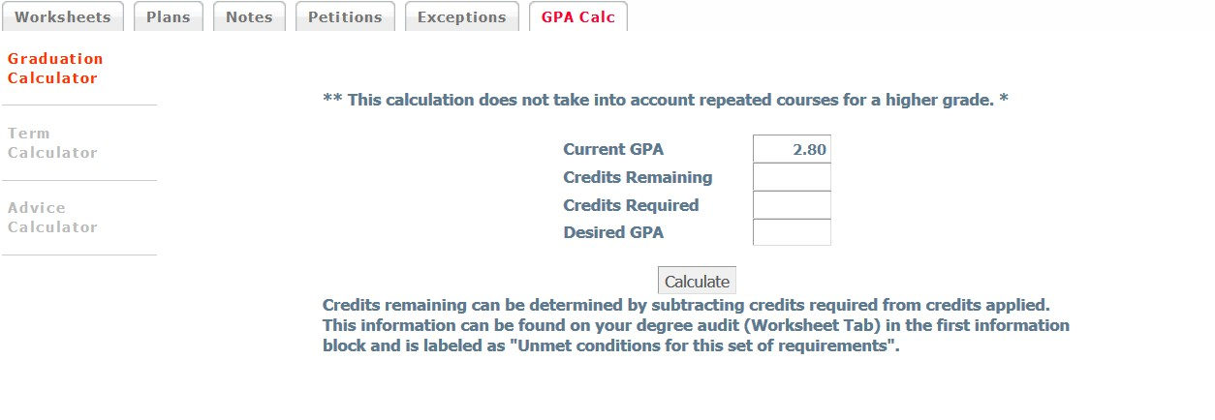

Term Calculator

  - This is the most specific calculator. It can be used for goal setting as well as mapping paths to avoid probation, achieve honors, etc.
    - The student’s current classes and credits (if applicable) are pre-loaded into the form. When done entering class information with expected grades, select calculate. The following screen will produce the new calculated GPA.

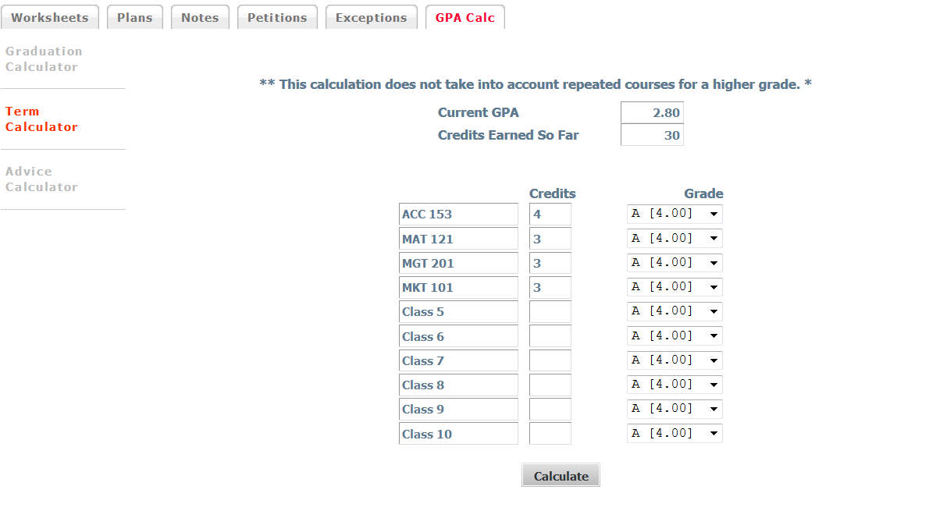

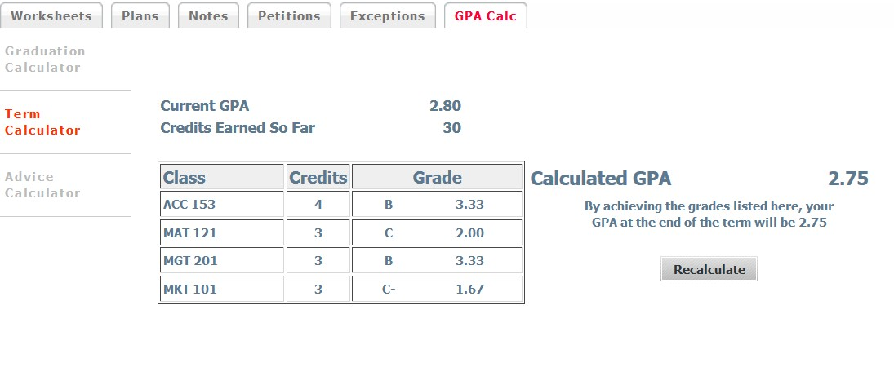

Advice Calculator

  - This calculator is used for students to input their desired GPA. It is used to figure how a student can raise their GPA with giving specific grades for advice.
    - It is also a realistic tool that will let students know if their desired GPA is not attainable.
