PIP System Overview for 2017-2018 – Guide to logging in and entering information for Planning & Budgeting:
Go to MySUNYOrange portal and click on the Employee tab and you will find “PIP (Planning & Initiative Prioritization) located in the Institutional Plans and Reports box to the bottom right.
Enter your network username and password to log into PIP.
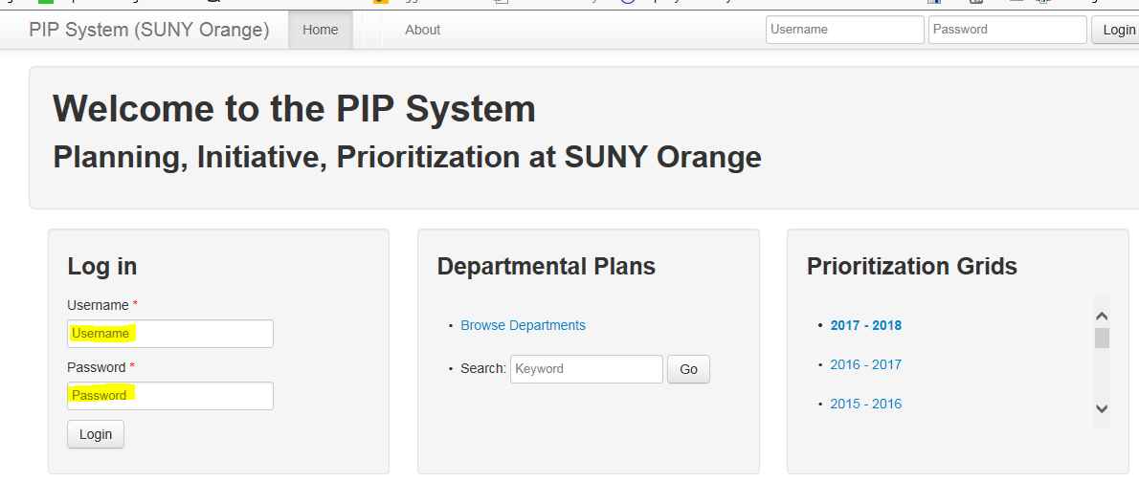
Click on “Plan”
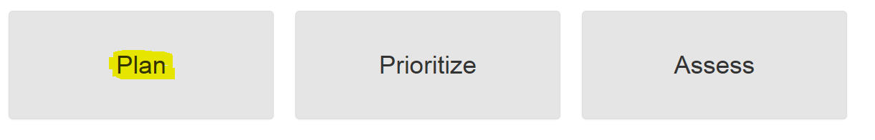
After selecting your department, select 2017-2018.
Enter Plan Summary, this will be an overview of what you want your department to accomplish.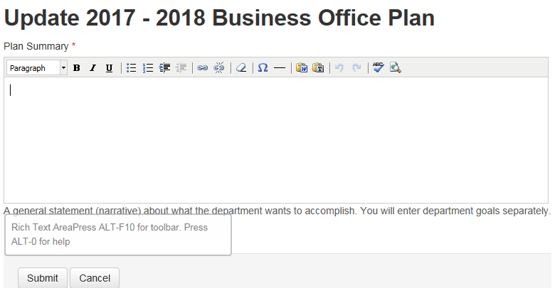

Then add “Goals”
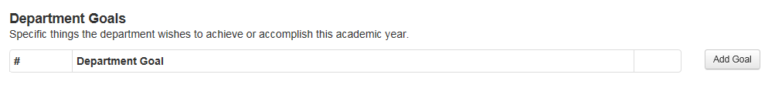
Next add “Initiatives” (aka Objectives) that are related to each of your goals
After adding the initial Initiative, the PIP system then will place the entered Initiative under “General Information” located to the left of the screen. To fully complete the initiative section the end user must complete “Institutional Goals”, “Action Steps”, “Expected Outcomes”, “Assessment Methods”, and “Resources” (all located to the left of the screen).
Use the Resource Planning Tips found on the 1718 Planning and Budgeting Packet to properly enter new resources in PIP’s “Resources” screen.
Please note: Only fully completed initiatives will be reviewed and prioritized by the President, Vice Presidents and Cabinet, and the highest priorities will be implemented in the 2017-2018 year. 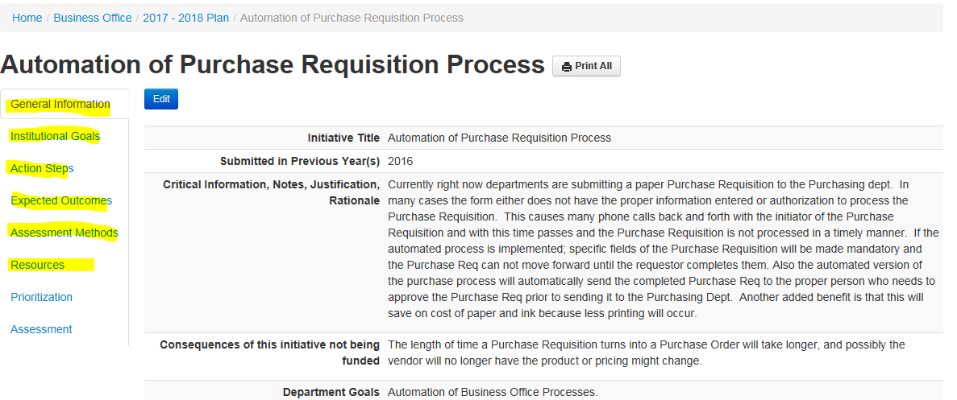

To assure that all required fields of an initiative is fully completed, click on “Prioritization”. If everything was entered, you will get a message that states, “This initiative is ready for prioritization”. If everything was not entered, it will list the fields that need to be completed.
