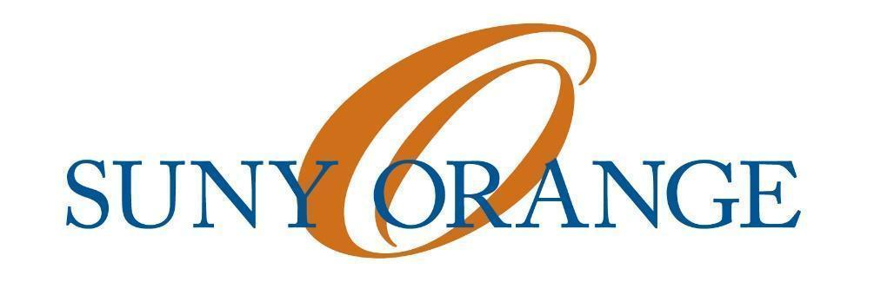
Newburgh Student Senate
March 16, 2017
Meeting Called to Order at 11:00 a.m.
Attendance: Zipphora Rutty, Daniel Perdomo, Jonny Santiago, Rosa Santiago, Jarrett Blaize, Bolaji Anjorin, Rebeka McGee, Annie Luna, Juan Carlos.
I. President’s Report
A Madeline Torres Diaz
- Conversations have been productive.
- Minutes must be submitted as soon as possible.
B. Unity Day
- Space must be booked for April 18th event will be from, 11 am - 2 pm.
- 150 shirts will be available
-20 small
-50 medium
-50 large
-50 x-large
-10 2x-large
3. More events must be created to promote interaction and unity amongst student body.
4. Posters that relate to unity must be made to be on display.
C. Senate Bonding
- Possible options for networking with MSS
-Volunteer work followed by dinner
D. Talent Show
1. Date has been changed to Wednesday April 26 from 7 pm - 9:30 pm
2. There will be 1 open week for auditions on both campuses
3.There will be a grand total of 16 acts which will be chosen by Student Senators.
4. Sign-up sheets to schedule for auditions must be made which will include the student's name, act and an e-mail where they can be reached at.
5. Auditions for the Newburgh Campus will be held in either the Great Room or Basement.
E. CSI Survey
1.Survey is collective thoughts on clubs from the student body.
2. We have concluded many students say they simply do not have the time to participate in any clubs.
F.Constitution
- The Constitution must be updated
-Add Promotions Chair Role
-Add a Mission Statement
Motion to Update: 1st Jarrett Blaize 2nd: Rosa Santiago Approved: 7-0-0
II. Vice President's Report
A. Food Services
1. A 5-year contract has been signed with Aventi a 3rd party through Pepsi. Delivery to both campuses will be provided daily.
2. Food giveaways and bake sales will no longer be permitted.
3. Vending machines will be replaced on Middletown campus.
4. Compromise regarding food giveaways and bake sales will be available midway through the 5-year contract.
III. No Treasurer's Report Today
IV. No Secretary’s Report For Today
V. No Promotion's Chair Report
VI. Advisor’s Report For Today
- Student Senator Juan Garcia has not been present in any meetings this semester and is affecting quorum.
Motion to vote Juan Garcia Out: 1st Daniel Perdomo, 2nd Jonny Santiago
Approved: 6-0-0
VII. Open Forum
1. President Christina M. Young will be attending NSS meeting on Thursday April 6th
2. Professor Hector Leal a previous NSS,would like to attend NSS meeting to share ideas and thoughts for branching out and promoting. Will attend on Thursday, March 30th.
Motion to Approve: 1st Jonny Santiago, 2nd Jarrett Blaize
Meeting Adjourned at 12:30 p.m.

