COVER LETTERS

The purpose of a cover letter is to answer the big question in the Manager’s mind: “Why should I interview this person?”

This document is your chance to market yourself as the best person for the position offered. It is as equally important as the resume. An effective cover letter can help you get an interview, while a poor one will cause your resume to be ignored.

However, be careful not to repeat information from the resume. Your job is to introduce yourself, your selling points, and the resume. While the resume presents your experiences and skills, the cover letter is pointing out the type of position you want and how qualified you happen to be. You need to highlight the portions of your experiential background that would interest the employer, your skills and talents. The cover letter can also explain gaps in your education or employment history or explain the reasons behind your changing career focus!

Plan on the three paragraph approach:

OPENING PARAGRAPH
- Explain the reason for the letter and/or identify the position you are seeking.
- Mention how you learned of the position (newspaper, Career Services Office, name of contact, Internet website…..).

MIDDLE PARAGRAPH
- Demonstrate your knowledge and interest in the organization.
- State the skills you can bring to the position that would meet the requirements of the job.
- Refer the reader to the resume for details, but do not repeat this information.

CLOSING PARAGRAPH
- End with an action statement – make a request for a personal interview.
- State clearly how you wish to be reached (phone number, etc.). Tell the employer if you plan to follow up with a phone call or if you want the employer to contact you. Clarify when and where you may be reached and end with an expression of enthusiasm or thanks.

COVER LETTER FORMAT

Remember that there is no one official format for the cover letter, but there are some guidelines to follow:
- Use bullets, indent, or bold face to emphasize and organize information.
- Every cover letter is an original letter aimed at one specific position and/or corporation. Avoid re-using letters from other applications.
- Address the letter to a specific person (phone the company to ask for a name!). Spell names and titles correctly.
- Write the letter in standard business format. Left-justified form is most commonly used today. Make sure the entire letter is framed evenly on the page. From top to bottom it must appear balanced.
- Include your contact information (name, address, phone number).

- Vary sentence structure to create interest, and avoid beginning too many sentences with “I”.
- Keep the letter to one page.
- Proofread. Then have someone else proofread!
- Use the same bond paper and laser-quality print as your resume.
- Personally sign each letter.
- Remember to follow-up every letter and resume you send.

GENERAL OUTLINE FOR A COVER LETTER
(Include your contact information as it appears on your resume!)

__________________ ___James A. Roy____________________________
17 Prospect Street (845) 531-9005
Pine Bush, NY 12566 jroy@aol.com

(2 spaces under your address)
Date
(2 spaces under the date)
Full Name
Title
Address of letter’s recipient
Mark Hansen
Director of Human Resources
ABC Corporation
999 Dunderberg Avenue
New York, NY 10005
(2 spaces)
Dear Mr. Hansen:
(2 spaces)
FIRST PARAGRAPH: State the reason for writing, the name of the position or the kind of work you are seeking, and mention where you heard about the opening.
(2 spaces)
SECOND/THIRD PARAGRAPH: This is where you state your reasons for being interested in the position or company and mention that you have the qualifications. You can briefly review your past experience, education, and volunteer work (as appropriate) to show your abilities required to do the job. DO NOT restate information from the resume, but refer the reader to sections of the resume instead.
(2 spaces)
THIRD PARAGRAPH: State what you want to happen next. Mention your interest in meeting with the employer and indicate clearly how he/she is to contact you. You may also plan to follow-up to ensure that your letter/resume has been received. Thank the employer in advance for his/her consideration.
(2 spaces)
Sincerely,

Your Signature (4 spaces)

Your Typed Name Here
(2 spaces)
Enclosure (This indicates your enclosed resume)
8 COVER LETTER MISTAKES TO AVOID

During your job search, you’ll probably apply to hundreds of jobs, creating customized resumes and cover letters for each position. Most people spend a considerable amount of time perfecting their resume to best reflect their experience and show off their accomplishments, but throw their cover letter together quickly or worse—don’t write a cover letter at all.

To make sure your cover letter gets noticed, make sure to avoid the following mistakes:

- Not personalizing your greeting - If possible, address your cover letter to the person doing the hiring (Ex: “Dear Mr. Thompson:” or “Dear Ms. Fleming:”). However, if the recruiter or hiring manager’s name is unisex, include their full name: Dear Pat Chang: ”If you can’t find the hiring manager or recruiter’s name, avoid addressing the cover letter to “Dear Sir:” or ”Dear Madam:” in the 50/50 chance you guess wrong. Instead, use a gender-neutral phrase such as “Dear Hiring Manager:” or “Dear Selection Committee:”

- Writing a generic cover letter - Although creating a template cover letter can be a time-saver during your job search, you should customize each one to each employer and job to show how you fit the requirements. Not to mention, accidentally inserting the wrong job title or forgetting to switch out the name of the employer is a sure-fire way to get your application dumped in the trash or deleted.

- Writing too much or too little - Many recruiters and hiring managers won’t spend a lot of time reading your cover letter, but you need to include enough information to sell yourself. Keep your cover letter to two or three high-impact paragraphs that describe how you fit the role’s requirements and are a perfect candidate for the position.

- Making it all about you - While it’s important to show off all of your awesome experience, the cover letter should equally be about you and the employer. Through your cover letter, show how you can benefit the company if they hire you and how you fit the employer’s needs.

- Forgetting to include your contact information - Resumes and cover letters can easily become separated, so make sure to include your contact information on both documents. By doing so, an employer can still know how to contact you by referring to your cover letter.

- Forgetting to proofread - Many job seekers forget to proofread their cover letter or do it too quickly and miss some of those pesky typos. If your cover letter has too many misspellings, typos, or grammar mistakes, you won’t send a positive message to the employer. Ask some friends or family members to review your cover letter before sending.

- Not following directions—If the employer has asked that you address a certain question in your cover letter or send it in a particular format, make sure you follow these directions. Employers often base their decisions on information they ask you to include and sometimes include application instructions—such as including the cover letter in the body of the email—as a way to test how well candidates can follow directions. If you can’t follow their instructions, it’s an easy way to eliminate you from consideration.

- Not sending a cover letter—Some job seekers don’t even attach a cover letter when they apply for a job or include a quick note such as “My resume is attached.” Take the time to write a clean, professional and direct cover letter that introduces you to the employer and addresses how you fit the specific requirements for the role.

Cover letters are a way to introduce yourself to an employer and to show how you are the best candidate, so use it to your advantage! It’s worth it to spend the extra time creating a great cover letter if it helps you land the job!



SOURCE: Website: http://blog.simplyhired.com

SAMPLE COVER LETTERS

#1 – Letter in response
New England College is accepting applications for an experienced outside sales recruiter. Duties will include travel to high schools, job fairs, etc., soliciting, continual follow-ups, and closings. Requires excellent verbal and communication skills, ability to work with a diverse group. Prior sales experience and Bachelor’s degree a must. Send resume and references to:
Director of Marketing, New England College, Box AG, Henniker, NH 25802
to classified ad

Date

Name
Director of Marketing
New England College
Box AG
Henniker, New Hampshire 25802

Dear Mr./Ms. X:

I noted with great interest your advertisement in the New Hampshire Union Leader for an Assistant Director of Marketing Recruitment. I understand your need for a person with excellent verbal and communication skills and I believe that my background as President of a national management collegiate chapter may be of great value to you.

Overseeing the 400 members of this chapter strengthened my knowledge and appreciation of working with students from across the country. Additionally, I have two years’ experience as a sales associate for a local clothing store where our compensation was based on soliciting, continuously following-up, and closing sales. I feel my experience and Bachelors degree in marketing make me a unique candidate for this position.

As requested, a copy of my resume and references are enclosed. I look forward to an opportunity to discuss my credentials in a personal interview. I will call on April 27th to arrange a time to meet and discuss the position.

Sincerely,

John Q. Public
John Q. Public

Enclosures
_____________________________________________________________________________________
SOURCE: Job Search Tactics by Kathleen M. Lordan. Pages 52-53. Charleston, West Virginia: Cambridge Educational.

#2- Letter in response
ADMINISTRATIVE ASSISTANT
To be a liaison with public & clients
5 years experience, 65 wpm,
Microsoft Word.
Attention: Teresa Micelli
to a classified ad

JUAN ORTEGA
1124 Bakery Avenue
Bakersville, NC 90000
___________________________________(555) 998-0090______________________________

Date

Teresa Micelli
Box 7344
Sunday Times
1123 N. Center Street
Bakersville, NC 11233

Dear Ms. Micelli:

I read with great interest your ad for an Administrative Assistant which appeared in the Sunday Times, April 14th. I am very enthusiastic because my background matches the qualifications you are seeking.

As you will note from my enclosed resume, I have more than five years experience in the field. I began as a secretary and worked my way up to an administrative position at Martel & Martel. I type 85 words per minute and am proficient in Microsoft Word and Excel.

I have always been complimented on the quality of my work and was personally responsible for designing our successful company newsletter.

Although I enjoy my current position, I would prefer a more challenging job where I can combine my creative talents and interpersonal skills.

I look forward to meeting with you in person to demonstrate that, along with my credentials, I have the personality that makes for a successful team player.

Sincerely,

Juan Ortega
Juan Ortega

Enclosure
________________________________________________________________________
NOTE: This is a targeted letter with a specific job focus. Notice how the letter answers the job qualifications.

SOURCE: The Resume Writer’s Workbook by Stanley Krantman. Page 101. 2nd edition.
Delmar
#3

SUSAN CHEN 1212 Otter Drive
Smithton, NY 9000
(555) 889-8789
____________________________________________________________________

Date

Michelle Irani
Process Engineer
Sealico Steel & Metal
700 Sparrow Lane
Tiger Creek, AK 90000

Dear Ms. Irani:

I enjoyed speaking with you on the phone earlier this week regarding a position with Sealico. Your division sounds exciting and your commitment to “total quality” is very impressive – a conviction I share with you.

As you can see from my enclosed resume, I have twelve years experience in metallurgy. At Pershall, my contributions as Process Engineer cut production costs by 14% and increased productivity.

I am optimistic that my knowledge and expertise in metallurgy, as well as my business experience in dealing with customer’s needs and material selection, will be an asset to Sealico.

I look forward to meeting you personally and will follow-up this letter with a call next week to arrange a meeting at your convenience. I welcome the opportunity to prove that I can make an effective contribution to Sealico.

Sincerely,

Susan Chen
Susan Chen

Enclosure
_______________________________________________________________________
NOTE: This is an example of a cover letter which follows up an informational phone call. Although four paragraphs in length, it remains an expansion of the three paragraph format.

SOURCE: The Resume Writer’s Workbook by Stanley Krantman. Page 102. 2nd edition.
Delmar

#4

SUSAN CHEN 1212 Otter Drive
Smithton, NY 9000
(555) 889-8789
__________________________________________________________________

Date

Michelle Irani
Process Engineer
Sealico Steel & Metal
700 Sparrow Lane
Tiger Creek, AK 9000

Dear Michelle,

I want to express my sincere appreciation for the interview on June 18th. The opportunity to meet you and become acquainted first hand with the fine work you and your team have been doing, has strengthened my interest in working for Sealico.

I think your plan to implement a quality control checklist is excellent. I feel this is an area that I can be of great assistance to you. I am confident that my experience in setting up such a program will add to Sealico’s efficiency and save you money.

Sealico is a dynamic and growing organization, and I would love to be a part of your team. I hope I am extended the opportunity to prove that I can make an effective contribution.

Sincerely,

Susan Chen
Susan Chen

_______________________________________________________________________
NOTE: The above is an example of a Thank You letter written after a job interview. This is just a courtesy, but it can be a factor that leads to an employer’s choosing you for the position! The informal salutation instead of “Dear Ms. Irani:” is only appropriate if the interviewer prefers informality.

SOURCE: The Resume Writer’s Workbook by Stanley Krantman. Page 102. 2nd edition.
Delmar

#5 – Letter in response to classified ad which focuses on candidate’s experience and college degree.

EDWARD JONES 1405 State Street
Goshen, NY 10924
(845) 526-9874
__________________________________________________________________

Date

Mr. Andrew Hampton
Director of Human Resources
Media Corporation
495 Interstate 10
Westchester, NY 90051

Dear Mr. Hampton:

Your ad in the Middletown Record on Sunday, August 26th, for an Entry Level Manager in the Marketing Division describes someone with my qualifications. My background and education provide me with the candidate profile which is just what Media Corporation needs.

As indicated in my enclosed resume, I have over three years experience in office administration at another Westchester advertising firm. As a junior level manager, I was able to write all of my own business correspondence and do so at 80 words per minute. I am also proficient in Microsoft Office Suite including Publisher and PowerPoint, and I have presented office demos utilizing Excel and Access.

My degree, an A.A.S. in Business Management from Orange County Community College, provides me with a solid background in the Principles of Marketing, Management, and Accounting. It was my Internship with the ABC Corporation during my last semester, however, which gave me the experience and confidence needed to head a seven member team which brainstormed new marketing trends in the lower Hudson Valley. Our team efforts resulted in expanding our retail market by 20%!

I will call your office early next week to make sure you have received my resume. Perhaps, at that time, we can determine a mutually convenient time for an interview. If you wish, you may reach me beforehand at (845) 526-9874. I thank you for your consideration.

Sincerely,

Edward Jones
Edward Jones

Enclosure

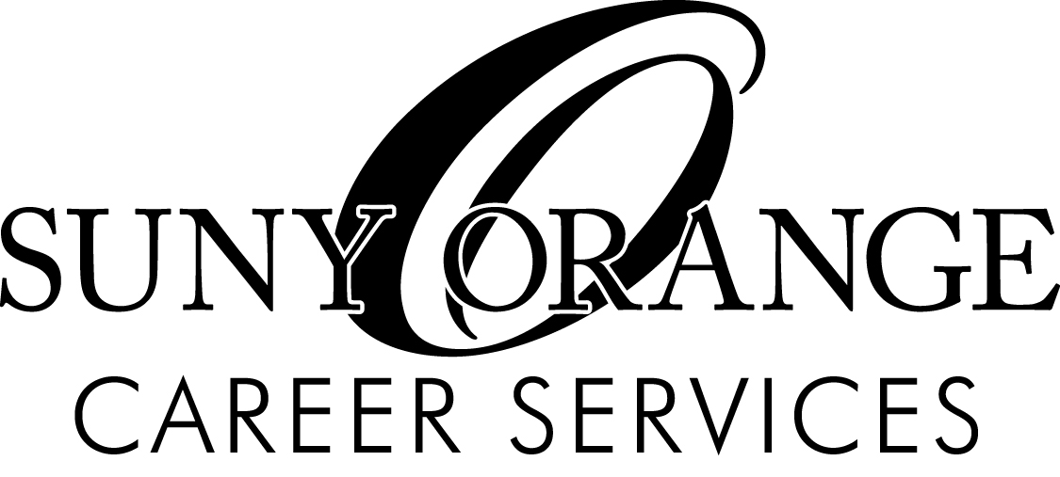

“Your Portal To Career Success”

Shepard Student Center
Room 227
115 South Street
Middletown, NY 10940

845-341-4444
FAX: 845-341-4447
careers@sunyorange.edu
www.sunyorange.edu/careers



