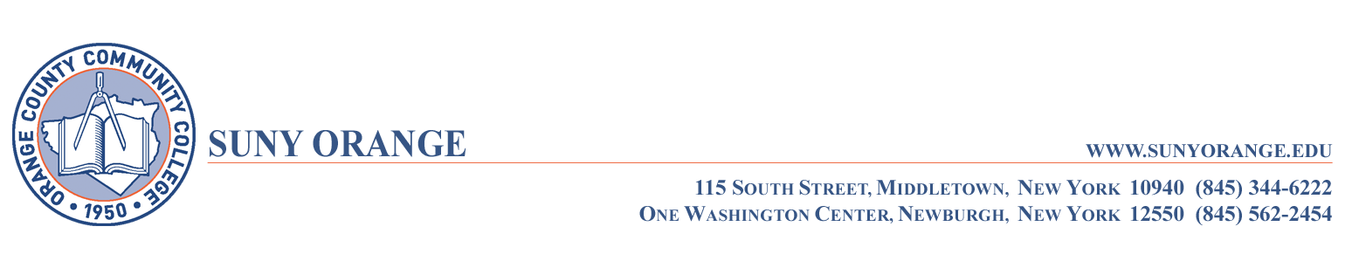

I certify that I have viewed the assigned

Medical Laboratory Technician PowerPoint

presentation posted on the college website

and am prepared to attend the

Pre-Admission Seminar on October 27, 2020.

___________________________________
Name

_____________________
Date

