SUNY ORANGE
Club Resource Manual

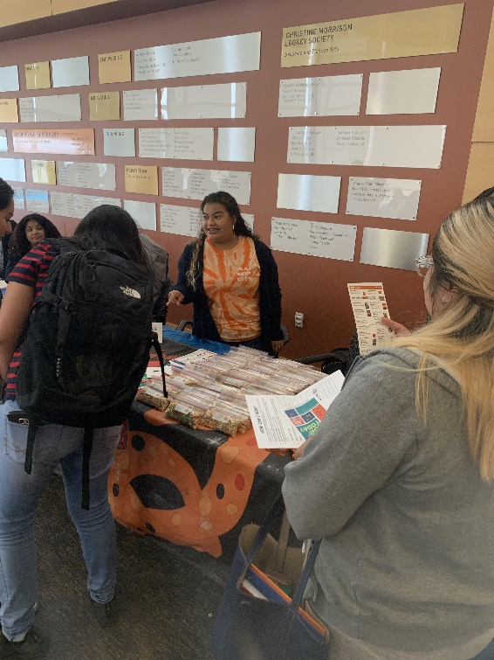

Contents
CLUB REGISTRATION 4
Starting a New Club 4
Registering a Returning Club 5
CLUB RECOGNITION 6
What is a recognized club? 6
Maintaining Recognition 6
CLUB PARTICIPATION 8
CODE OF CONDUCT 8
CLUB FINANCES 9
New Club Finances 9
Returning Club Finances 9
Treasurer Training 10
Fundraising 10
Club Accounts 11
How to spend money: Approval Process for Club Purchases and Spending 11
CLUB TRAVEL 13
Trip Requirements 13
Meals 15
Travel Vehicles 15
Trip Tickets 17
Hotel Reservations 17
Conference Registration 17
EVENT/ACTIVITY PLANNING 18
Event Supervision, Guidelines, and Approval Paperwork 18
Reserving a Room/Maintenance Requests 18
Guest Speakers 19
Technical Needs 19
Movie Policy 19
Adding Events to Website Campus Calendar 20
MARKETING AND PROMOTIONS 20
Posting Policy 20
Ordering Club T-shirts and Other Promotional Items 21
Electronic Advertising 21
Club Social Media 22
Posters/Flyers 22
COMMUNICATION WITH CSI 23
Fax 23
Club E-mails 23
MANAGING YOUR CLUB 23
Getting Started 23
Recruiting and Retaining Members 24
Conducting a Meeting 24
Officer Transition: Passing on What You Know 25
APPENDICES 27
35

CLUB REGISTRATION

Starting a New Club
- Meet with Center for Student Involvement Staff
This initial meeting is to discuss your idea for a club, review the requirements and paperwork, and talk about how the Center for Student Involvement can assist you.

To schedule a meeting
- e-mail the Director for CSI at adriennevictor@sunyorange.edu
OR
- Stop by the Center for Student Involvement in the Shepard Student Center in Middletown or Tower Basement in Newburgh

- Recruit Members
A club must have at least 6 active members in order to be recognized.
- Active members attend meetings regularly and participate in group events and planning.
- All members must be currently enrolled, credit students at SUNY Orange.
- The Center for Student Involvement can help you in your recruitment efforts by reserving rooms for meetings and reproducing flyers, posters and other advertisements. Word of mouth can also be a very effective recruitment tool. Talk to students in your classes and in the cafeteria and student lounges.

- Find an Advisor
All clubs are required to have a Faculty or Staff Advisor, but finding the right one can sometimes be difficult. A good Advisor is extremely important to a club’s success. They must be an active and involved part of your club, and not just a name on paper. They can help you avoid potential problems and to understand how to best use available College resources to accomplish your club goals. The Advisor does not run your club---student clubs are always student run. However, their experience and knowledge is extremely important and their suggestions and feedback should always be seriously considered. The best way to find a good Advisor is to talk with faculty and staff members that you know well. While they may not be best suited to be your club Advisor, they may be able to recommend a colleague that could help. Before deciding on an Advisor, your club should meet with them and review the expectations outlined in the Club Advisor Agreement found on the website. The Club-Advisor relationship should be viewed as a partnership with expectations on both sides and in which frequent and open communication is the key to success.

- Write a Constitution and Complete the Club Recognition Paperwork
Every club must complete the Club Recognition Form on our website and have the Advisor complete the Advisor Agreement/Grade Verification form. Please note – new clubs do NOT need to complete a budget request (this is for returning clubs only). Every club is required to have a constitution. This is a very important document because it lays out how your club is going to operate and the rules that you will follow. Important elements might include job descriptions for officers, how and when elections are held, and, for those “worst-case scenario” situations, how and under what circumstances members and/or officers may be removed. Writing the constitution should be taken very seriously and all members should be involved, especially in approving the final draft. A sample constitution can be found in APPENDIX A. The CSI staff can also assist your club with writing your constitution. Once all of the forms are completed, they should be returned to the Center for Student Involvement.

- Meet with the Student Senate- The final step in the recognition process is to obtain the approval of the Student Senate. When you submit your completed form, the Senate will schedule a meeting for final approval. It is strongly recommended that the club send representatives to both of these meetings to answer questions that may arise. You will be notified via e-mail of the vote to recognize your club.

Registering a Returning Club
In order to be recognized for a new academic year, all clubs must complete the club recognition documents which can be found on our website
- Club Recognition Form
  - Includes info about the club, officers, a constitution request, and a full membership List (clubs must maintain a minimum of 7 active members)
- Signed Club Advisor Agreement/Grade Verification form
  - Must be completed by your advisor
- Budget Request Form

They must be returned to the Center for Student Involvement by the advertised deadline each semester or the club will lose its recognition and all related privileges. A club would then have to reapply for recognition.

A club will only receive “returning club” status if they were registered with the college before Spring Break of the previous academic year. Any club registered after Spring break will be considered a New Club come Fall and receive a New Club budget.

CLUB RECOGNITION

What is a recognized club?
The club is officially part of the College and will be included in official listings and publications such as the College Catalog, the Student Handbook, and the College Website. Recognized means clubs can:
- reserve rooms and facilities on campus
- hold meetings and sponsor events on campus
- advertise and post notices on campus bulletin boards and online
- hold fundraising events
- apply for funding from the Student Senate
- have a mailbox in the Center for Student Involvement and receive mail at the College
- make use of Center for Student Involvement resources including faxing, photocopying and producing posters

Maintaining Recognition

Title IX
About Title IX
- All club officers are must fulfill their Title IX requirements. Title IX is a federal civil rights law that prohibits sexual discrimination in education programs including athletic programs or activities that receive federal funding. The Violence Against Women Act (VAWA) and Reauthorization Act (2013) also prohibit sexual assault, domestic violence, dating violence and stalking. SUNY Orange is committed to the prevention of sexual assault and provides workshops, prevention information programs, and links to direct services and resources in the area.
Title IX Completion
- All club officers are required to view Not Anymore, an online interpersonal violence prevention program from Student Success™. This video-based program will provide critical information about Consent, Bystander Intervention, Sexual Assault, Dating and Domestic Violence, Stalking, and campus specific policies and reporting procedures.
This training will inform you of your rights as a student, provide you with Title IX related college policy information, and give you the steps involved to make a report if it becomes necessary for you to do so. Not Anymore will help you better understand how vitally important these issues are and what you can do to help make your campus safer.

Disclosure: The training contains sensitive material involving sexual and interpersonal violence. While trigger warnings and resources are provided throughout the program, we understand such programming may be problematic for some viewers. Please contact Madeline Torres-Diaz for confidential support and/or to discuss alternatives.
A notice will be sent to all clubs and advisors at the beginning of each academic year with instructions and the deadline date for club officers to complete the training. Any club that fails to meet this requirement will lose its Student Senate funding. Additionally, if the club officers change at any point during the academic year, the new officers must immediately complete the Not Anymore training.
This is an important state requirement that must be taken seriously. If you have any questions about the policy or the process, please contact the Center for Student Involvement.

COLT Night (and Organization Leadership Training)
Each year COLT Night (Club and Organization Leadership Training) brings together representatives from every recognized SUNY Orange club and organization on both campuses for an evening of networking and leadership training focused on addressing real problems and challenges our clubs are facing and helping participants to develop the skills and strategies needed to help their clubs continue to grow and prosper. It also gives the clubs an opportunity to network with each other and their student government representatives to foster more cooperation and support. The program derives its name from the school mascot, the SUNY Orange Colt.
COLT Night features three interactive workshops facilitated by staff and faculty from the college. The three workshops are each offered twice in two 50 minute blocks, allowing participants to attend the sessions of their choice.
Inter-Club Council (ICC)
Meets once a month and brings together the Student Senate, the Board of Activities and representatives of all clubs. It is an opportunity to ask questions, share ideas and look for opportunities to work together. Each club is required to send one representative to the ICC. It does not have to be an officer, just a member who knows what is going on with the club and will bring back information to share. The Student Senate will notify all clubs of the ICC meeting dates, times and locations at the beginning of each semester. Clubs who do not send a representative are subject to financial penalty. On the rare occasion that no person from a club can attend an ICC meeting, the Student Senate must be notified in advance of the meeting in order to grant an excused absence.

Meeting Minutes & Attendance
To maintain recognition by the college and Student Senate, clubs must upload their attendance and meeting minutes to the SUNY Orange Clubs Shared drive at the end of each month during the academic year.

Inactive clubs
If a club is not active for 30 days they will receive a notice from Student Senate asking for proof of activity. If inactivity continues for 60 total days, the club will lose their recognition and their budget for the remainder of the academic year. Clubs maintain recognition through the steps listed above. Funds from the budget will go back to the SA fund and the club will have to reregister and receive the $300 new club allocation.

CLUB PARTICIPATION

All clubs are open to any currently-enrolled SUNY Orange credit student. Alumni or students not currently enrolled may NOT participate in a club. There is no minimum grade point average required to be a member of a club, but club officers are required to maintain a 2.0 or better semester and cumulative grade point average.

CODE OF CONDUCT

All students and clubs are required to abide by the Student Code of Conduct which can be found in the Student Handbook. This includes attendance at club events and trips held off-campus. Clubs are expected to, within reasonable limits, be responsible for their members’ and guests’ actions. The club and any individuals involved will be held responsible for any violations of the Code and clubs may face restriction of privileges or suspension or revocation of College recognition.

CLUB FINANCES

New Club Finances
New clubs that receive recognition are allotted a predetermined budget from the student activity fee. New clubs may request more money throughout the semester and Senate will attempt to assist based on available funds. For questions about how much money new clubs are allotted for your current semester, see the Center for Student Involvement.

Returning Club Finances
- All clubs must submit a budget form request (found on our Clubs Google Site) to the Center for Student Involvement by the deadline assigned. Clubs will receive the budget forms, guidelines, and deadlines via club email around the second week of classes.
- Budget Samples are available on our Clubs Google Site.
- All instructions must be followed and budgets must be submitted on time. Incorrect or incomplete budgets will be returned to the club and the delay may result in less funding being available for the club. If an extension of the deadline is required, requests must be e-mailed to the Senate Treasurer and to the Director of CSI.
- Other club requests that were submitted by the deadline will continue to be reviewed and late budgets may receive decreased funding based on the amount of funds left to allocate.
- The more detail included in your budget request, the easier it is to process in a timely matter.
- Once budget requests are received by the Student Senate, hearing dates will be set to review the requests. Clubs will be notified of the hearing dates and times via their club e-mail. It is strongly encouraged that clubs send either the treasurer or a representative who is familiar with the budget. If no representative is sent, the Senate will make cuts/adjustments to the budget based on available information.
- Once the finalized budgets have been approved by Student Senate, a copy via Google sheets will be returned to the club through their e-mail. This copy will be updated in real time by the Student Senate and CSI for clubs to review their ongoing expenditures.
- Allocated funds can only be used for the items detailed in the budget. Requests for changes to the budget or appeals of the allocation amount may be made in writing to the CSI office. Any questions about the budget process should be directed to the Student Senate treasurer or the Director of the Center for Student Involvement.
- All budgets close for the year on the last day of spring semester classes. All arrangements for payment must be made one week prior to that time. Any remaining budget money left after the last day of classes will be returned to the Student Senate for re-allocation the next semester.
- Clubs can request Student Senate’s approval to re-allocate money if they are not spending it on what was originally listed in the budget. Senate reserves the right to deny these requests as the expectation is that club’s plan ahead of time when submitting their budget. Emails clubs.studentsenate@sunyorange.edu to request a re-allocation.

IMPORTANT: All requests to spend money must be completed one full week before the LAST Senate meeting of the academic year.

Treasurer Training
A Treasurer's Workshop will also be held at the beginning of each semester where all of the above information will be reviewed in detail. All clubs are strongly encouraged to attend including instructions on how to complete a budget request, how to appropriately spend club money, and the required approval process to use the club budget. Notification of workshop dates/times will be sent to all club e-mails.
Click here to view budget request tutorial video
Click here to view club purchasing tutorial video

Fundraising
All fundraisers MUST be approved by the Center for Student Involvement. Clubs may submit a fundraising request via this form. Clubs may face sanctions for holding unapproved fundraisers. All clubs have the ability to do fundraising to supplement what the Student Senate can provide. There are many types of fundraising activities available and clubs are encouraged to be creative and try new and different projects. Fifty-fifty raffles and bake sales are NOT permitted, but there are many other options available. Clubs looking to do fundraising must speak with the Center for Student Involvement staff before arrangements are made and the event is held to make sure the planned event meets all College and legal guidelines. CSI can also offer a number of resources and ideas for fundraising events and can even do a fundraising workshop for your club. Any funds collected through fundraising efforts must be brought to the Center for Student Involvement for deposit in the College Association where all your fundraising money is held and accounted for. Clubs can also bring it directly to the College Association (small house across the street from the Shepard Student Center on East Conkling Ave.)

The college requires that all advertising for any club fundraising events state specifically what the money raised will be used for (i.e.-International Red Cross, Nursing Pinning Ceremony, club trip to -----, etc.)

Club Accounts
Clubs have two possible accounts to draw funds from:
- Student Senate Club Budget: This was the budget request that was filled out by your club and approved by Student Senate. This budget does NOT rollover to the following academic year
- Fundraising Account: If a club does ongoing fundraising, an account is set up with the College Association to hold onto those funds. The money may be used by the club at any time and rolls over to future academic years, so long as the club remains active and in good standing.

How to spend money: Approval Process for Club Purchases and Spending

Purchase Request Form
- Clubs can submit a request to make a purchase here.
- The Director of CSI will review and approve/deny all purchase requests and reach out to the person who submitted the form to move forward with the purchasing.
- Review this video tutorial for how to complete a purchase request

Timeline for Submission
- Purchase requests under $500 must be submitted a minimum of 3-5 business days in advance of when money is needed
- Purchase requests over $500 must be submitted a minimum of 7 business days in advance of when the money is needed as they also require AVP signature

Purchase Options
- Check
  - Check for Cash Advance
    - A check can be written for a cash advance for a club advisor for a trip or shopping
  - Check for vendor/business
    - A check can be written to pay a vendor or business.
    - Invoices/Quote must be attached to the purchase request form in advance
  - Check for Reimbursement
    - Although not encouraged, checks may also be used for reimbursing purchases out of pocket. Keep in mind without a purchase request being completed PRIOR to a purchase, there is no guarantee of reimbursement.
  - Once a purchase request is approved for a check, the check will be either mailed or available for pickup at CSI
- Club Credit Card
  - Clubs may request a credit card through the purchase request form.
  - After submission, the request will be sent to the club advisor for approval
  - Upon approval from advisor, a member of the CSI staff will reach out to your club to confirm pickup date for the card
  - Credit card must be returned to CSI within 24 business hours with copies of all receipts
- Shoprite Card
  - CSI has a shoprite card available for use. Clubs may request it through the purchase request form.
  - After submission, the request will be sent to the club advisor for approval
  - Upon approval from advisor, a member of the CSI staff will reach out to your club to confirm pickup date for the card
  - Shoprite card must be returned to CSI within 24 business hours with copies of all receipts along with a note of what it was used for

Re-Allocating Money
- Clubs can request Student Senate’s approval to re-allocate money if they are not spending it on what was originally listed in the budget. Senate reserves the right to deny these requests as the expectation is that club’s plan ahead of time when submitting their budget.

Tax Exempt Form
- Any purchases within New York State qualify for tax exempt. Please obtain a tax exempt form from CSI for any purchase made within NY as any tax must be paid for out of pocket without this form

Beverage Purchases
- All beverage purchases are to be Pepsi products only due to our college contract.
- If the food vendor that you are using does not provide Pepsi products, contact Kathy Goulden at 845-562-5400 ext. 410 or at kathygoulden@pepsihv.com to place a beverage order.
- Pepsi products may also be purchased from Shop Rite.

CLUB TRAVEL

Trip Requirements

Off Campus Travel Policies & Guidelines
- A club or organization trip is any off-campus excursion that uses a club or organization name and/or money allocated by Student Senate or from a club fundraising account
- All trips are subject to the approval of the college and require the completion of a Travel Approval Request and individual Liability waivers. Only those who complete a liability waiver are permitted to attend. Participants under the age of 18 must have this signed by a parent/guardian
- Upon receipt of travel documentation, the Director of the Center for Student Involvement will review the information and take the following considerations when determining trip approval
  - Health/safety/risk concerns for participants
  - Budgetary restrictions
  - Trip relevance to mission or purpose of the student group and Student Senate’s funding approvals
  - Any other concerns as determined appropriate by the Director of CSI and college administration
- Personal vehicles may be used for single one-day trips that are less than six hours from the Middletown or Newburgh campus and only at the discretion of the Director of CSI and/or college administration. Personal vehicles are not permitted for overnight trips.
- A club or organization advisor or designated campus employee must travel with the student group unless written permission is granted by the Director of CSI or a student involvement staff designee within 14 days prior to the departure date.
- The Student Code of Conduct is in effect for all sponsored trips. Students are expected to abide by the behavioral expectations set forth by this document.
- All participants are prohibited from consumption of alcohol and use of recreational drugs and any illegal substances, even if they are of age.
- Participants who fail to abide by any of the off campus travel policies and the student conduct may face sanctioning surrounding their future participation or disciplinary action by the college.

Travel Approval Request
Travel Approval Request form must be completed no less than two weeks prior to the date of the trip. This is a firm deadline and no exceptions will be made. Please plan ahead accordingly.

Before the Travel Approval Request Form is submitted to the Center for Student Involvement, it must be signed by the following people:
- The club Advisor
- The appropriate Associate Vice President (AVP)
  - If a club is affiliated with an academic department, the form must be signed by that department's AVP (example: Business Club-signed by AVP for Business, Math, Science, and Technology; Nursing Club-signed by AVP for Health Professions, etc.)
  - The Academic AVP's offices are located on the second floor of the Library.
  - Those clubs not affiliated with an academic department (example: Billiards Club, GSA, etc.) must submit their form directly to the Director for CSI
- The Director for Student Involvement
- The Director will then submit it to the VP for student services for final approval. You will be notified when you are fully approved or if there are any issues or concerns

Advisor in Attendance
A club Advisor is required to accompany a club on any trip. It is the club's responsibility to cover the Advisor's mandatory costs (transportation, lodging, required admissions and similar expenses) through budget requests and/or fundraising. The club is only required to cover food or ancillary expenses for ONE Advisor. The club is not required to cover any expenses for additional advisors, faculty, or staff who wish to attend.

Waiver of Liability
Also, every person going on a trip, including non-student guests and advisors, must fill out and sign a Travel Waiver of Liability. Completed waivers must be submitted to the Center for Student Involvement no less than two weeks prior to the trip. Students and guests that do not have waivers submitted by the deadline cannot go on the trip and refunds for any payments made may not be provided.

Links to both the Travel Approval Request Form and the Waiver of Liability can be found on the Center for Student Involvement web site at http://www.sunyorange.edu/csi/trips.shtml.

Meals

Funds Allocation
Trip meals may be covered by the club budget according to GSA per diem rates. The updated rates for each fiscal year can be found on the U.S. General Services Administration webpage. These rates are based on locational cost. For example, Orange County’s rates for 2023 are $14 for breakfast, $16 for lunch, and $29 for dinner.

Travel Vehicles

Personal Cars
Students may carpool and use personal vehicles for club trips at the discretion of the Director of CSI and college administration. Advisors are not permitted to take students in their own vehicles. See travel policies above for further details. Reimbursements for mileage may be submitted using either approved Senate budget funds or fundraising accounts per the GSA reimbursement rate.

Van Rental
Vans can be rented through Enterprise Rent-A-Car through the college’s account and must be driven by a SUNY Orange employee. Before making a van rental reservation, clubs must notify the Center for Student Involvement how they will be paying for the rental (Senate Budget or Club Account) and ensure they have sufficient funds to cover the charges. If needed, clubs may rent mini vans from Enterprise Rent-A-Car (phone 374-5010). When making a reservation, specify that it is for a club at Orange County Community College and billed to the Center for Student Involvement. They do not require a credit card for your rental, but they will require the name and driver’s license for each driver (Enterprise requires all drivers to be at least 25 years of age). It is the club's responsibility to obtain a final bill from the rental company and submit a voucher to the Center for Student Involvement for payment within one week of the trip. If this is not done, clubs may be held responsible for the final costs from their fundraising accounts. Vehicles must be returned to Enterprise with the same amount of fuel they had when signed out. Enterprise will charge a very high refueling fee if this is not done and this cost will be passed on to the club. Clubs that do not follow these guidelines may be restricted from using vehicles in the future

An Important Note regarding Rental Vehicles and Insurance
All vehicles rented through Enterprise for authorized College activities come with Enterprise's insurance coverage for the vehicle. College employees are also covered by the College's policy over and above what is not covered by Enterprise. Students, however, are NOT covered by the College policy and, therefore, any coverage beyond that provided by Enterprise is the responsibility of the student driver's personal insurance and/or the student him/herself.

Buses
For trips involving larger groups, clubs have the option of renting a bus. Bus rentals must be done through the Center for Student Involvement. Clubs should remember that bus rentals are expensive (approx. $700-1200 for local day trips) and usually require advance booking of at least a month. A club using a bus for a trip must open the trip to any student on campus and must advertise the trip accordingly. Also, all students must sign-up for bus trips at the Center for Student Involvement, including club members. The club member coordinating the trip should bring the trip information to the Center for Student Involvement as early as possible so the sign-up list can be created. There must be a minimum of thirty people signed up by 2 weeks before the date of the trip or the bus will be cancelled.

Recommended bus charters include Hudson Valley Charter and West Point Tours.

Trip Tickets
If a club is taking a trip that requires an advance purchase of tickets (museums, tours, etc.), arrangements can be made through the Center for Student Involvement to buy the tickets using the office credit card.

Hotel Reservations
A Credit Card Purchase Request needs to be submitted complete with approved Travel Authorization Form, and must include the hotel name, address, dates for check in and check out, and any other supporting documentation related to the purpose of stay. The credit card will be used to hold the room(s), but the club must verify with the hotel that they will accept a college check.
CSI will make the reservation and forward any e-mail confirmation to the club advisor who will be travelling with the club. The club is then responsible to submit a voucher for final payment to the hotel. Most hotels require that any check be received two weeks prior to check-in. Please make sure to allow enough time for a voucher to be approved, processed and mailed to the hotel.

Conference Registration
Conference Registrations are made by the Center for Student Involvement using the College Credit Card. A Credit Card Purchase Request needs to be submitted complete with an approved Travel Authorization Form, and must include any other supporting documentation related to the Conference. Since some Conference Registrations have unique questions, it is recommended to schedule an appointment with a member of the CSI staff to complete the online registration.
- Follow the Travel Approval Process which includes the submission of a Travel Approval Request form and Waiver of Liability form. Instructions and forms can be found on the VPA’s page of the school website.
- Ensure that all persons on a trip have completed and signed a Waiver of Liability, copies sent to the Center for Student Involvement and to keep copies of the waivers with them for the duration of the trip.
- Ensure that students are aware of the Code of Conduct and that they are responsible for it during the trip. Students are also responsible for the conduct of any non-student guest that accompanies them. Advisors/Trip Organizers are not responsible for the conduct of any student or guest on any trip.
- Mediate or diffuse any conflicts that may arise during the trip to the best of their abilities. Advisors/Trip Organizer who witness and/or become aware of any Code of Conduct violations during the trip are required to document the incident and report it to the Director of the Center for Student Involvement and the Vice President for Student Services immediately upon their return to campus.
- Serve as a point of contact in the event of an emergency during the trip and relay information to SUNY Orange security and/or administration as necessary.
- If traveling with students by car, advisors are strongly encouraged NOT to transport students in their personal vehicles due to liability issues. Faculty/staff can drive rental vehicles.
- During any off-campus trip, club Advisors/Trip Organizers are covered by the College's general liability insurance while in the performance of their duties.

EVENT/ACTIVITY PLANNING

Event Supervision, Guidelines, and Approval Paperwork
The club Advisor must be at all club events. This is a College rule and there are no exceptions. When planning an event, make sure to discuss it with the club Advisor early in the process to make sure they will be available to attend. All clubs must fill out and return an Event Oversight Agreement found on our website to the Center for Student Involvement in order for an event to be approved. Marketing may occur AFTER event approval. Events should only take place during the semester, though some exceptions may be made with approval from the Director of CSI. Events may not occur during Finals week to prevent and scheduling conflicts and distractions during this crucial academic period.

Reserving a Room/Maintenance Requests
Reserving a Room
All rooms for a meeting or event on campus must be reserved through the Center for Student Involvement TWO WEEKS PRIOR to an event. Please complete the Club Room Request Form. A club may be refused a room reservation if they do not meet the this deadline.

For Events: Club advisors must complete the Event Oversight Agreement prior to CSI staff submitting the request to Central Scheduling and confirming room reservation.

The staff will submit your request in to the Central Scheduling Office. As soon as we receive notification that your request is approved, you will be notified via email Keep in mind this may take a couple of days. This does NOT include setup for the event. See section below on Maintenance Requests for details

Available Club Meeting Rooms in Shepard Student Center
- Club Meeting Room (Left Side)
- Club Meeting Room (Right Side)
- Pathways Room

Maintenance Requests/Technical Requests
Any setup for an event or meeting requires a maintenance request or IT ticket. For event setup like tables, chairs, etc. please have your advisor complete a request via MYSUNYOrange Facilities Request. For any technology needed for an event, please submit an IT Ticket through the website.

Guest Speakers
Student clubs retain the right to extend invitations to individuals, groups, and community leaders to speak or present at club meetings and events. However, it is very important that, prior to any invitations being made, the club speaks with their advisor and the Center for Student Involvement in order to insure that proper arrangements are made and all college protocols and procedures are followed.

Technical Needs
If you are having a meeting or event that requires technical assistance or equipment (television, projector, sound system, etc), you must make that request to the Center for Student Involvement no less than five days before the date of your meeting or event. This request is then forwarded to the college's Information Technology Department. If a request is made less than five days prior to your event, it may not be met.

Movie Policy
In order to hold a public screening of any film, the rights to hold the screening must be obtained from a film distributor and a licensing fee must be paid. A public screening is anytime you show a film for a group of students or the community at large including at a club meeting. Fees for films can range anywhere from $100 up to as much as $900 for recent releases. It is important to understand that renting or owning a movie yourself only covers the right to show that movie in a private home. This includes if the movie is available on a streaming service. To show it anywhere else, including classrooms, a licensing fee must be paid. Showing a film without obtaining the licensing rights can result in huge fines from the film production company. The Center for Student Involvement can assist clubs in obtaining the rights for a film. Showing a film without following these guidelines will result in possible disciplinary action being taken against the club.

Adding Events to Website Campus Calendar
Clubs should post all meetings and events on the SUNY Orange website calendar so all students can view it. You can post your events here.
- Put [Student Club] at the beginning of the title
- Use the "Create Recurring Event" option assuming the weeks are at regular intervals (such as weekly)
- Please ONLY select "Student Clubs" as the category (unless a department KNOWS you are adding them as a second category for your club meetings)
- Enter Location. For virtual events - enter "online" and that should show an option to select "Online Only" as the location, which will fill in the rest of the address

MARKETING AND PROMOTIONS

Posting Policy
Orange County Community College
Policy for Posting Advertising and Materials

- Promotional materials may be posted on campus by recognized student organizations or College departments. The sponsoring group must be identified on posted materials and they must be stamped by the Center for Student Involvement. Flyers and posters should be brought to the Center for Student Involvement to be stamped before they are duplicated. The Director of the Center for Student Involvement can make exceptions.
- All promotional materials to be posted from groups outside the college community must be approved and stamped by the Center for Student Involvement.
- Promotional materials must be placed only on bulletin boards or designated posting areas. Bulletin Boards and cases reserved for specific clubs, offices or departments may not be used.
- Posters and flyers placed on walls, doors, windows, trees or painted surfaces will be removed.
- Student organizations and College departments are responsible for the removal of materials within 24 hours after the event.
- Materials depicting or announcing activities at which alcohol is to be served are prohibited. Materials promoting activities sponsored by alcohol manufacturers are prohibited.
- Posting on campus is not a right, it is a privilege open to members of the College community. Postings are permitted only on certain exterior and interior areas. Messages that contain abusive language, threats or obscenities will be removed, as well as all messages, regardless of content, that appear in prohibited locations or that fail to comply with other relevant restrictions.
- Student organizations or individuals that violate this policy may lose posting privileges and/or face disciplinary action.

Ordering Club T-shirts and Other Promotional Items
The Center for Student Involvement has access to a large selection of imprintable items and maintains relationships with a number of companies that do this type of printing. When planning to order such items, clubs should first stop in the Center for Student Involvement to determine options and pricing. Any orders for shirts or other imprintable items must be placed no less than 3 weeks prior to the last day of classes to allow proper processing time. Clubs are not required to use the company recommended by the Center for Student Involvement and may, at their discretion, use their own printer or online services such as Customink.com. The Center for Student Involvement is still always ready and willing to assist clubs in placing their orders.

Electronic Advertising
There are a number of electronic resources available to help you get the word out about your club and any upcoming events. They include:

TV Displays: There are large flat screen televisions located in the Shepard Student Center and the Rowley Center in Middletown and Kaplan Hall in Newburgh that constantly display advertising slides for campus offices and organizations. Instructions for how to create and submit a PowerPoint slide for display can be found at http://www.sunyorange.edu/csi/publications.html.

Social Media: Submit announcements and information about upcoming events to Justin Cole, Digital Media Coordinator at
justincole@sunyorange.edu to request posting on the College's Facebook or Twitter pages. There is also a CSI office Instagram and twitter that can be used for marketing purposes. Contact the office to request a post of your ad or anything to show off your club.

Grapevine: The Grapevine is the College's bi-weekly electronic newsletter. There are two versions: the College Grapevine (for faculty, staff and public) and the Student Grapevine (exclusively for students). Your club Advisor has access to help you post announcements to either Grapevine. Students may submit a grapevine post and write in their club advisor’s email as the contact information to get the post approved. After the club advisor approves the grapevine post, the Communications office will approve it for publication.

Club Social Media
Clubs can work with the Office of Communications to create a social media account. Approval from the college is required. Please complete this google form so the college can provide you with your club’s social media account.

Click here for full view of SUNY Orange Social Networking and Procedure Guidelines

Posters/Flyers
Posters: The Center for Student Involvement has the ability to produce full-color posters up to 24 inches wide for club events and promotions. The club must design the poster and email it to studentinvolvement@sunyorange.edu. There will be a 2 poster maximum per club event

Flyers: The copier in the Center for Student Involvement is available for club use. The office staff will assist with making copies of minutes, flyers or anything related to club business. If a club needs a larger number of copies (more than 25 per event), the Center for Student Involvement staff will help complete a Photocopy Request Form, which can be dropped off at the College Copy Center. Please keep in mind that copy center orders may take up to five days to complete.

Handouts: CSI can also print 25 copies of quarter sheets per club event. This equates to 100 quarter sheet “handouts” that may be used as promotional materials for clubs.

COMMUNICATION WITH CSI

The staff of the Center for Student Involvement is here to help answer questions and assist clubs in planning and carrying out successful events and activities. Club officers and members, as well as all students, are encouraged to call, email or stop by anytime. Listed below are some of the services offered to clubs at SUNY Orange.

Fax
There is a fax machine in the Center for Student Involvement available for club use. Please contact the Center for Student Involvement staff if you need to send or receive a fax.

Club E-mails
All clubs have been issued a college e-mail address. Your club advisor is the manager of this account and must activate it each year to assign which club members have access to the e-mail. Please make sure to work with your advisor so that your e-mail is functioning as this will be the main line of communication with CSI and Student Senate. New clubs should reach out to the CSI office to set up their club e-mail.

MANAGING YOUR CLUB

Getting Started
To help you with beginning your club and ensuring that all important paperwork has been completed, please view our Beginning of the Year Checklist (Appendix C).

Recruiting and Retaining Members
The current and future success of any club depends on how well it recruits and retains its members. The Center for Student Involvement requires all clubs to have an active membership of at least 7 students in order to maintain recognition. Hopefully, clubs will strive to have far more than the required 7 members. The Center for Student Involvement sponsors a major event each semester to help clubs in their recruiting efforts (Student Life Day-Middletown Campus/Student Involvement Day-Newburgh Campus in September and the Club Fair in February), but membership recruitment should be an ongoing effort. Every event that a club sponsors and every advertisement that it hangs on a bulletin board, is a chance to let other students know about the club and encourages them to get involved. Clubs can set up recruitment tables in any building by making a reservation with the Center for Student Involvement. All club members should look for opportunities to get other students involved.

Once you have new members coming to a club meeting, you have to keep them involved and interested. Some strategies include:
- Take time in the meeting to have the members introduce themselves and help new members become more familiar with the group.
- Encourage new members to join in discussions during the meeting. Remember that, as new members, they may not be aware of what has been going on and can feel left out. This may cause them to not come back. Let them know the current topics and projects under discussion.
- Ask new members to take on a particular role or task in an upcoming event, such as helping with publicity.

Find some way to get them involved and feel welcomed and, chances are, they will keep coming back.

Conducting a Meeting
Conducting an organized and efficient meeting is much more difficult than it seems. Running a good meeting means that decisions are made fairly, everyone has the opportunity to voice their opinion, and the club is able to accomplish its plans and goals. In most organizations, it is the job of the President to run the meetings. While practice is the best way to improve your skills, just as important is the time put into preparation before each meeting. An agenda should be prepared with all of the items to be discussed at the meeting and the President should be prepared to keep an eye on the clock to make sure everything gets done in the allotted time. The agenda should be distributed to club members prior to the start of the meeting. All group decisions should be made by a vote of the membership after time is made for discussion. The overall goal is to create an atmosphere of order and fairness within the meetings. Most organizations use the standard practices of parliamentary procedure to run their meetings. The most frequently recognized resource for parliamentary procedure is Robert’s Rules of Order. A summary of some of the basics from Robert’s Rules is located in the back of this handbook (APPENDIX B). The Center for Student Involvement offers resources and can do workshops for groups interested in running more effective meetings and learning more about parliamentary procedure.

Officer Transition: Passing on What You Know
Each year new club officers eventually wander into the Center for Student Involvement, essentially unaware of what their responsibilities are and what resources are available to them. Most don’t even know they have a club mailbox. What they tell the staff is almost always the same - “The old officers just left and nobody told me anything.”

For a club officer, taking the time to pass on what you know to the next year’s officers (or potential candidates if elections have not been held yet) is one of your most important jobs. It does not have to be a difficult process. You can view a transition checklist in APPENDIX D. These steps can help ease the transition process:
- Officers should inform club members about what they are doing during regular meetings so everyone understands the basics of their jobs. The officers’ roles within the club should not be a big secret.
- Target members who are interested or might make good officers early on in the year. Encourage them to get more involved.
- Utilize your Advisor! The club Advisor should be the one guaranteed constant within the club from year to year. Keep them informed and active and encourage new officers to meet with them first thing at the beginning of the new year.
- Keep good records! Past semester’s budgets, meeting minutes and copies of any correspondence are basic club records that are invaluable to new officers. Keep them in a safe place (possibly with your Advisor) and make sure they are kept up-to-date and everyone knows where they are.
- Use this handbook as a guide. All club members should know the information in this publication. Informed and involved members are the key to a smooth transition between years and help the club to accomplish more.

APPENDICES

APPENDIX A
Constitution Checklist
Sample Constitution

APPENDIX B
Parliamentary Procedure Basics

APPENDIX C
Beginning of the Year Club Checklist

APPENDIX D
Officer Transition Checklist

APPENDIX A
Constitution Checklist
Sample Constitution

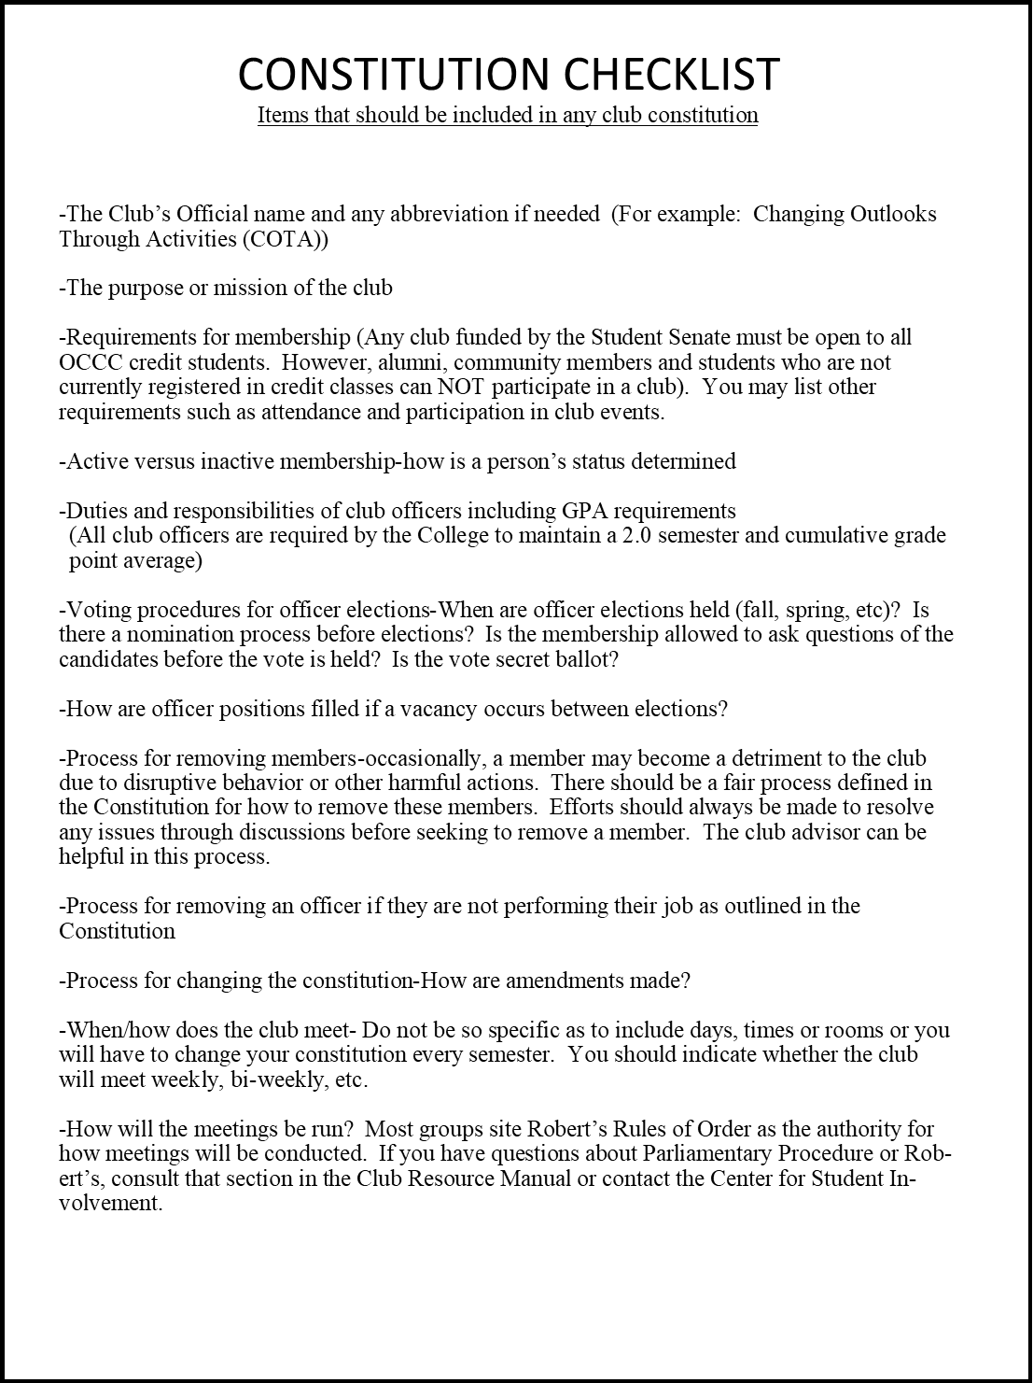

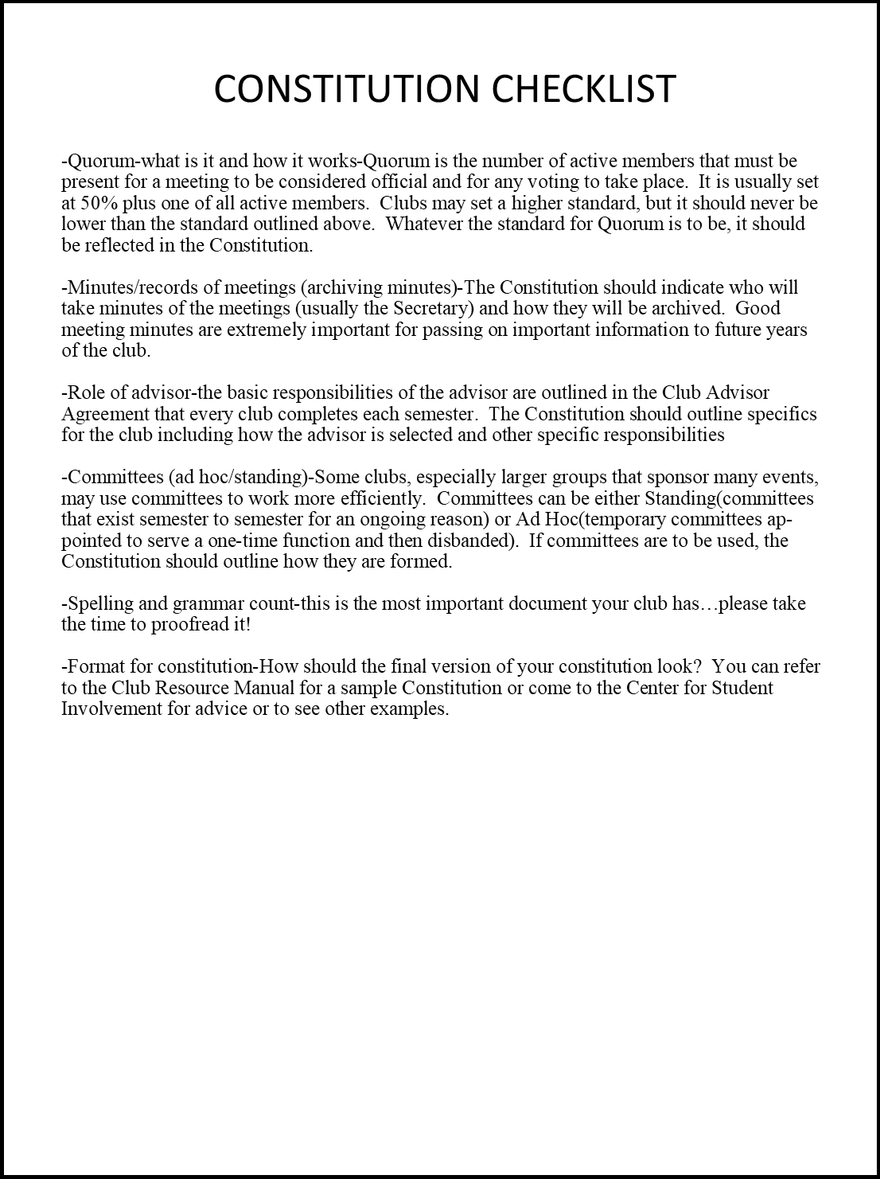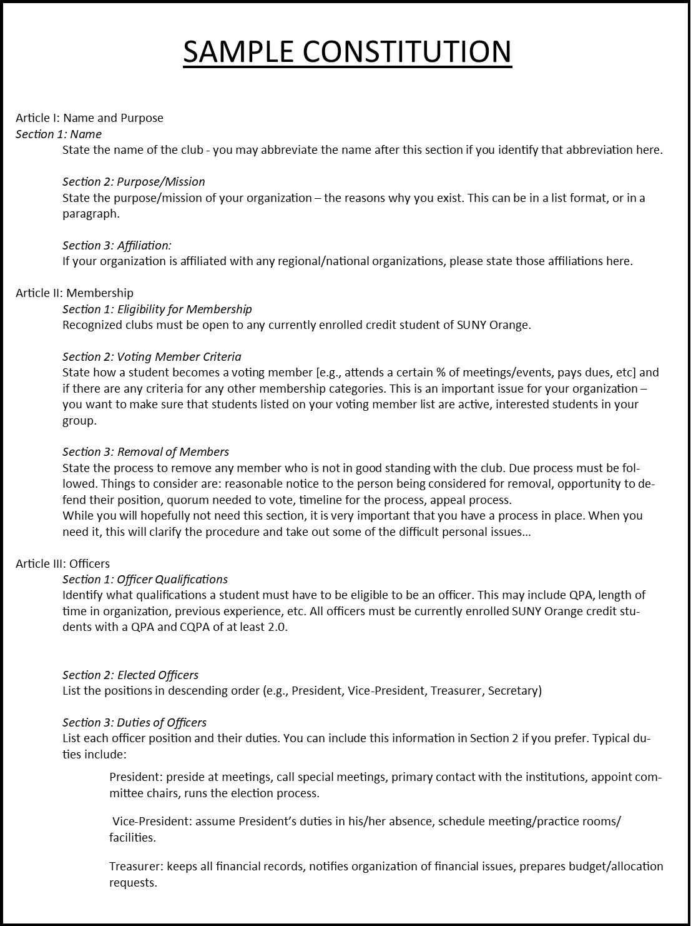
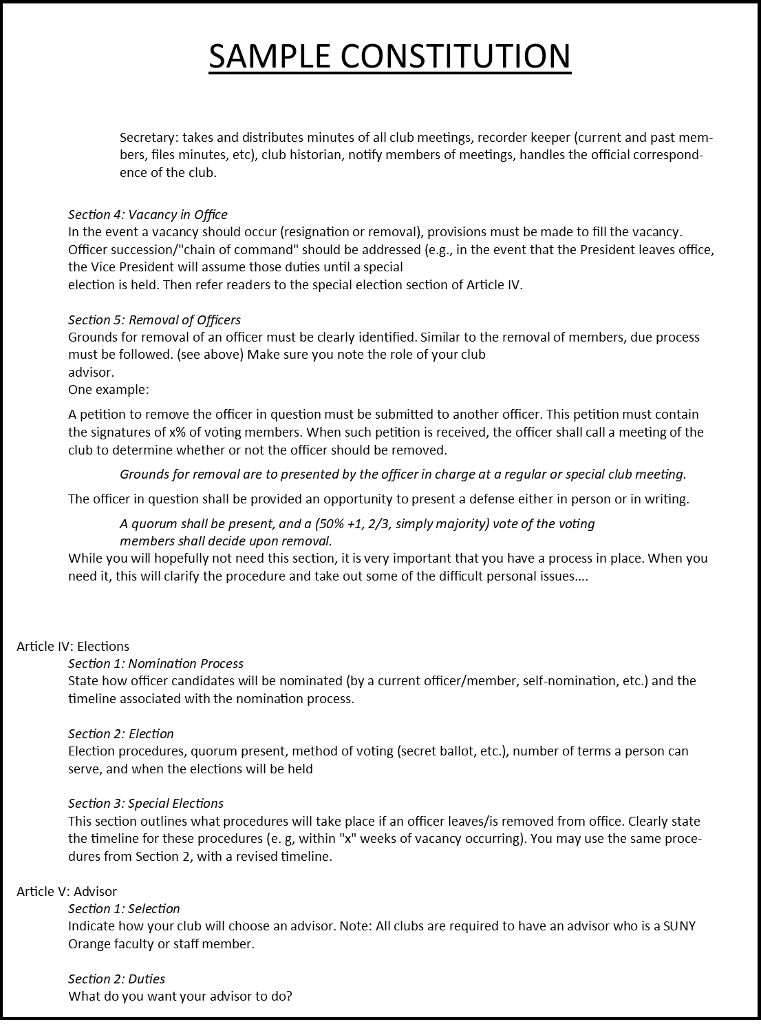
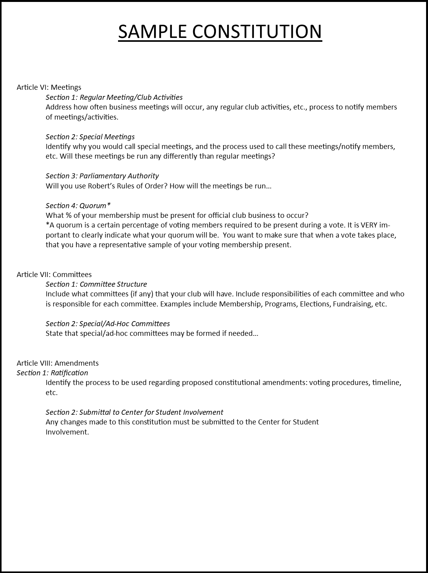

APPENDIX B
Parliamentary Procedure Basics

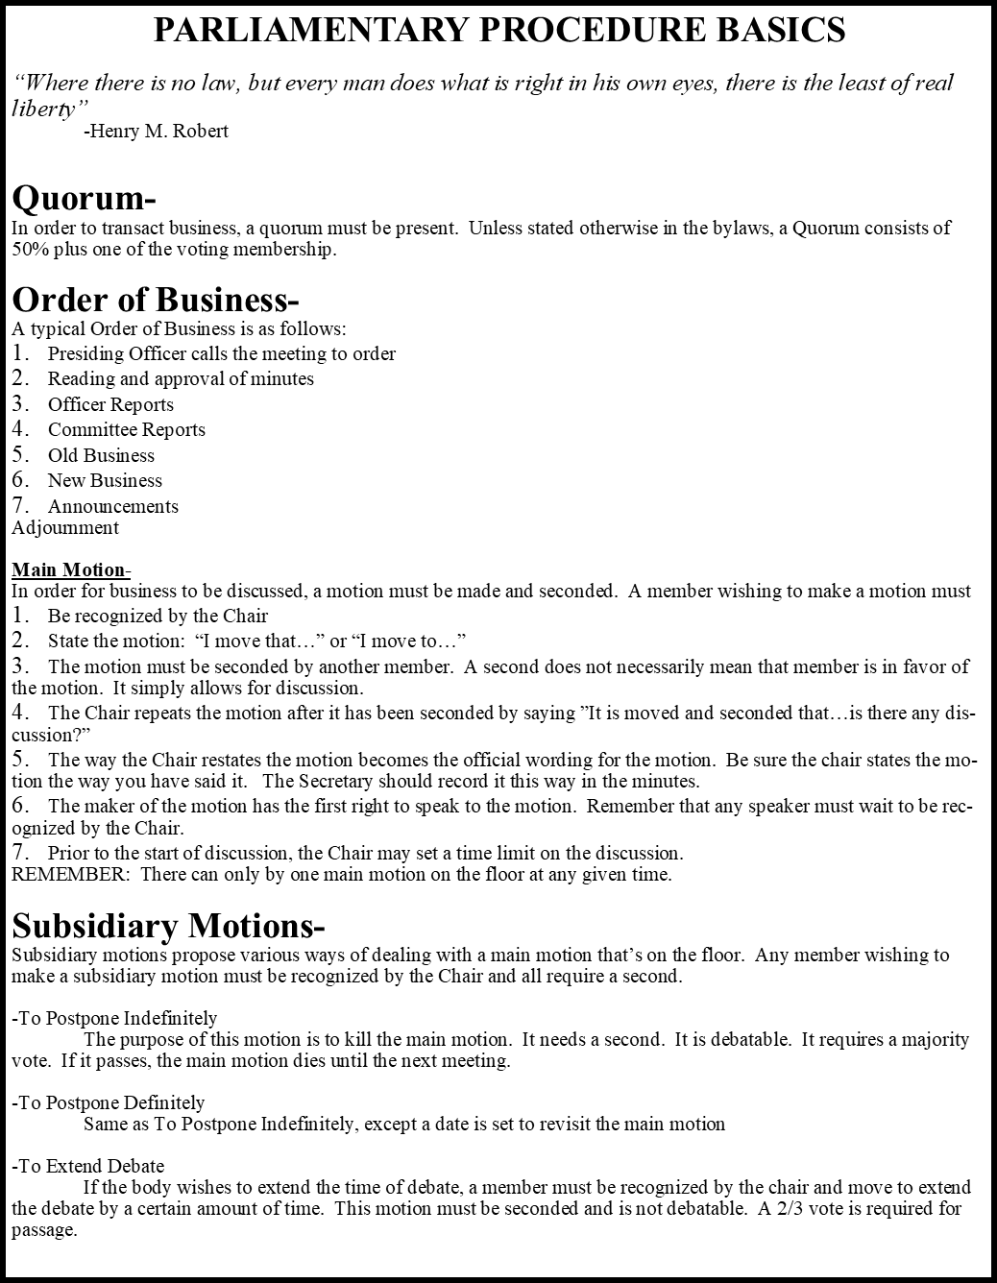

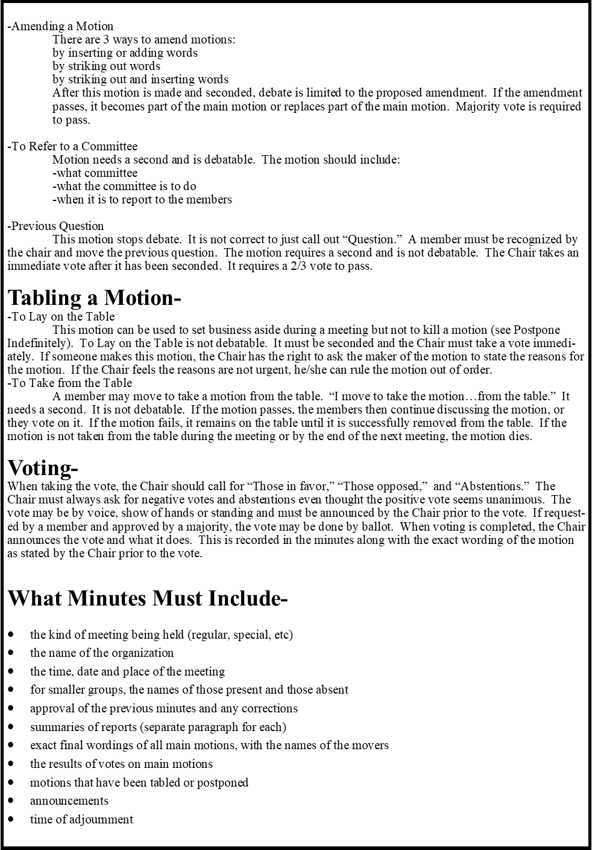

APPENDIX C
Beginning of the Year Club Checklist

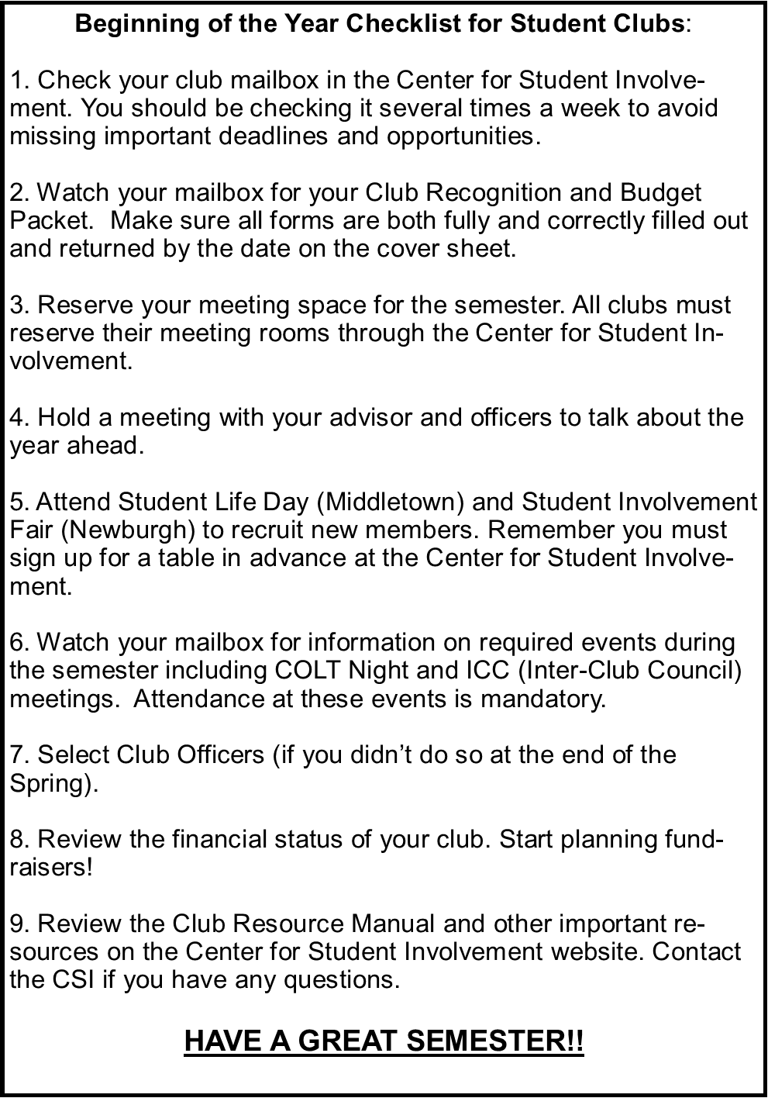

APPENDIX D
Officer Transition Checklist
Student Organization Leader/Officer Transition Checklist
A thorough and intentional Leadership Transition plan will provide an organization with continuity so that next year's officers can build on the knowledge gained rather than starting from ground zero. Below are only suggestions, take pieces that work for your group.

Tips for a successful transition
- Officer terms should provide at least one month of overlap so new officers have the opportunity to shadow and learn from the outgoing officers.
- When new officers have been elected, orient them together as a group with all of the outgoing officers. Include the organization's advisor in this process as well. This process provides the new leaders with an opportunity to understand each other's roles and to start building their leadership team. Outgoing officers should openly share what they believe went well and what they would change if they had it to do over again.
- Make introductions to resources. Schedule time to walk around campus with the new officers and introduce them to important people who can serve as key resources (Advisor, Center for Student Involvement, etc.).
- Recognize your outgoing officers. Could be certificates, gifts, thank-you cards, etc. Show your group that leaders are valued and an important part of your organization.

The Basics
__ Introduce new officer(s) to and meet with the club advisor(s)

__Give contact information of all club leaders and advisor(s)

__ Review the Club Resource Manual (http://sunyorange.edu/csi/docs/ClubResourceManual- Spring2016.pdf)

__ Give access and instructions to any online platforms, such as:
o Club Email
o Facebook/Twitter, etc. accounts
o Website/Blog
o Online document storage (such as Google Drive)
o Any other communication tool your club may utilize

__Review the Constitution/Bylaws for the club and discuss any updates or changes that are needed

__ Show new officers where the club mailbox is located in the Center for Student Involvement. Remind them to check it at least once per week!

__Explain how to reserve meeting/event space on campus for the year. Please reference the Club Resource Manual for more information about how to do that.

Share any and ALL documents
Sharing documents electronically allows new officers to easily update/change. Hard copy binders are an option as well, but harder to pass along to future leaders or edit documents. Google Drive and/or Dropbox are two popular online tools to help store documents online easily. Below are ideas of what to include:
__Mission, philosophy, goals and/or purpose of the organization
__Organization history
__Constitution/By-Laws
__Budgets/Financial reports
__Meeting minutes
__Agendas
__Any evaluations of events/programs
__Calendar of events and deadlines
__Officer position descriptions
__Committee position descriptions
__Organizational chart for organization
__Election process and timeline
__Membership recruitment information and timeline
__List of members and their contact information (e-mail, phone number)
__List of people expressing an interest but not joining
__Past Correspondence
__E-mails from the advisor or Center for Student Involvement with important information
__Event planning guide/checklist for any past events or programs
__Sample posters/flyers from past projects
__Copies of all Chapter/Organization event materials (e.g., invitations, posters, awards, informative quarter sheets, etc.)
__Professional contacts in the area
__ Marketing logos (club logos, past events, etc.)
__Any past print publications, press releases
__Photos

Finances
__ Discuss the financial status of the organization
__ Share where your organization receives money from
__ If your club received funding from Student Senate, share information and budget
__Discuss any fundraising plans or goals
__Documents to share: Budget spreadsheet, past student organization funding applications, any approved budgets

Introduce & Explain the Center for Student Involvement (CSI)
Explain this office provides support and resources to all Student Organizations. Feel free to stop by our office to introduce your new officer(s)!
__Being a Registered Student Organization All student organizations must register every semester to remain a recognized club. The required forms will be attached to the Student Senate budget request packet and placed in club mailboxes at the beginning of each semester.
__ Student Organization Funding If your club has funding, pass any information on to the new officer. If you do not have funding, but wish to apply, please contact the Student Senate or CSI.
__Trip Requirements There are specific forms with very specific deadlines that are required whenever a club plans a trip. Review the requirements in the Club Resource Manual and ask the CSI staff if you have any questions.
__COLT Night and ICC Participation in COLT Night and Inter-Club Council (ICC) is required in order for a club to receive funding. They are also important opportunities to promote events, address concerns, share resources and learn ways to lead your club more effectively.
__Trainings The CSI will offer trainings throughout the year and will post dates and times in the club mailboxes.
__ Website CSI is building their online resources (such as this document) to help clubs be successful as well as many other resources and all things clubs! http://sunyorange.edu/csi/
__ Fall & Spring Club Fairs CSI hosts a Club Fair in September and January and all clubs are encouraged to participate to recruit new members.
__Poster Service All recognized Student Organizations are eligible for the free poster service through the Center for Student Involvement. Clubs can request to have color flyers and a limited number of large, full-color posters for their upcoming events.
__Club Mailboxes All clubs have an on-campus mailbox located in the CSI and should check it at least once a week.
__ Information Keep your contact information up to date with CSI to make sure you receive important updates and announcements.

Pass along your wisdom!
You may not see it as wisdom, but being in a position for a year (or whatever amount of time) is invaluable! You have learned important things along the way that can help future leaders. Mistakes, tips, tricks, ideas and successes are all important things to share. Think: What would you have wanted to know when you took office?
Using the hindsight that you now have, identify the areas of responsibility, people, details, phone numbers, etc. that you wish someone had told you when you took office

Review the organization's constitution, by-laws, written material, and goals and outline any areas needing attention or revision
Tips of running an effective meeting
Ideas for improvement
Prepare an end-of-the-year report incorporating the organization's goals, activities, and accomplishments
Recruitment ideas
Fundraising ideas/projects
Do not “drop off the face of the earth” - be available for consultation or questions

Reflections
Another way to pass along your wisdom and also give outgoing leaders a chance to reflect on their year is to ask yourself these questions:
1. What was the best experience in this position?

2. What was the most difficult?

3. What tips could you give to make things smoother?

4. Name the administrators/staff you found helpful.

5. What collaborations were successful?

6. List any projects or ideas you were developing that you would like to see continue.

7. If you could do it all over again, what would you change?

8. Name at least two things you wished you knew when you started.
Incorporate these into a meeting with the incoming officer taking over your position. As an alternative, write them a letter including your answers to these questions. It can be a great tool to encourage and inspire the next generation of club officers.

Checklist of Suggested Tasks for Incoming Officers
__ Read Transition Binder (or online documents) and previous executive reports. Become familiar with the general history of the organization and its recent activities. Remember you need to know all of the little details as well as the big picture.

__ Determine training and guidance you will need from the outgoing officers. Think of questions you have after reviewing the transition documents.

__ Make appointments with key people (outgoing officers, advisors, CSI)

