**CTL Tuesday Tip for 10/15**

--------------------------------------------------------------------------------------------------------------

**UDL**

***Universal Design for Learning***

**Critically important to student success!**

**Not sure where to start?**

There are a number of tools and approaches to teaching that can support a transition to instruction that ***all*** students can benefit from.

Universal Design for learning is founded in a few core principles...

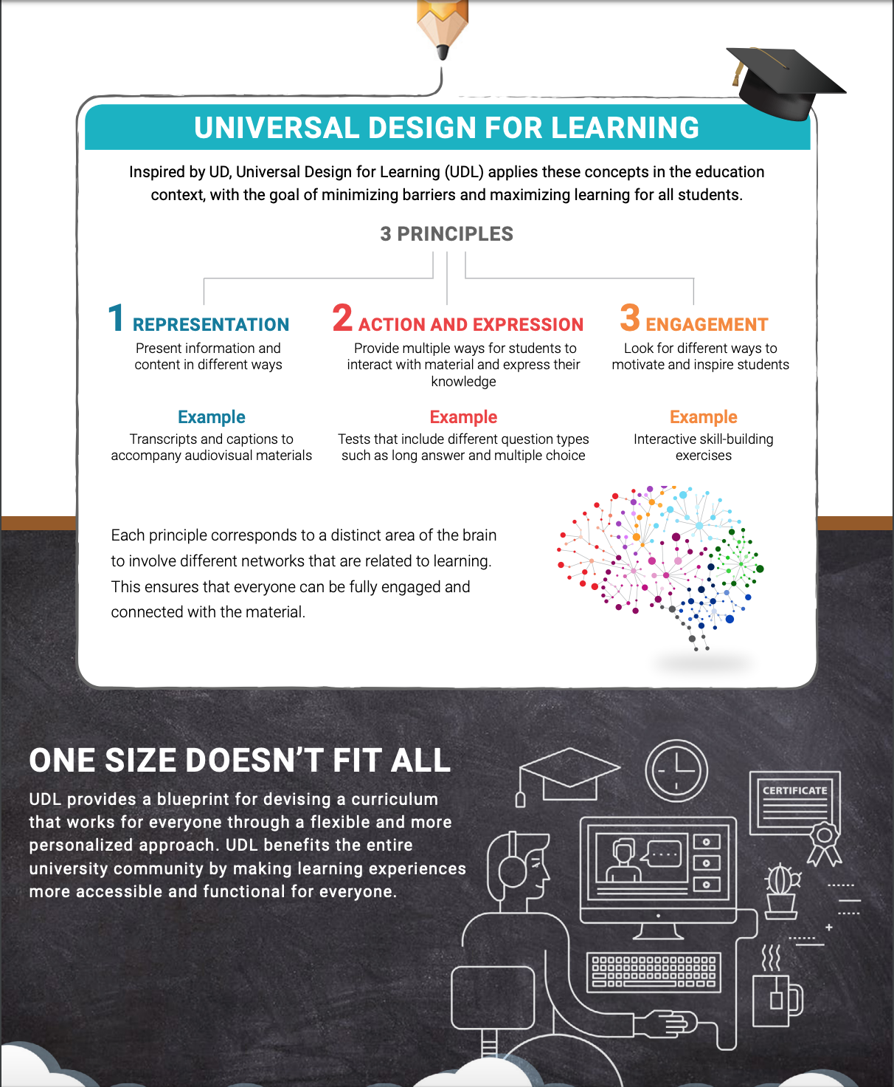

**The Challenge...**

* Working with a diverse student population with wide ranging levels of foundational knowledge and skill
* Taking time to understand students' needs and capabilities
* Incorporating creative approaches to teaching and assessment

**The OPPORTUNITY...**

* **Identify a topic/lesson:**  create a multi-faceted approach with tools or guidance from CTL
* **Utilize tools:** translation software, captioning for audio/video, document accessibility, discussion scaffolding and assessment design
* **Share your success:**  let us know about a design shift you have made and the CTL will help you share it with colleagues

**Resources and Information...** check the CTL schedule for sessions on a variety of topics that support UDL from tools for accessibility to seminars on working with students.

**SCHEDULE HIGHLIGHT...** (participate in person *or via ZOOM link*)

**WHO:**  Dr. Jane Thierfeld-Brown

**WHAT:** Working with students on the Autism Spectrum

**WHEN:** Wednesday 10/16/19 at 3:00pm

**WHERE:**  Rowley Room 112 / ***or*** / via Zoom @ <https://sunyorange.zoom.us/j/739284411>

The increasing numbers of students on the autism spectrum entering post-secondary education present higher education institutions with challenges previously not at issue. Impacts outside of the academic realm may be unique for College faculty and staff to consider. Academic and Student Services offices are sometimes faced with behavior management and conduct issues, sensory and stress management issues. Students with autism spectrum disorders sometimes do not disclose until there is a problem: therefore pro-active, campus wide training and awareness is critical for a successful interface between the institution and student.

This session will address ways to work with students on the spectrum, to deal with possible classroom issues, and provide helpful strategies to increase learning and address difficult behaviors.

__________________________________________________________________________**YOU**

**make a difference everyday!**