How to Accept/Decline Student Loans / Work Study www.sunyorange.edu

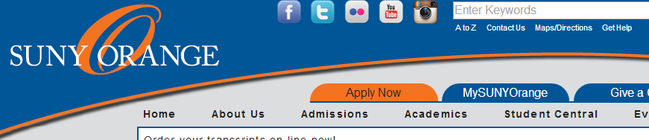

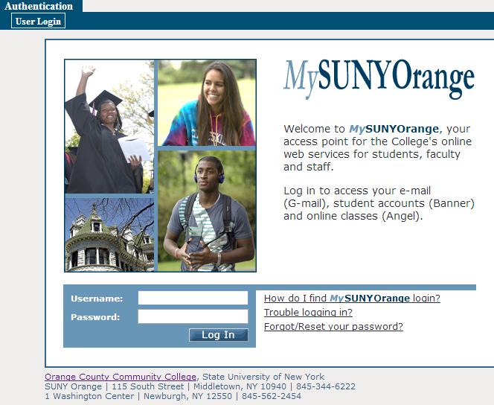

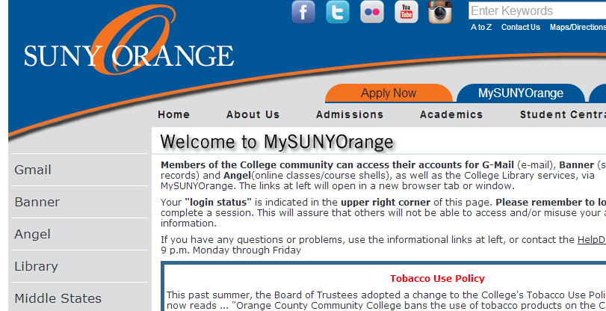

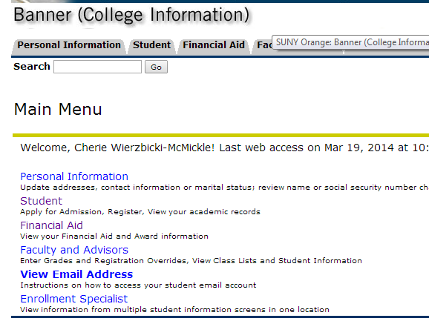

* Click “**MYSUNYORANGE”**
* **Log in here**

Your user name is your A number. Example: A00123456

Your default password is your date of birth in 6 digits: MMDDYY

Example: If your birth date is April 4, 1996 your password is 040496

NOTE: If you change your password, record the NEW one somewhere safe. SUNY Orange cannot retrieve your new password.

*note username and password directions

** Banner Self-service is not compatible with all web browsers, if you experience any problems you may use the computers in the College Library or Student Success Center.

* **Click on “Banner”**
* **Click on “Financial Aid”**

**(from TABs or List)**

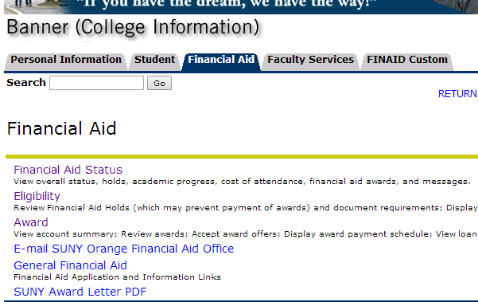

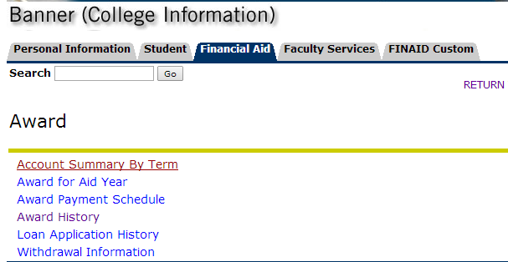

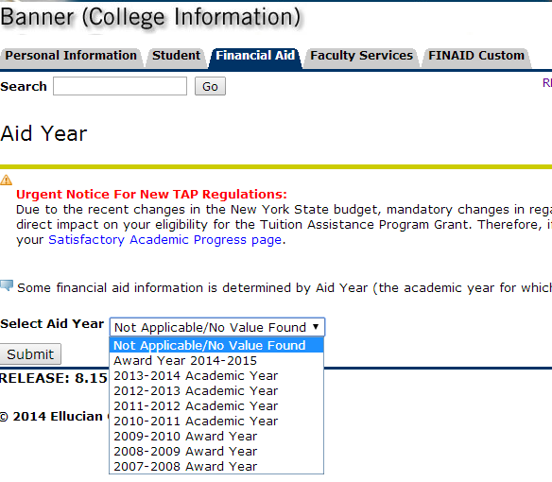

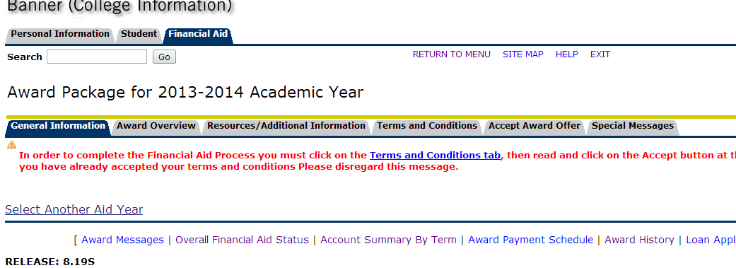

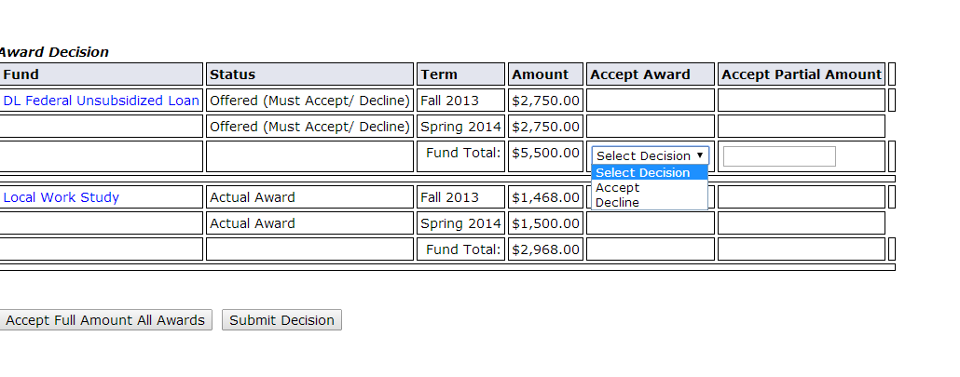

* **Click on “Award”**
* **Click on “Award for Aid Year”**
* **Select Aid Year**
* **Submit**
* **Click on the**

**“Accept Award Offer” TAB**

**Scroll Down to Award Decision**

* **Accepting Partial Award(s)**
  + - **Choose Decision**
    - **Enter in Amt. to accept**
    - **Submit Decision**
* **Accepting awards in FULL**
* **Accept Full Amt. of Awards**