How to Accept Terms and Conditions www.sunyorange.edu

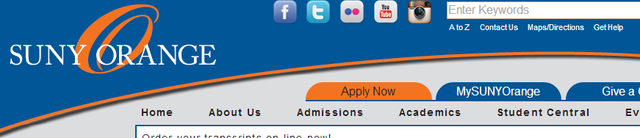

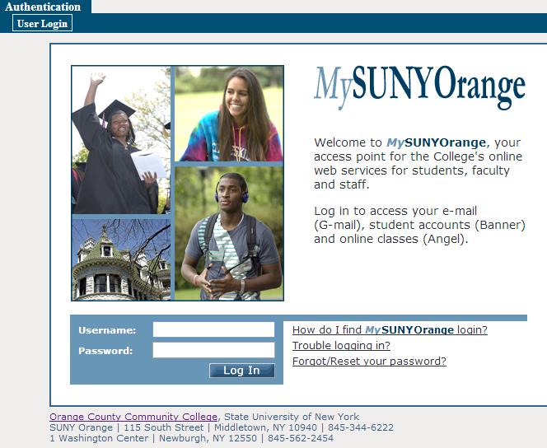

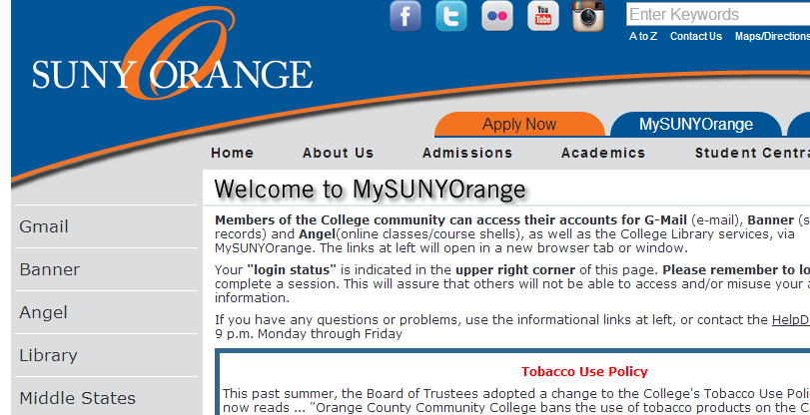

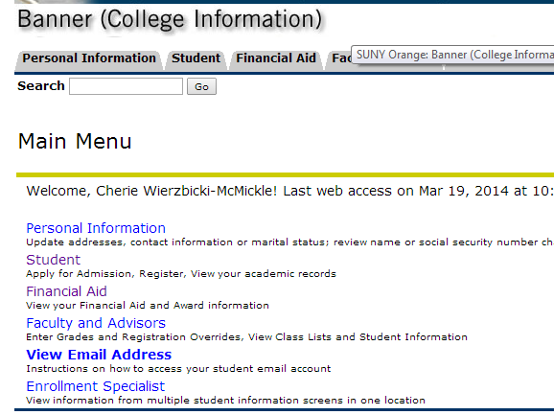

* Click “**MYSUNYORANGE”**
* **Log in here**

Your user name is your A number. Example: A00123456

Your default password is your date of birth in 6 digits: MMDDYY

Example: If your birth date is April 4, 1996 your password is 040496

NOTE: If you change your password, record the NEW one somewhere safe. SUNY Orange cannot retrieve your new password.

*note username and password directions

** Banner Self-service is not compatible with all web browsers, if you experience any problems you may use the computers in the College Library or Student Success Center.

* **Click on “Banner”**
* **Click on “Financial Aid”**

**(from TABs or List)**

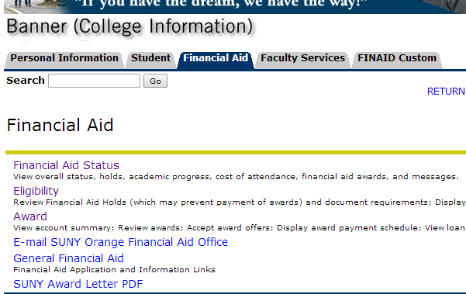

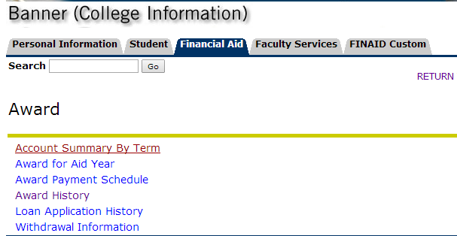

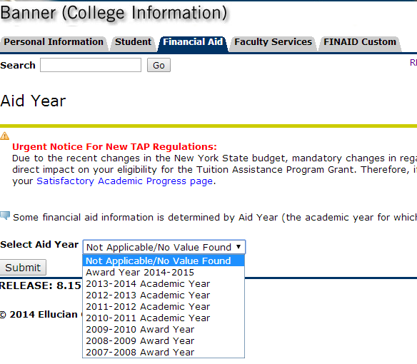

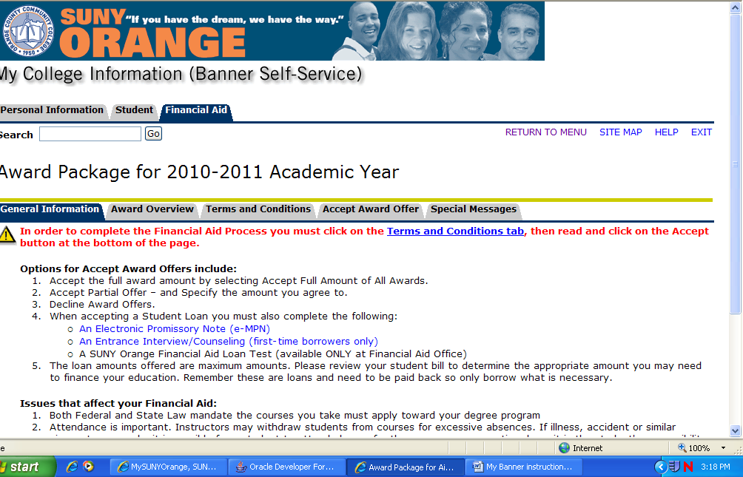

* **Click on “Award”**
* **Click on “Award for Aid Year”**
* **Select Aid Year**
* **Submit**
* **Click on the**

**“Terms & Conditions” TAB**

* **Read all Terms and Conditions**
* **At the end check the “accept” box**

