How to check if any of my classes are INAPPLICABLE

**If you have any questions about you courses you must contact your academic advisor –**

**Financial Aid CANNOT ADVISE you on why courses are or are not applicable.**

www.sunyorange.edu









How to check if any of my classes are INAPPLICABLE

**If you have any questions about you courses you must contact your academic advisor –**

**Financial Aid CANNOT ADVISE you on why courses are or are not applicable.**

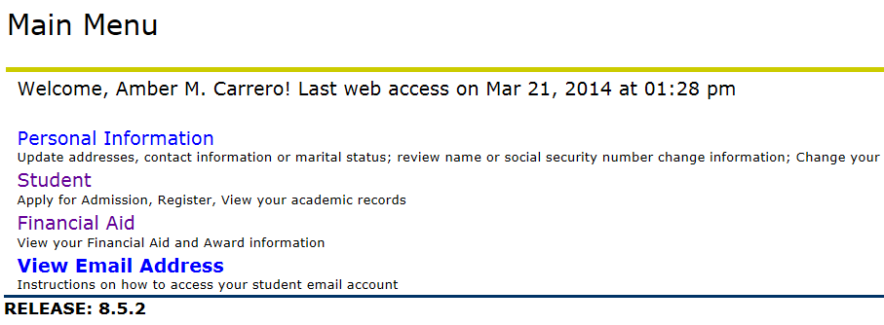

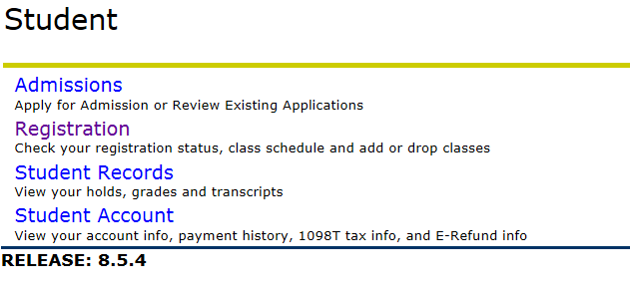

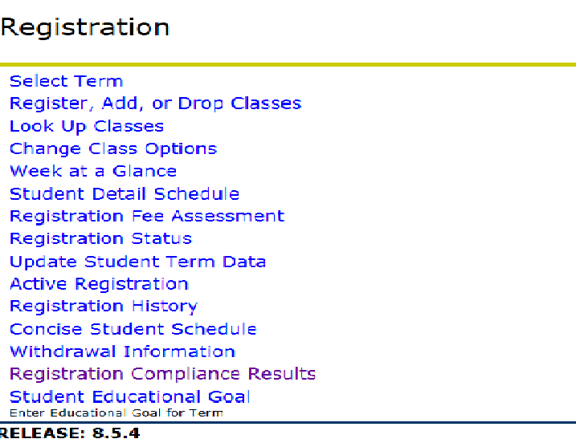

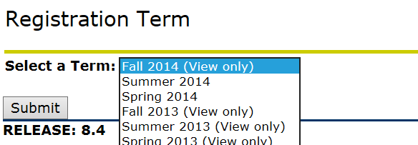

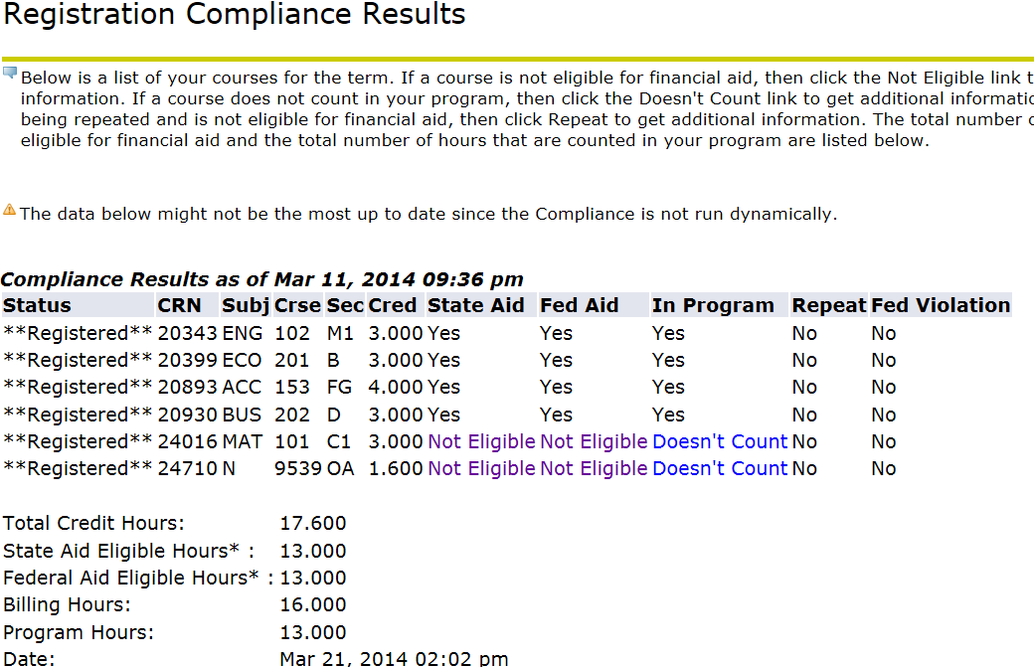

* **Click on “Student”**
* **Click on “Registration”**

* **Click on**

**“Registration Compliance Results”**

* **Select Appropriate Term**
* **Submit**

**Registration Compliance Results will be listed**

* **Both STATE and FEDERAL program results are shown:**
* **Inapplicable classes will have “Not Eligible” listed under the appropriate program.**

**NOTE: State and Federal Programs have different eligibility criteria and a class may be inapplicable for one program but**

**not the other. Please review the results carefully for EACH Program.**

**If you have any questions about you courses you must**

**contact your academic advisor – Financial Aid CANNOT**

**ADVISE you on why courses are or are not applicable.**