How to Check for Outstanding Documents www.sunyorange.edu

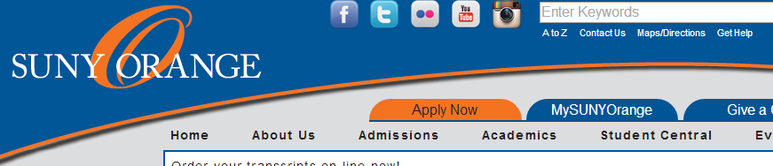

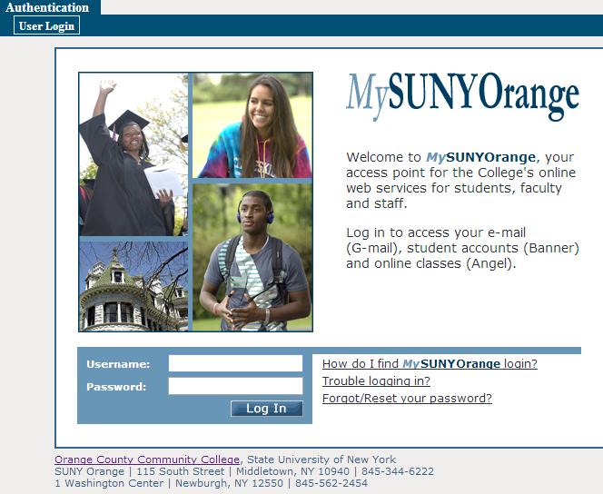

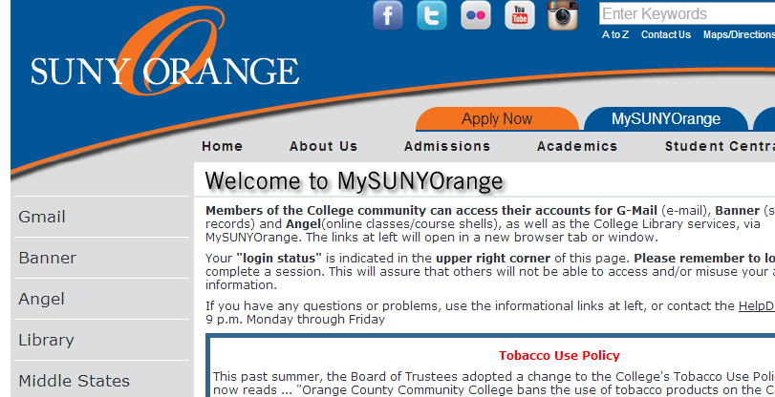

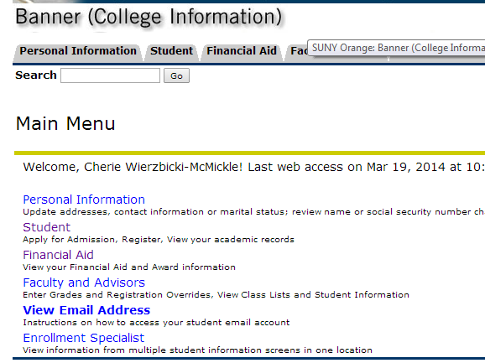

* Click “**MYSUNYORANGE”**
* **Log in here**

Your user name is your A number. Example: A00123456

Your default password is your date of birth in 6 digits: MMDDYY

Example: If your birth date is April 4, 1996 your password is 040496

NOTE: If you change your password, record the NEW one somewhere safe. SUNY Orange cannot retrieve your new password.

*note username and password directions

** Banner Self-service is not compatible with all web browsers, if you experience any problems you may use the computers in the College Library or Student Success Center.

* **Click on “Banner”**
* **Click on “Financial Aid”**

**(from TABs or List)**

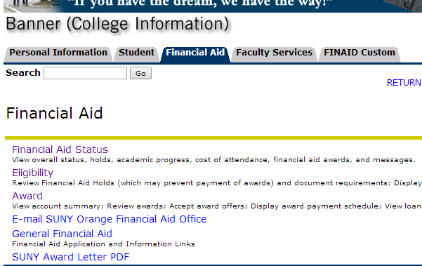

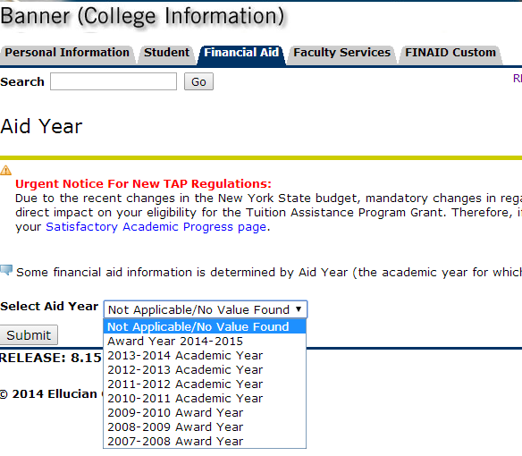

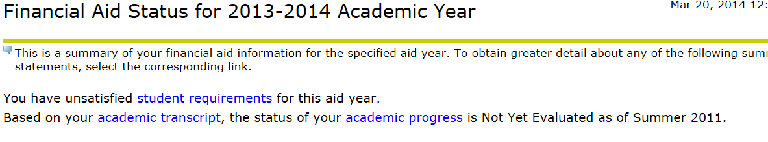

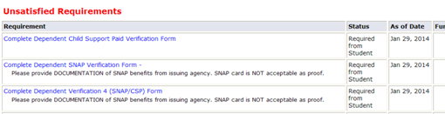

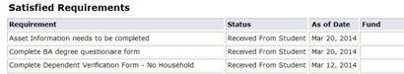

* **Click on “Financial Aid Status”**
* **Select Aid Year**
* **Submit**

**If you have any documents you need to submit to complete the Financial Aid Process – you will see the following message: “You have unsatisfied student requirements for this aid year.**

* **To view the missing documents click on “student requirements”**

**Documentation needed to complete the financial aid process will be listed under:**

* **“Unsatisfied Requirements” - with the Status of Required from Student**

**Submitted documentation will be listed under:**

* **“Satisfied Requirements –**

**with the Status of Received from Student**