**How to Order A Tax Transcript/"Verification of Non-Filing" letter** [**www.IRS.gov**](http://www.IRS.gov)

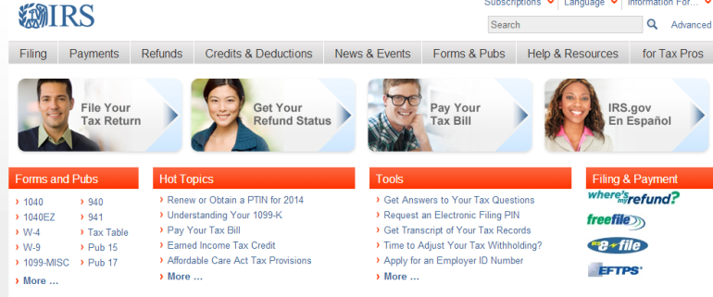

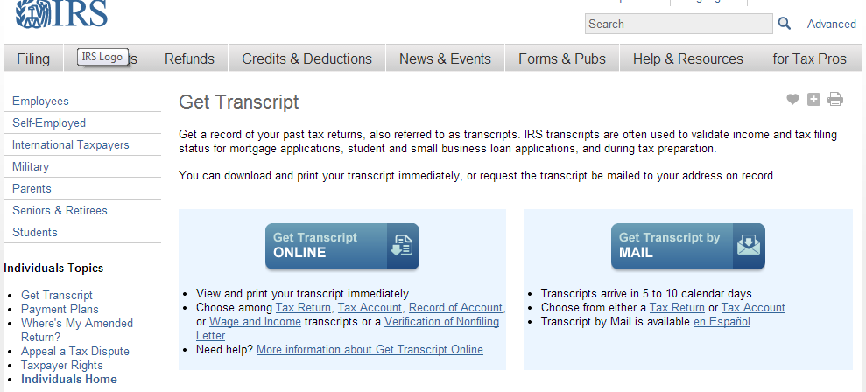

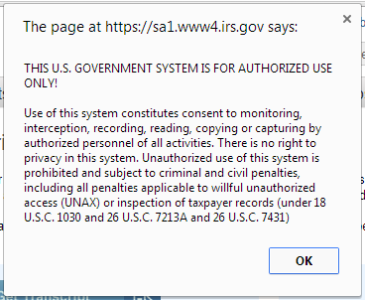

* **Select**

**“Get Transcript of Your Tax Records”**

* **Select**

**“Get Transcript ONLINE”**

* **Click “OK”**







* **If you already have a Sign In – login**
* **If you DO NOT have a Sign in**
* **Click “Create a Login”**

**Follow directions to create a login**

**Once account has been created – “Get Transcript” screen should appear**

* **At drop down Select**

**“Higher Education/Student Aid”**

**Click on GO**

**For copy of “Return Transcript” or ”Verification on Non-filing Letter”**

* **Under Return Transcript**

**Select Appropriate Year**

**For copy of “Wage & Income Transcript”**

* **Under Wage & Income Transcript**

**Select Appropriate Year**

* **Make sure “Pop-up Blocker” Is off**
* **Transcript will open in a new window**
* **Print Transcript**
* **Close Transcript Window**
* **Sign Out**