**How to Order A Tax Transcript/"Verification of Non-Filing" letter** [**www.IRS.gov**](http://www.IRS.gov)

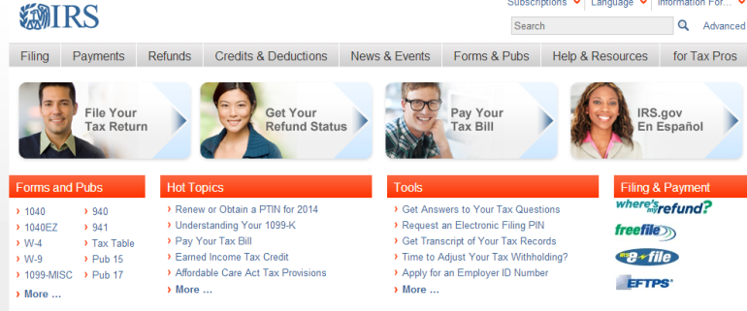



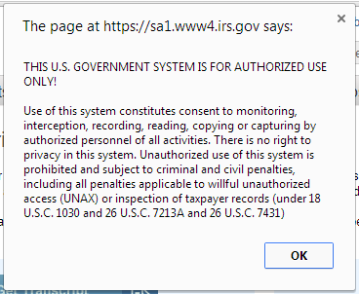

* **Select**

**“Get Transcript of Your Tax Records”**

* **Select**

**“Get Transcript by MAIL”**

* **Click “OK”**











* **Enter Requested information**

**NOTE: Use “primary filers’ ” information**

* **Click on Continue**
* **At drop-down select**

**RETURN TRANSCRIPT**

* **At drop down select appropriate “Tax Year”**
* **Click on Continue**

**Verify message that transcript will be mailed to you.**

* **Click on Exit**