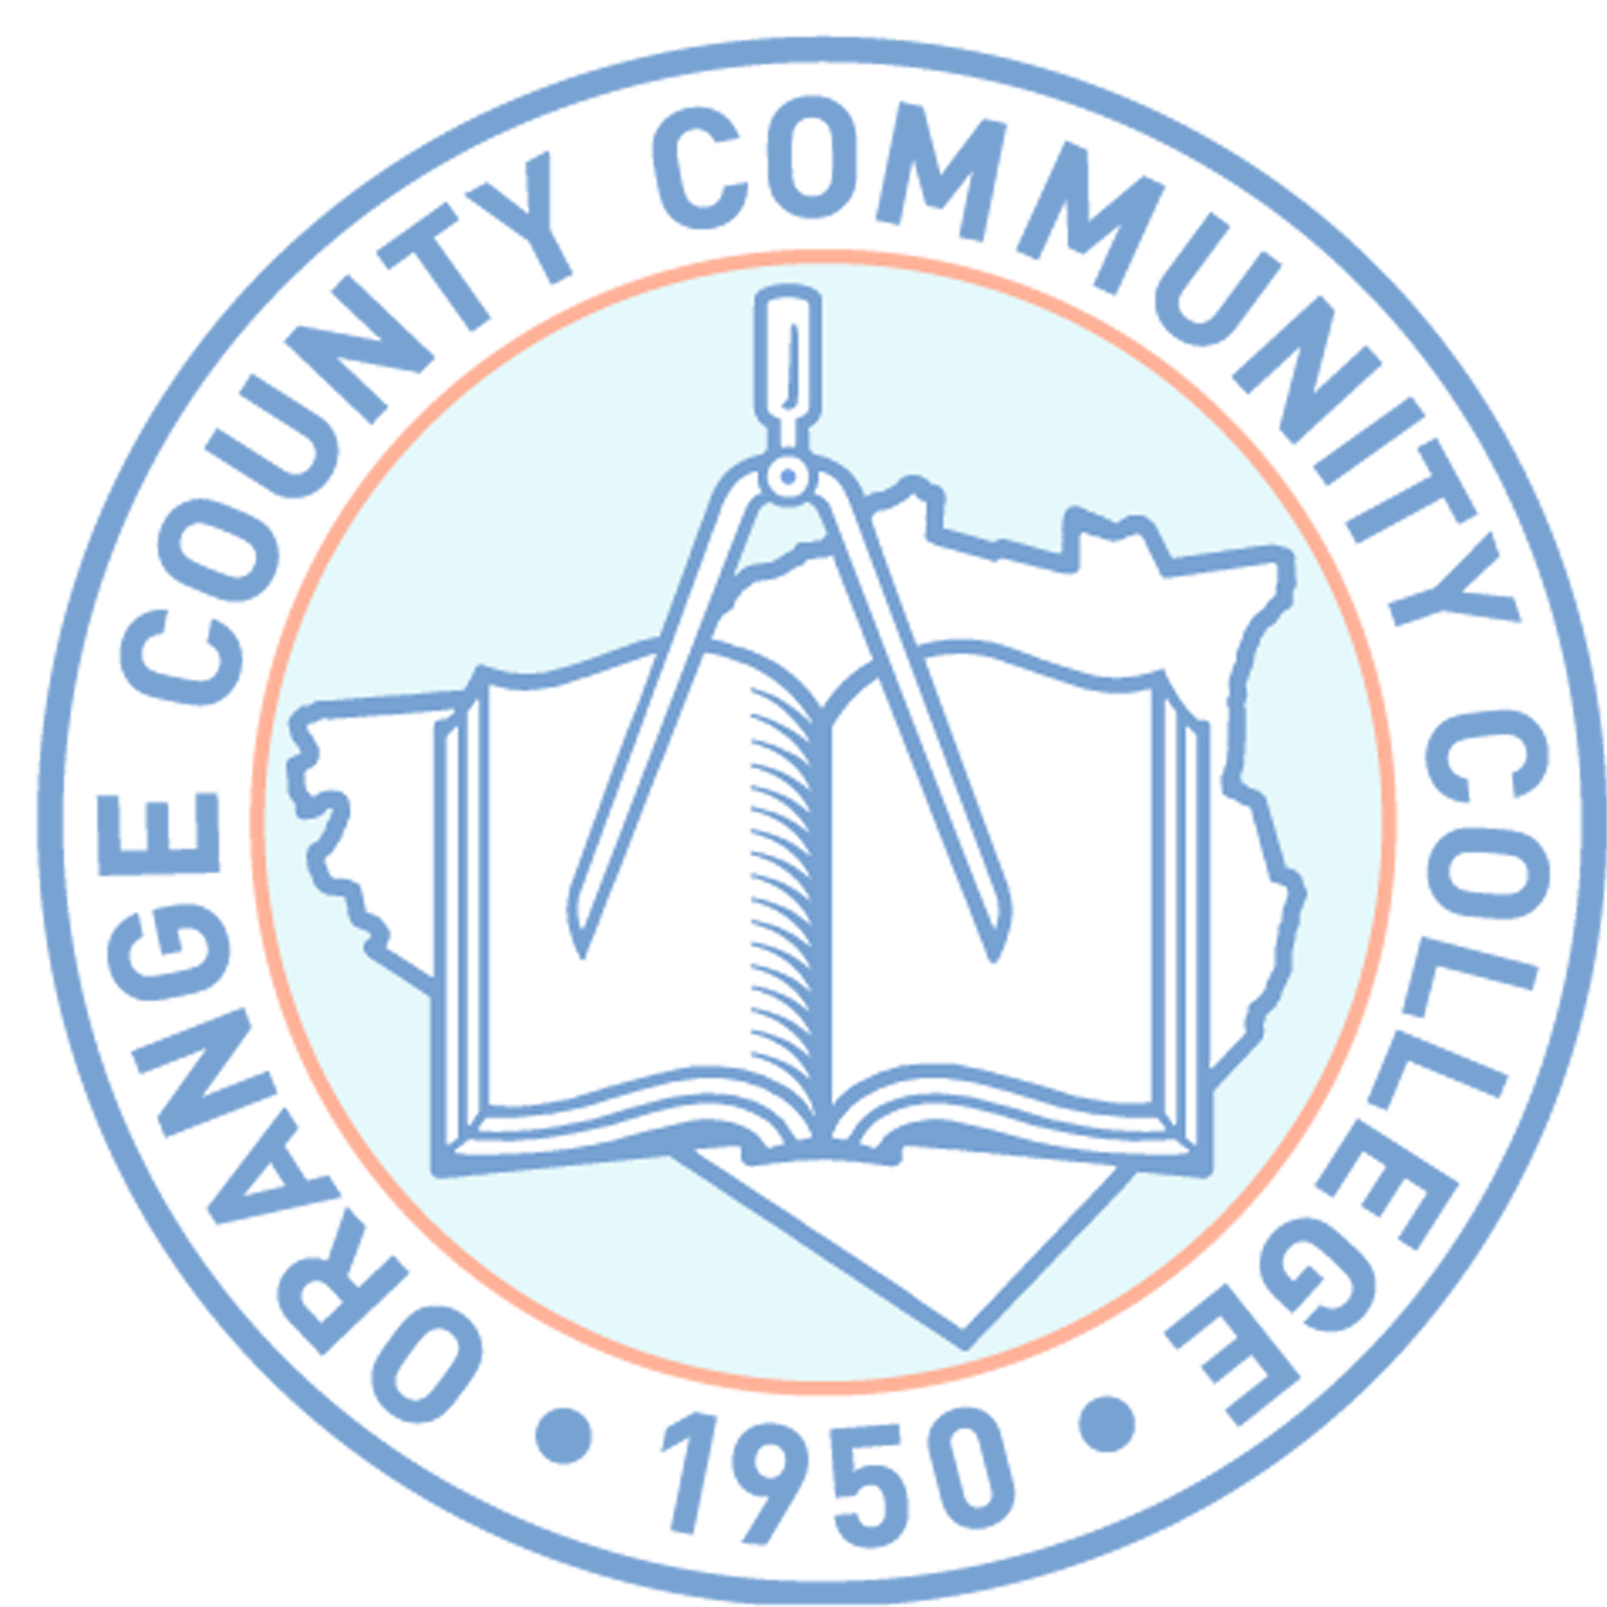

**SUNY ORANGE**

**OFFICE OF FINANCIAL AID**

**2011-2012 FINANCIAL AID WORKSHOPS**

MIDDLETOWN, NY – MAIN CAMPUS

HARRIMAN HALL ROOM 215

Wednesday Feb. 23, 2011 5:30 p.m.

Wednesday March 2, 2011 5:30 p.m.

Wednesday March 16, 2011 5:30 p.m.

Wednesday March 30, 2011 5:30 p.m.

Wednesday April 6, 2011 5:30 p.m.

Wednesday April 20, 2011 5:30p.m.

Wednesday May 4, 2011 5:30p.m.

Wednesday May 18, 2011 5:30p.m.

Wednesday May 25, 2011 5:30p.m.

Wednesday June 8, 2011 5:30p.m.

Wednesday June 22, 2011 5:30p.m.

Wednesday July 6, 2011 5:30p.m.

PLEASE NOTE:  **Financial Aid Workshops will be held at the Middletown Campus, Harriman Hall, Rm. 215**

**In order to assist you in completing the financial aid form, you will need to bring photocopies of your and /or your parents 2010 Federal Income Tax Returns, W-2s and any other taxed or untaxed documentation for the 2010 year.**

DEPENDENT STUDENTS UNDER 24 YEARS OF AGE:

IT IS IMPERATIVE THAT THE STUDENT AND PARENT BE PRESENT TO COMPLETE THE FAFSA PROCESS.

Financial Aid Workshops will begin promptly and depending upon the number attending may last up to 2 hours. ***No guarantee of admittance if late.***