My Banner – Self-service

www.sunyorange.edu

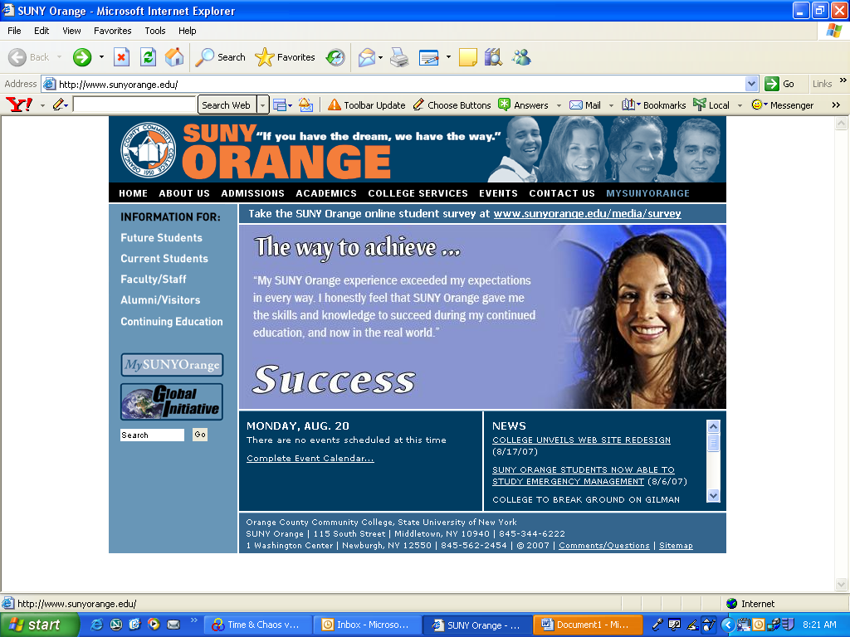

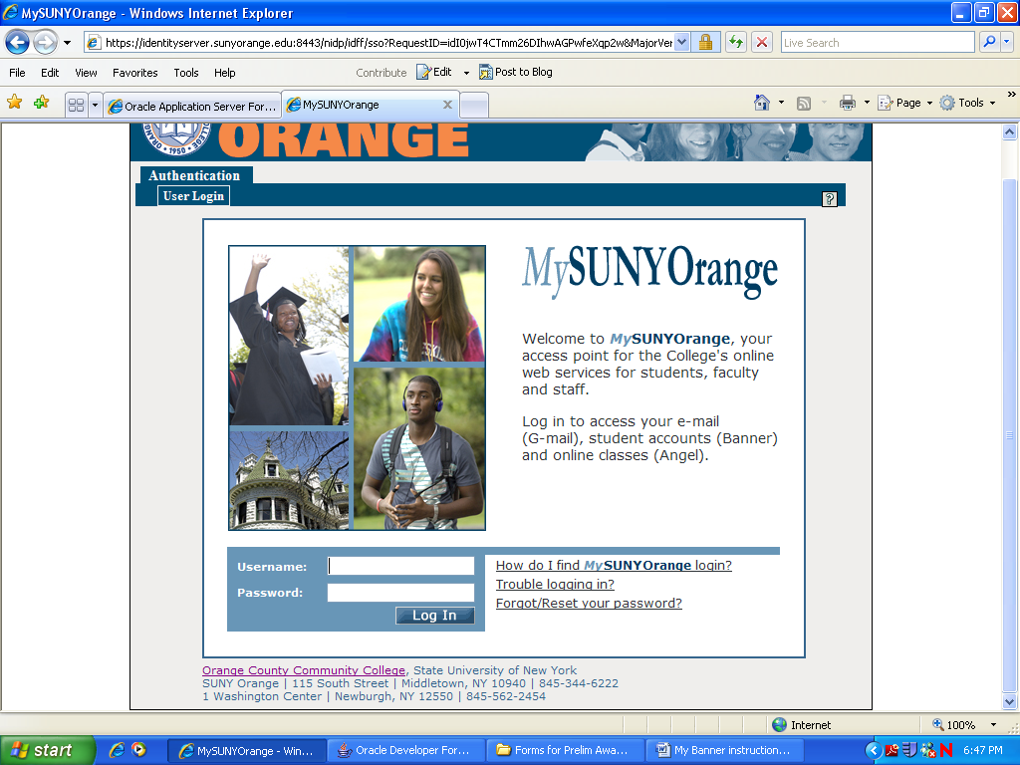

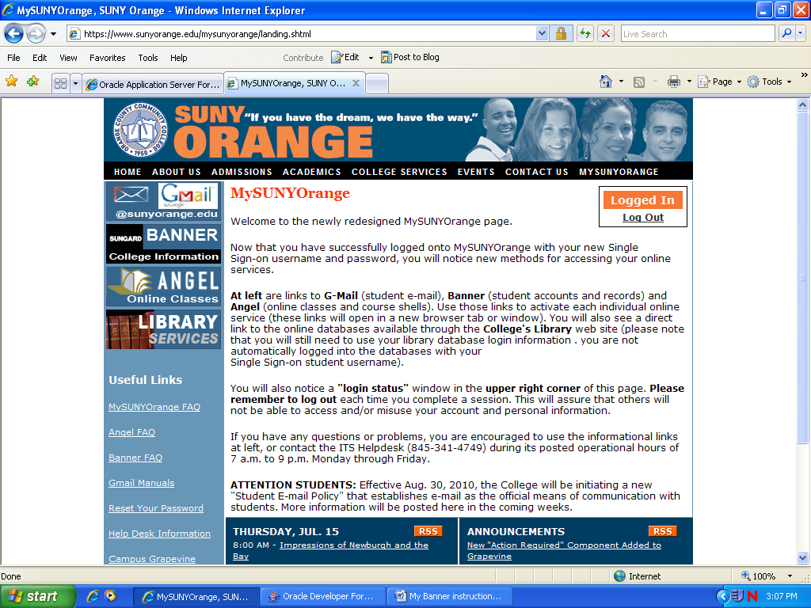

* **Sunyorange.edu**

Click My SUNY orange tab

* **Log in here**

My college information

(Banner self-service**)

*note username and password directions

** Banner Self-service is not compatible with all web browsers, if you experience any problems you may use the computers in the College Library or Student Success Center.

* **Click on the Banner Box**

**Over**

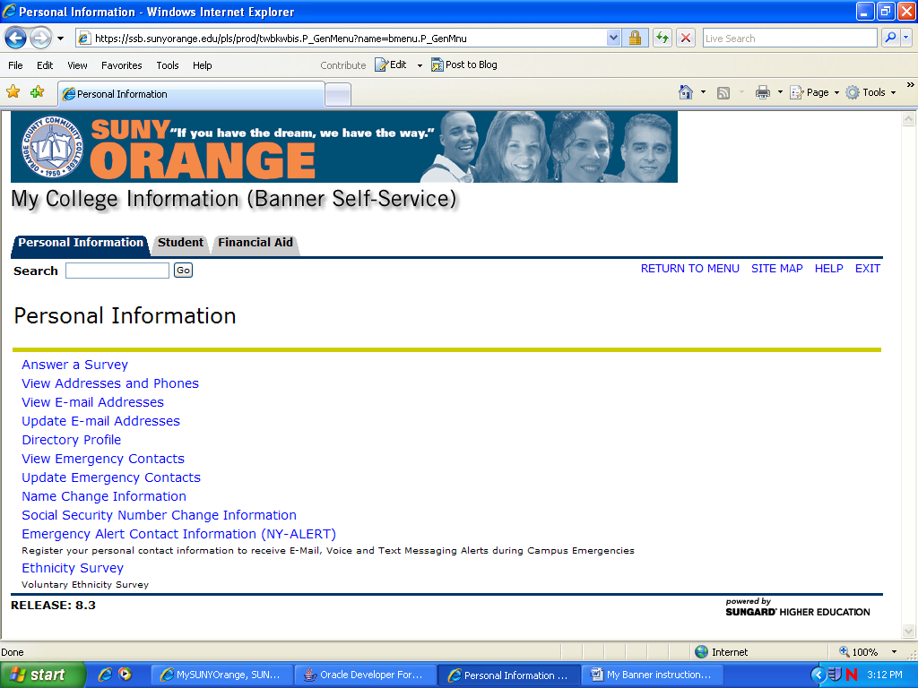

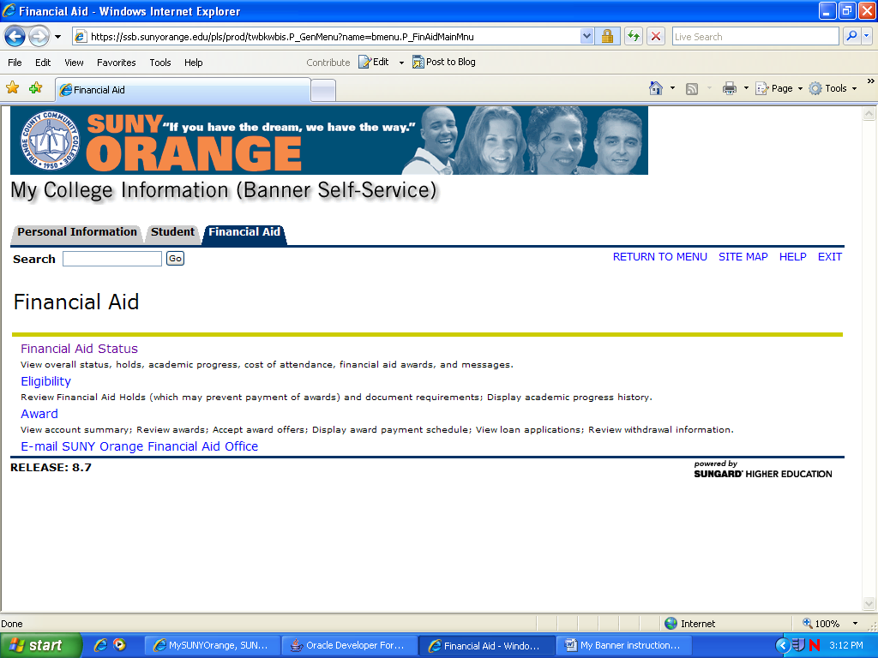

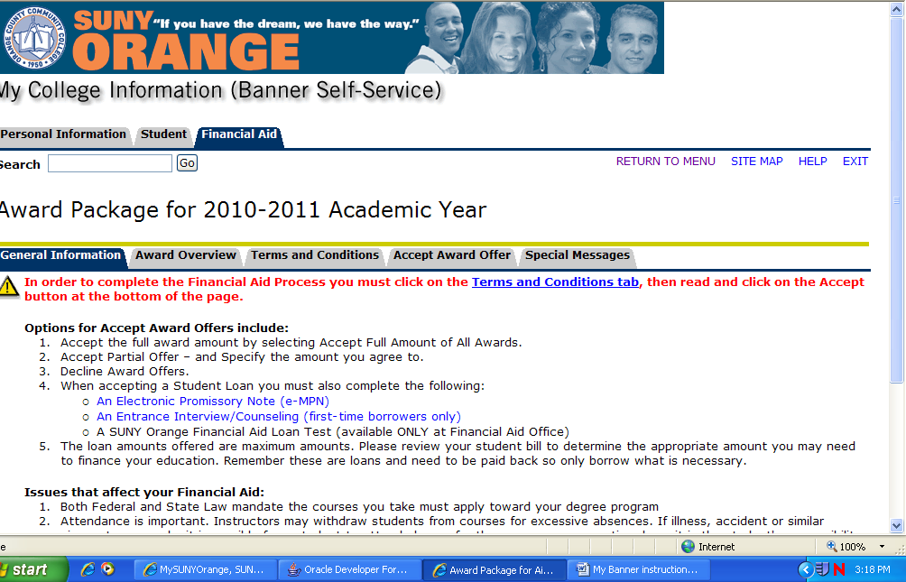

*** All student loans must be accepted / declined at the Accept Award Offer link. Failure to complete this step will delay the loan process**.**

* Click on the Financial Aid Tab

**To check to see if you are missing documents**

* Financial Aid Status
  + Choose year
  + If you need to submit additional information you will see *unsatisfied requirements* (click to see what is needed)
* **To accept Terms & Conditions / check & accept awards**
* Awards
  + Award for Aid Year
  + Choose Year
  + Terms & Conditions Tab.
  + Accept Awards Offer