MYSUNYORANGE - [www.sunyorange.edu](http://www.sunyorange.edu)

Banner – Self-service (View Financial Aid Status / Accept/Decline Awards / Accept Terms and Conditions)

Gmail - Official form of communication (Missing Information Letters / Financial Aid Award Letters)

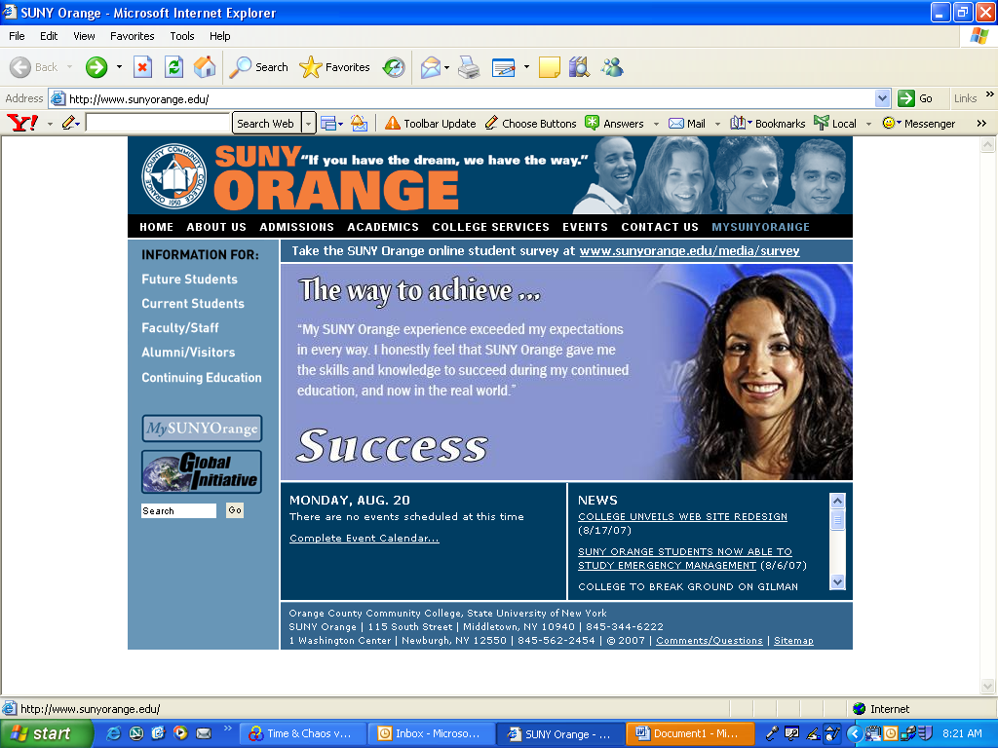

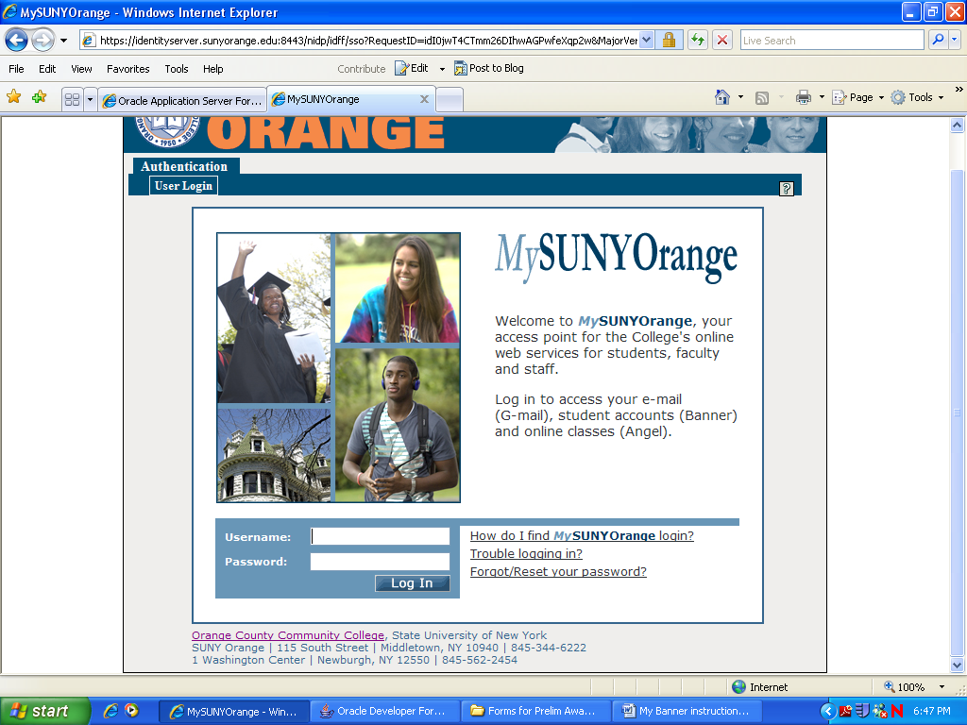

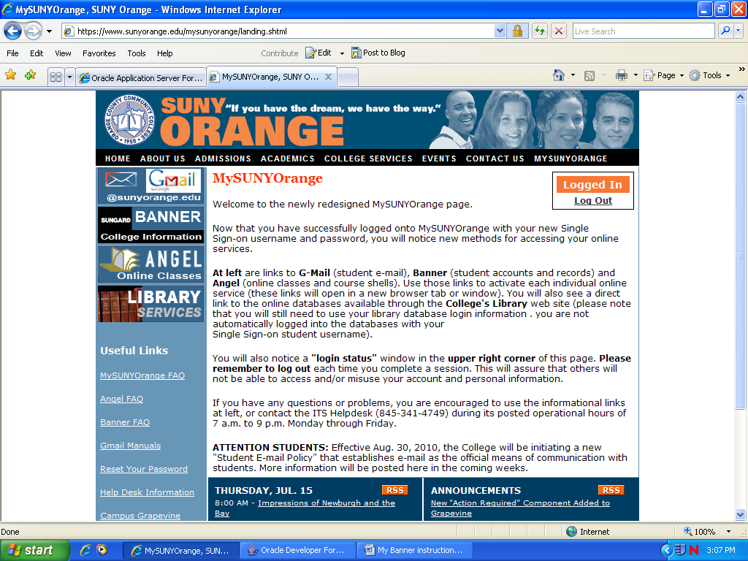

* Click **MYSUNYORANGE**
* **Log in here**

My college information

(Banner self-service**)

*note username and password directions

** Banner Self-service is not compatible with all web browsers, if you experience any problems you may use the computers in the College Library or Student Success Center.

**For your Gmail account**

* **Click on Gmail**

**For your Banner–Self-Service**

* **Click on BANNER**

**(See back for additional Banner-Self-service directions)**

**Over**

Banner – Self-service

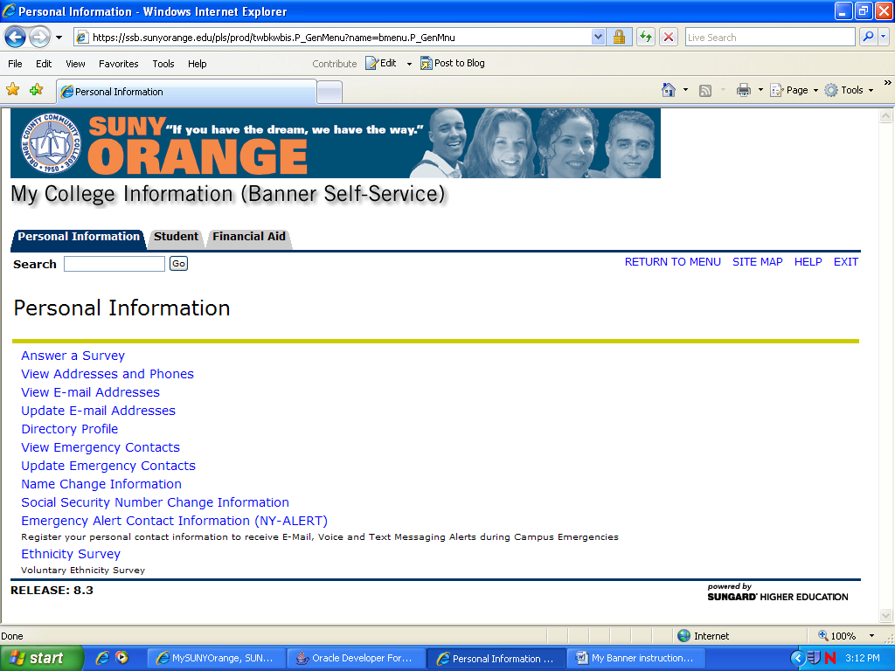

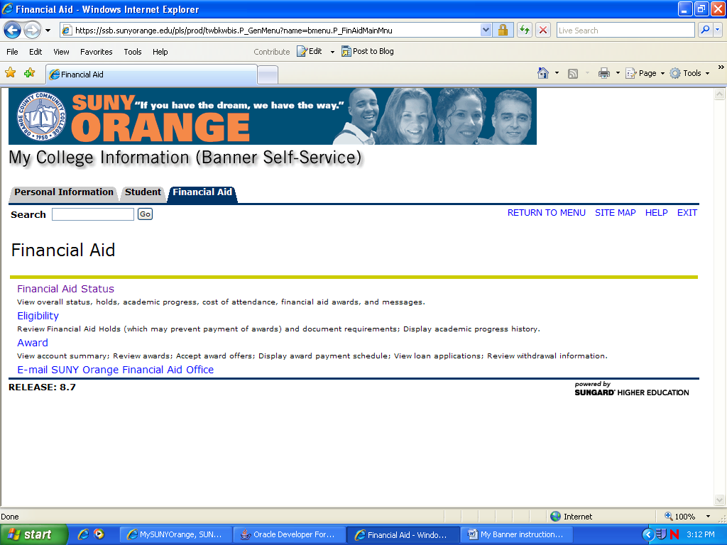

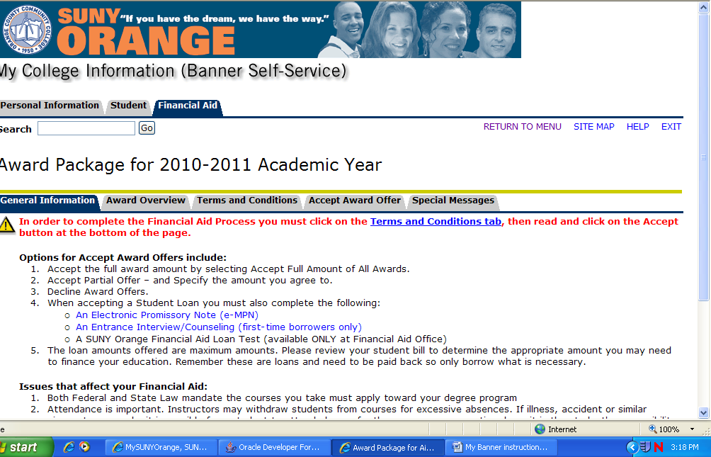

*** All student loans must be accepted / declined at the Accept Award Offer link. Failure to complete this step will delay the loan process**.**

View Financial Aid Status / Accept/Decline Awards / Accept Terms and Conditions

* Click on the Financial Aid Tab

**To check to see if you are missing documents**

* Financial Aid Status
  + Choose year
  + If you need to submit additional information you will see *unsatisfied requirements* (click to see what is needed)

**To accept Terms & Conditions**

**To check awards**

**To accept / decline awards**

* Awards
  + Award for Aid Year
  + Choose Year
  + Award Overview
  + Terms & Conditions Tab
  + Accept (Decline) Awards Offer