MYSUNYORANGE - [www.sunyorange.edu](http://www.sunyorange.edu)

Banner – Self-service (View Financial Aid Status / Accept/Decline Awards / Accept Terms and Conditions)

Gmail - Official form of communication (Missing Information Letters / Financial Aid Award Letters)

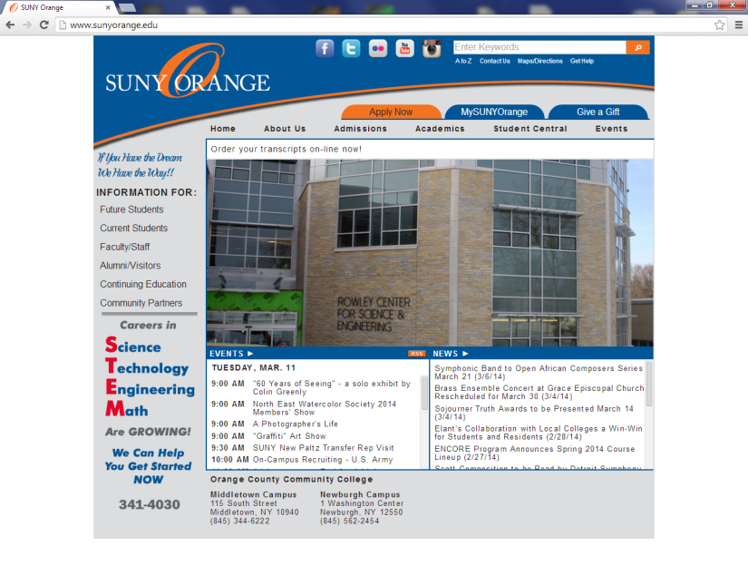

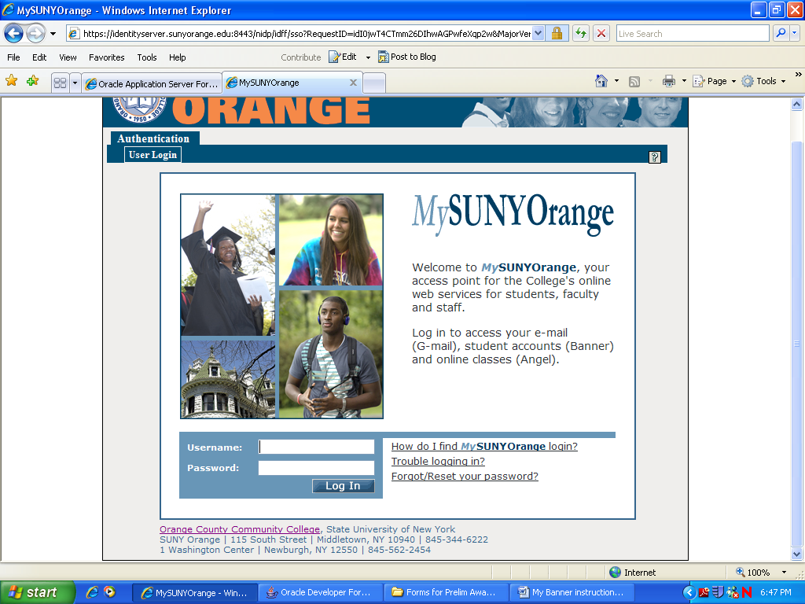

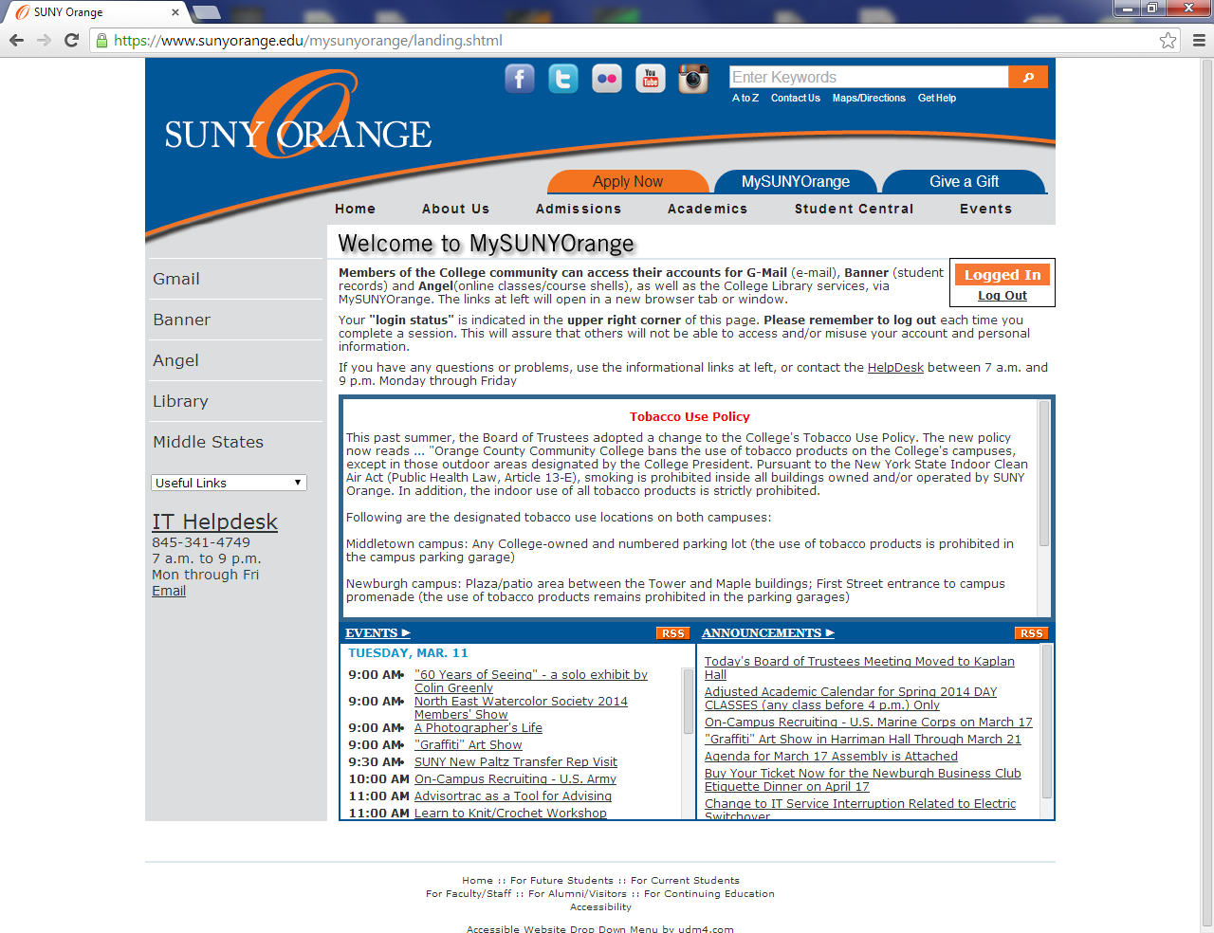

Click **MYSUNYORANGE**

**Log in here**

Your user name is your A number. Example: A00123456

Your default password is your date of birth in 6 digits: MMDDYY

Example: If your birth date is April 4, 1996 your password is 040496

NOTE: If you change your password, record the NEW one somewhere safe. SUNY Orange cannot retrieve your new password.

*note username and password directions

** Banner Self-service is not compatible with all web browsers, if you experience any problems you may use the computers in the College Library or Student Success Center.

**For your Gmail account**

**Click on Gmail**

* **Your e-mail address can be found in your inbox at the top of the page**

**For your Banner–Self-Service**

**Click on BANNER**

* **See back for additional Banner-Self-service directions**
* **Your e-mail address can be found under “View email address”**

**Over**

Banner – Self-service

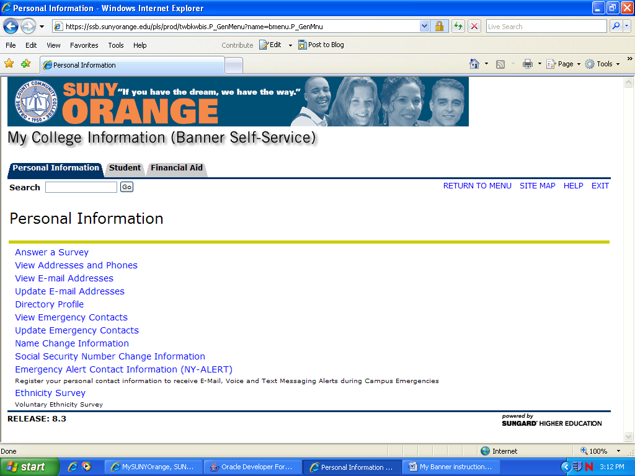

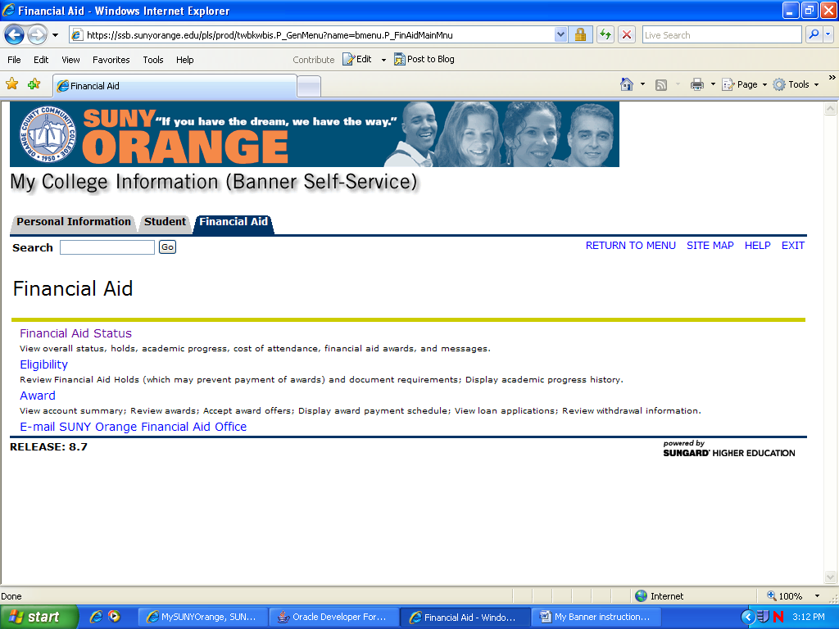

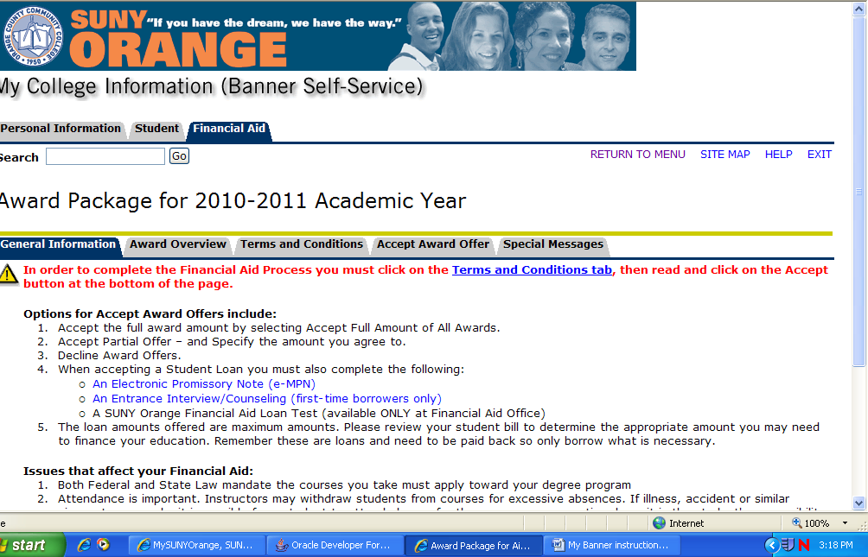

View Financial Aid Status / Accept/Decline Awards / Accept Terms and Conditions

**Click on the Financial Aid Tab**

**To check to see if you are missing documents**

**Financial Aid Status**

**Choose year**

* + **If you need to submit additional information you will see *unsatisfied requirements***

**(click to see what is needed)**

**To accept Terms & Conditions, check awards and/or**

**accept / decline awards:**

Awards

**Award for Aid Year**

* **Choose Year**

**Choose appropriate TAB**

**Award Overview (check awards)**

**Terms & Conditions Tab**

**Accept (Decline) Awards Offer**

* **All student loans must be accepted / declined at the Accept Award Offer link. Failure to complete this step will delay the loan process.**