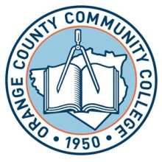

**SUNY ORANGE**

**OFFICE OF FINANCIAL AID**

**2011-2012 FINANCIAL AID WORKSHOPS**

Newburgh Campus

Kaplan Hall

Room 233

Tuesday Oct. 4, 2011 4:30 p.m.

Tuesday Oct. 18, 2011 4:30 p.m. Tuesday Nov. 1, 2011 4:30 p.m.

Tuesday Nov.15, 2011 4:30 p.m.

Tuesday Dec. 6, 2011 4:30 p.m.

Tuesday Dec. 13,2011 4:30 p.m.

PLEASE NOTE: All Financial Aid Workshops held at the Newburgh Campus, Kaplan Hall, Room 233.

In order to assist you in completing the FAFSA, you will need to bring photocopies of your and/or your parents 2010 Federal Income Tax Returns,

W-2’s and any other taxed or untaxed documentation for the year of 2010.

DEPENDENT STUDENTS UNDER 24 YEAR OF AGE: IT IS IMPERATIVE THAT THE STUDENT AND PARENT BE PRESENT TO COMPLETE THE FAFSA PROCESS.

Our Financial Aid workshops will begin promptly and, depending upon the number attending, may last up to 2 hours. ***No guarantee of admittance if late.***

NBGWKSHP/FA11