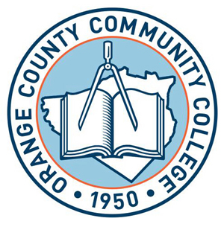

SUNY ORANGE
OFFICE OF FINANCIAL AID
2010-2011 FINANCIAL AID WORKSHOPS
Newburgh Campus - Tower Building

Tuesday Oct. 5, 2010 5:30 p.m.
Tuesday Oct. 19, 2010 5:30 p.m. Tuesday Nov. 2, 2010 5:30 p.m.
Tuesday Nov.16, 2010 5:30 p.m. Tuesday Dec. 7, 2010 5:30 p.m.
Tuesday Dec.14, 2010 5:30 p.m.

PLEASE NOTE: All Financial Aid Workshops held at the SUNY Orange Newburgh Campus will be held in room 214 of the Tower Building.

In order to assist you in completing the FAFSA, you will need to bring photocopies of your and/or your parents 2009 Federal Income Tax Returns,
W-2’s and any other taxed or untaxed documentation for the year of 2009.

TO DEPENDENT STUDENTS UNDER 24 YEAR OF AGE: IT IS REQUIRED THAT THE STUDENT AND PARENT BE PRESENT TO COMPLETE THE FAFSA PROCESS.

Our Financial Aid workshops will begin promptly and, depending upon the number attending, may last up to 2 hours. No guarantee of admittance if late.

FOR FURTHER INFORMATION AND FORMS CONTACT THE
FINANCIAL AID OFFICE AT: (845) 341-4190 OR 1-888-OCCCEXT

NBGWKSHP/FA10

