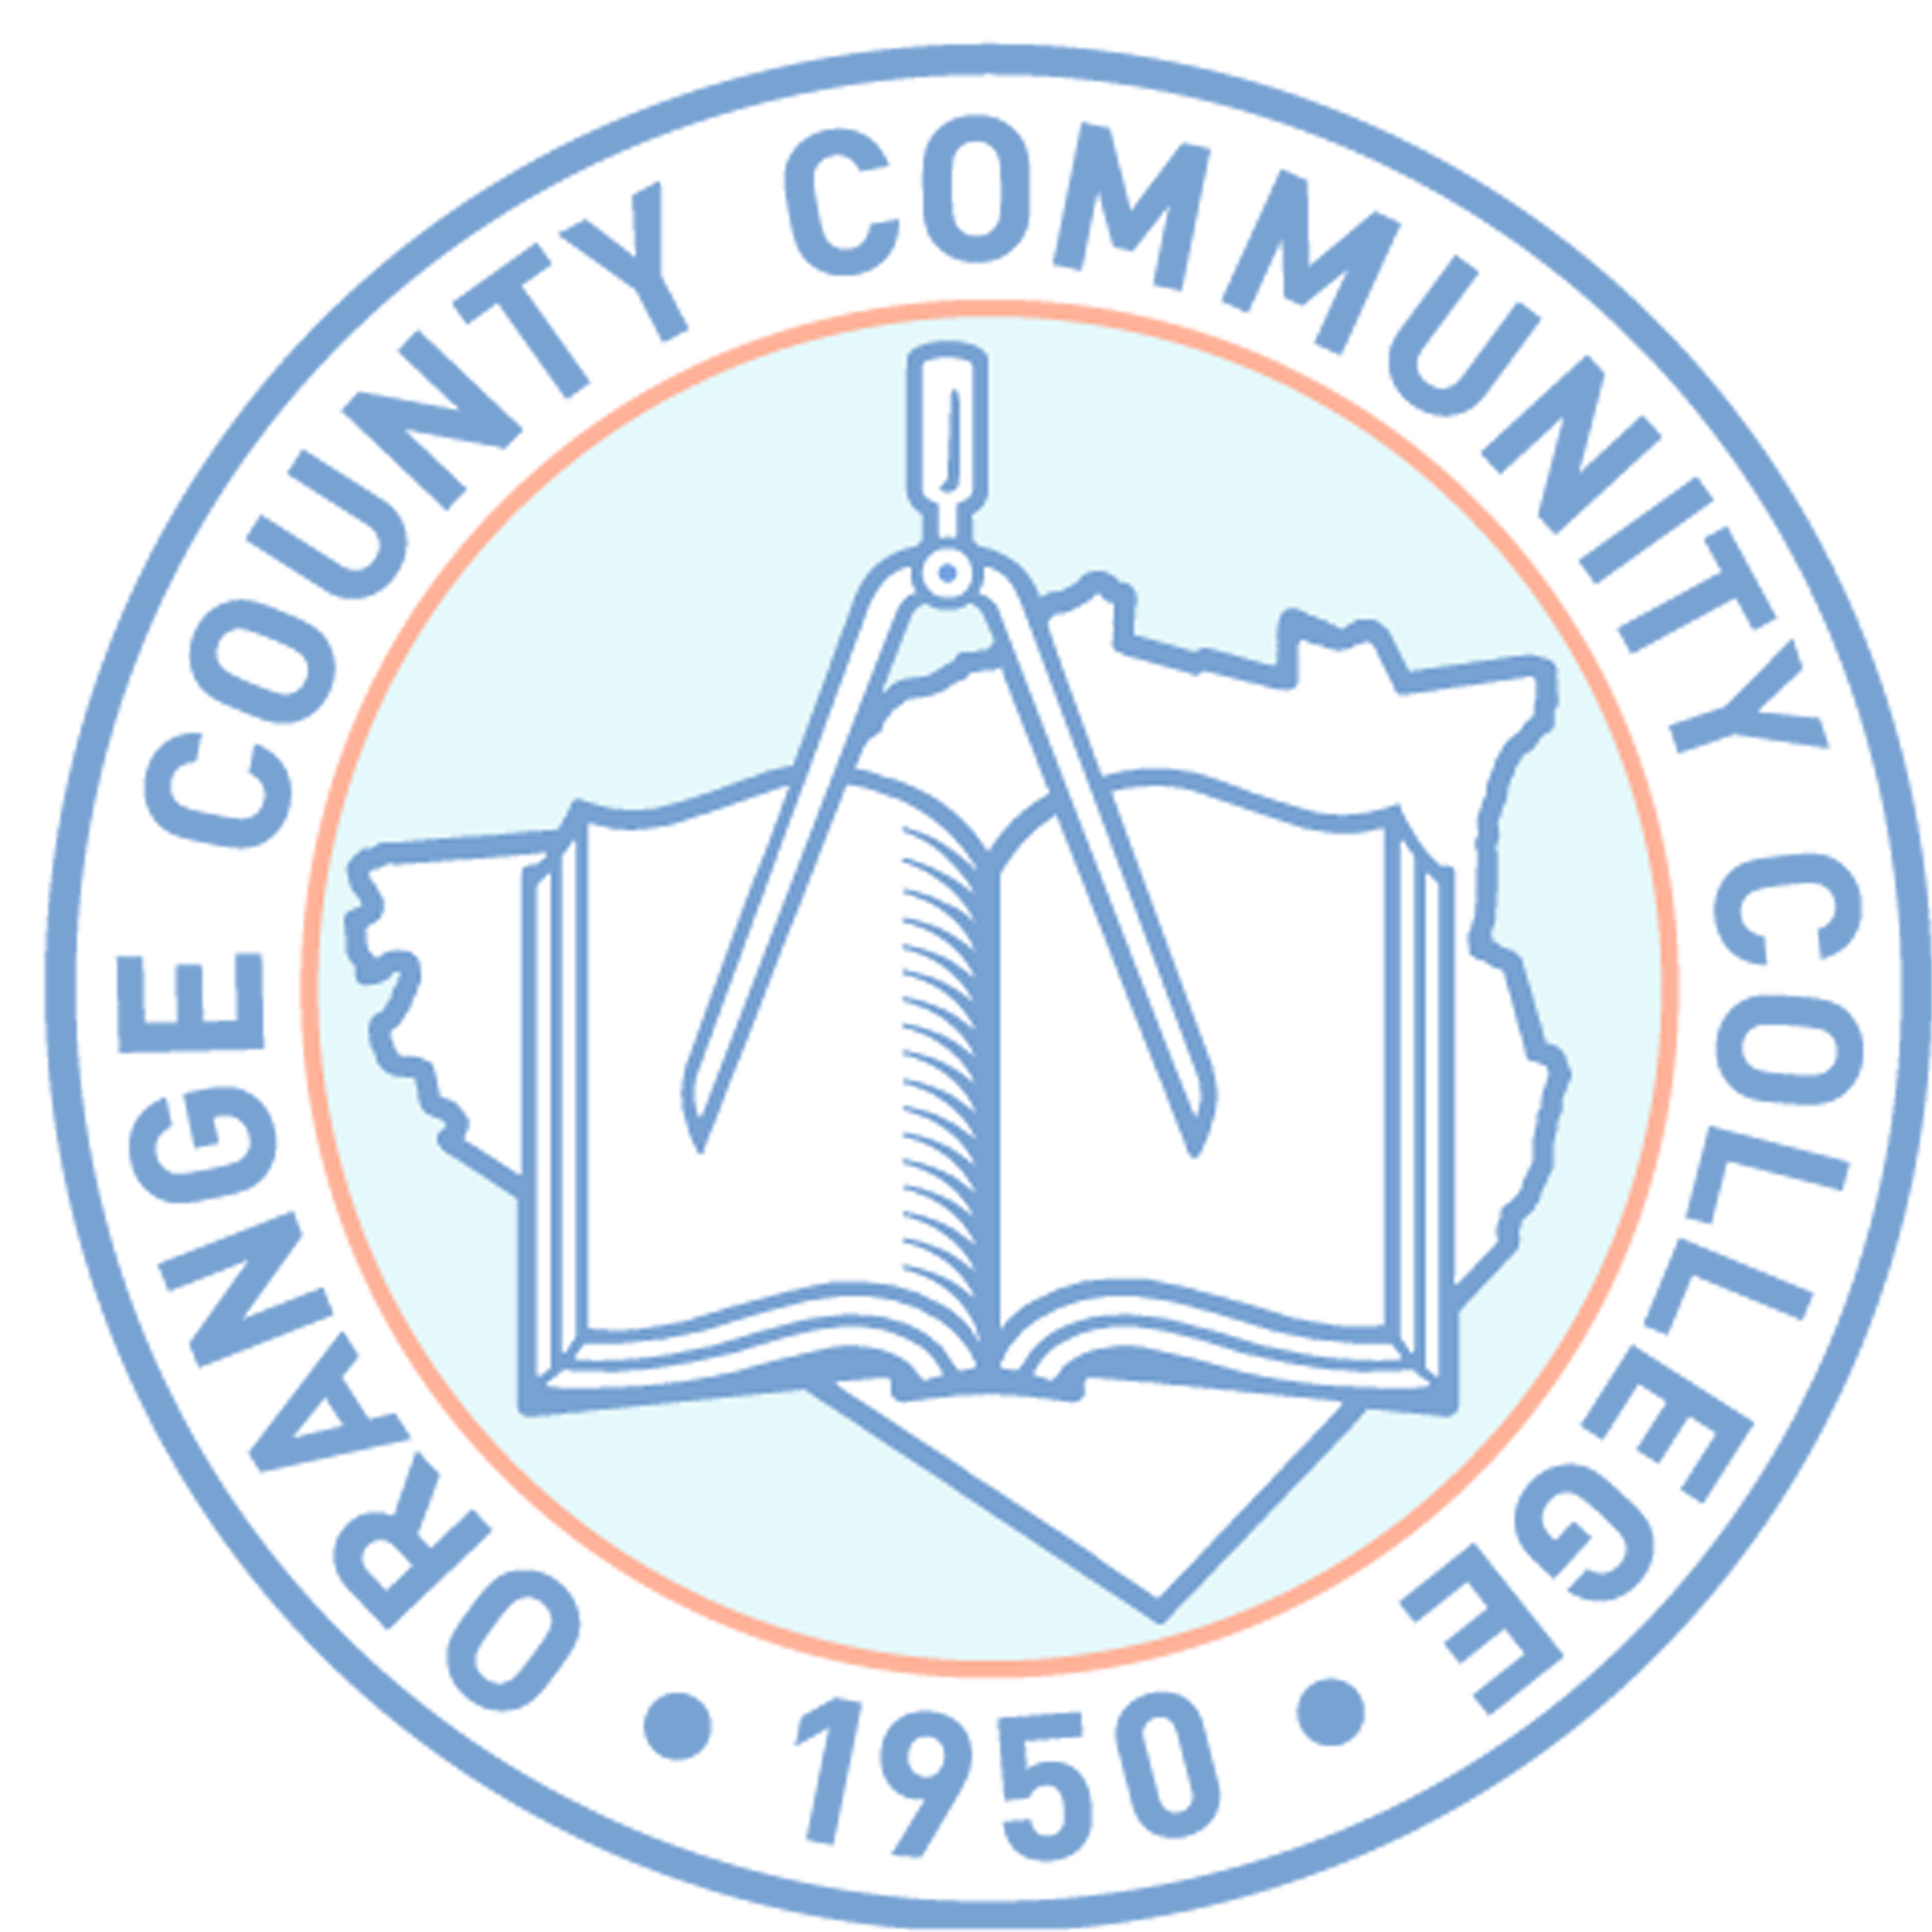

**SUNY ORANGE**

**OFFICE OF FINANCIAL AID**

**2011-2012 FINANCIAL AID WORKSHOPS**

Newburgh Campus

Kaplan Hall Room 233

Monday March 7, 2011 5:30 p.m.

Monday March 28, 2011 5:30 p.m.

Monday April 11, 2011 5:30 p.m.

Monday April 18, 2011 5:30 p.m.

Monday April 25, 2011 5:30 p.m.

Monday May 2, 2011 5:30 p.m.

Monday May 16, 2011 5:30 p.m.

Monday June 13, 2011 5:30 p.m.

Monday June 27, 2011 5:30 p.m.

Monday July 11, 2011 5:30 p.m.

PLEASE NOTE: **Financial Aid Workshops will be held at the Newburgh**

**Campus, will be held in room Kaplan Hall, Room 233**

**In order to assist you in completing the financial aid form, you will need to bring photocopies of your and /or your parents 2010 Federal Income Tax Returns, W-2s and any other taxed or untaxed documentation for the 2010 year.**

DEPENDENT STUDENTS UNDER 24 YEARS OF AGE:

IT IS IMPERATIVE THAT THE STUDENT AND PARENT BE PRESENT TO COMPLETE THE FAFSA PROCESS.

Financial Aid Workshops will begin promptly and depending upon the number attending may last up to 2 hours. ***No guarantee of admittance if late.***