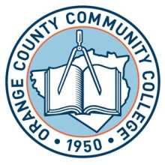**SUNY ORANGE**

**OFFICE OF FINANCIAL AID**

**2010-2011 FINANCIAL AID WORKSHOPS**

**Middletown Campus**

**Student Success Center on the 2nd Floor of the George F. Shepard Student Center**

Wednesday-----May 19, 2010 5:30 p.m. **-** 7:30 p.m.

Thursday--------June 10, 2010 4:00 p.m. **-** 6:00 p.m.

Thursday--------July 15, 2010 4:00 p.m. **-** 6:00 p.m.

**In order to assist you in completing the financial aid form, you will need to bring your and /or your parent(s) 2009 Federal Income Tax Returns, 2009 W-2(s) and any other taxed or untaxed income information for the year 2009.**

TO DEPENDENT STUDENTS UNDER 24 YEARS OF AGE:

IT IS IMPERATIVE THAT THE STUDENT AND A PARENT BE PRESENT TO COMPLETE THE FAFSA PROCESS.

Our Financial Aid workshops are two hours and will begin promptly.

***No guarantee of admittance if late.***

**FOR FURTHER INFORMATION AND FORMS VISIT OUR WEBSITE**

**www.sunyorange.edu/financialaid/**