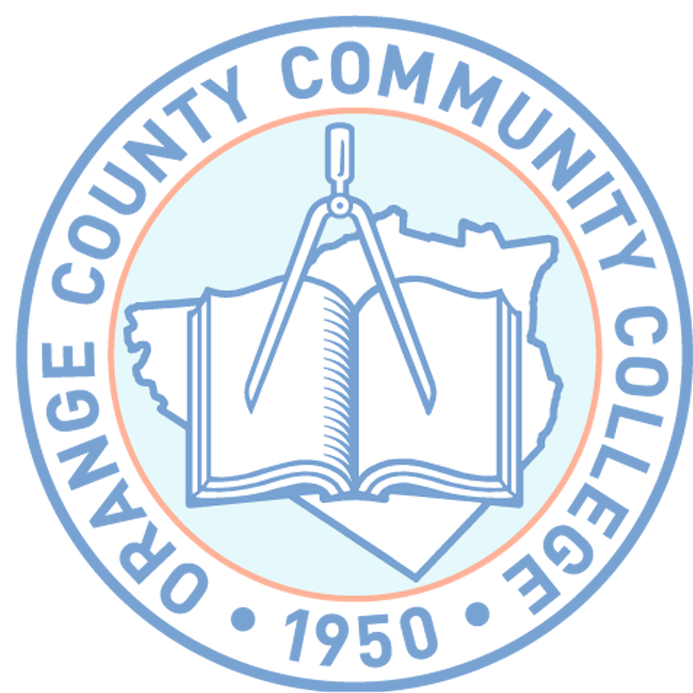

ORANGE COUNTY COMMUNITY COLLEGE

MIDDLETOWN, NEW YORK

**STATEMENT OF DEPENDENCY**

Under penalties of perjury, I declare that my dependent , is 24 years old or younger and will be a student during the year ___________.

Signature

Print Name

Date

Notary Stamp

S:\Human‑Resources\Blanche Folder\FORMS\DEPENDANCY STATEMENT