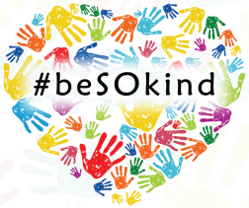

**Leave a kind note for someone**

**Leave a kind note for someone**



**Leave a kind note for someone**

**Leave a kind note for someone**



**Leave a kind note for someone**

**Leave a kind note for someone**



**Leave a kind note for someone**

**Leave a kind note for someone**



**Leave a kind note for someone**

**Leave a kind note for someone**



**Leave a kind note for someone**

**Leave a kind note for someone**



**Leave a kind note for someone**

**Leave a kind note for someone**



**Leave a kind note for someone**

**Leave a kind note for someone**