Leave a **kind** note for someone!

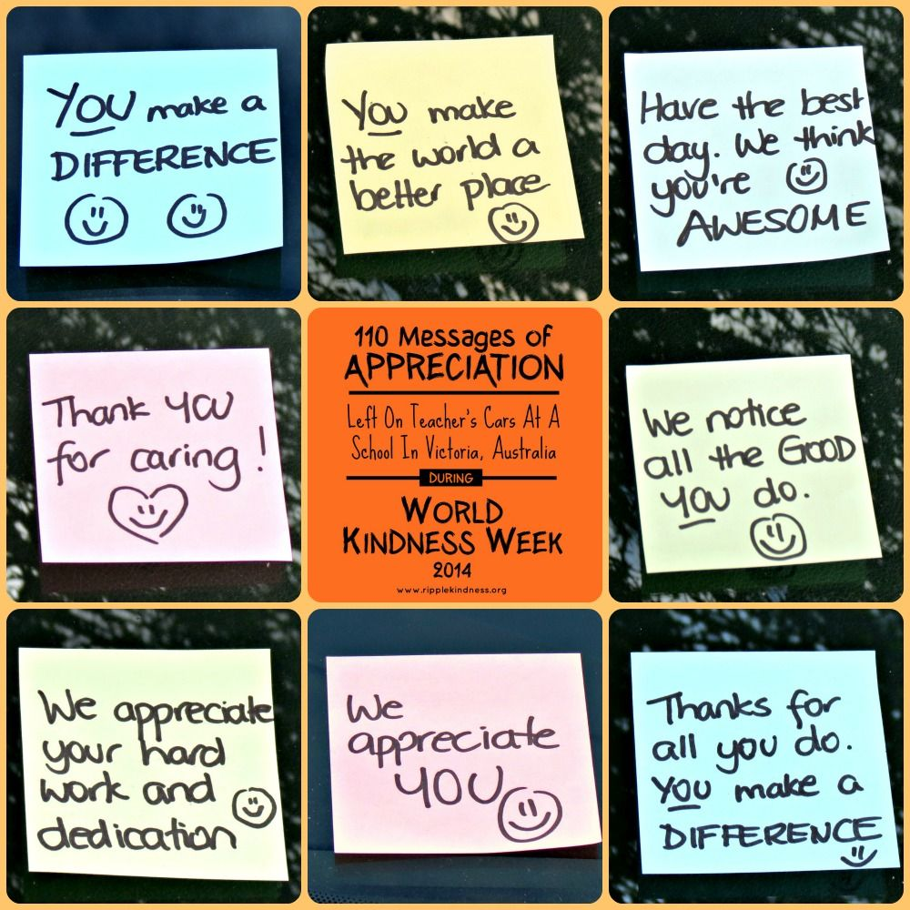

**#beSOkind**