How to Apply for Graduation
- Sign into your MYSUNYOrange account.

- Choose “Student Academics” from the blue column on the left-hand side:

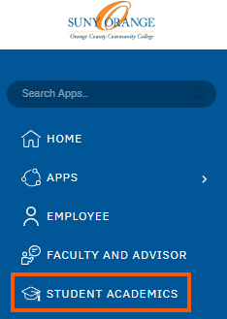

- Click the “Apply for Graduation” link, located under “My Academic Profile”:
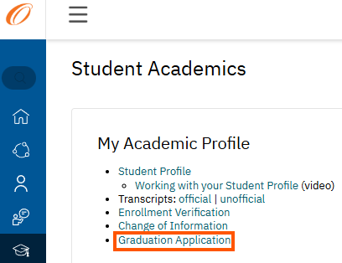

- Under “Curriculum Selection” select the term associated with your degree that you would like to apply for (there may be more than one option):
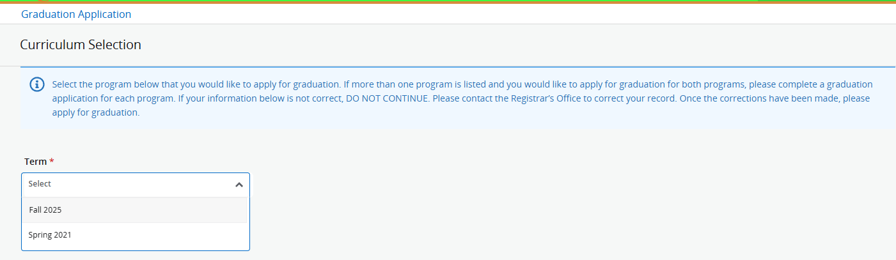
- Next, choose the program you would like to apply for:
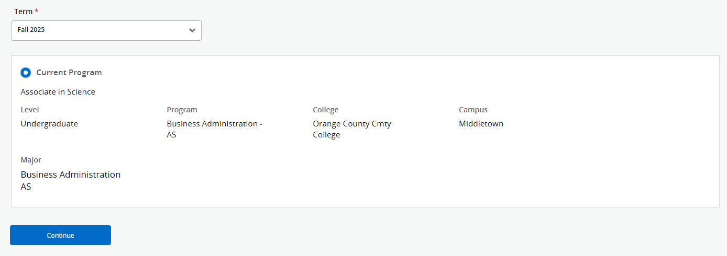
*If you are graduating with a dual degree, please complete an application for each degree program. (If the information listed under your degree is incorrect, do not fill out the application. Contact the Registrar’s Office so your information can be corrected. Once corrected, you can then submit your application.)

- Next, please select your graduation date:

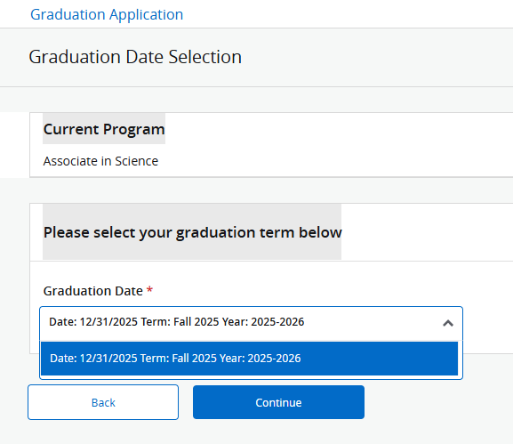

- Next, you will choose your “Diploma Name”. Click the drop-down menu for options. Please choose “New” if you would like to enter your information manually:
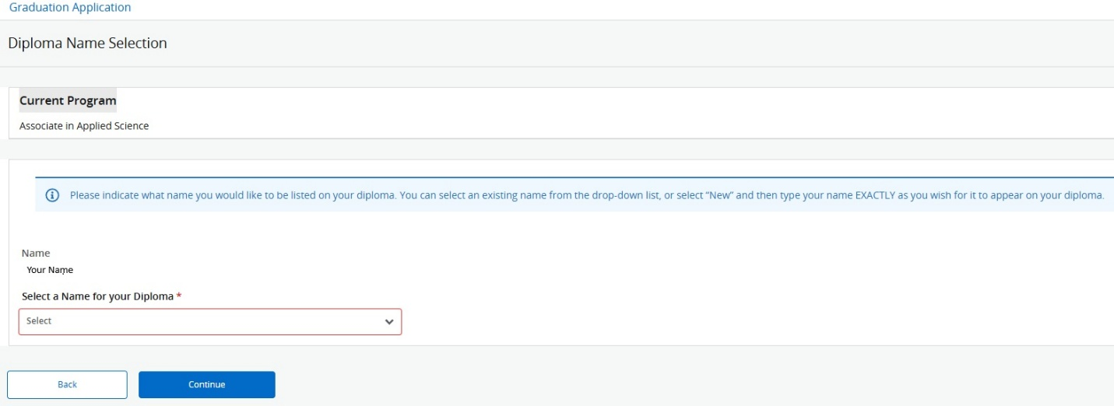
Please note: You can choose any name you wish on your diploma.

- Next, choose the Mailing Address you would like your diploma mailed to. Or you can select New and manually enter in a different address:
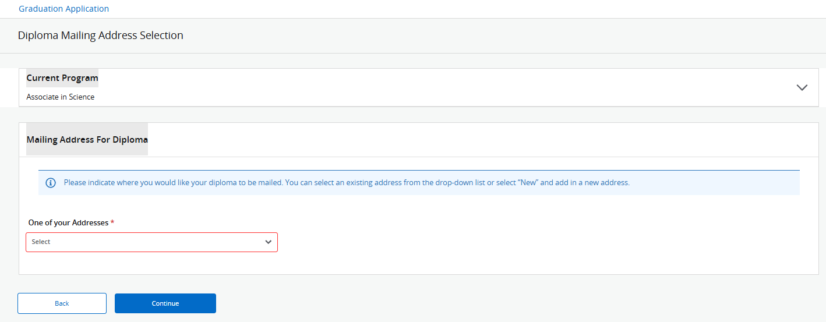
- Finally, review your Graduation Application Summary. If all of the information is correct, submit your application. If not, go back and fix the incorrect information, continue, and submit.

- You will receive an Acknowledgement with important information. Please read it carefully.

If you have any questions, please reach out to the Registrar’s Office at registrar@sunyorange.edu or (845) 341-4140.

