SUNY ORANGE


Emergency Management Plan (External)

June 2013
Table of Contents

Introduction 2

Section 1: Emergency Management Team
1.1 Organizational Chart 3
1.2 Emergency Management Team Roles and Responsibilities 3

Section 2: Specific Emergency Procedures
Emergency Phone List 4
Location of Emergency Call Boxes and Towers 4
2.1 Reporting General Emergencies 5
2.2 Reporting Medical Emergencies 5
2.3 Weather-Related Emergencies 6
2.4 Campus/Building Evacuation 7
2.5 “Shelter-in-Place” Procedure 9
2.6 Disorderly Behavior 10
2.7 Verbal/Physical Threats 10
2.8 Sexual Assault 10
2.9 Abduction or Missing Person 11
2.10 Fires 11
2.11 Explosive Devices/Threats 12
2.12 Hostage Situation 13
2.13 Chemical/Bio-Hazard Emergencies 14
2.14 Active Shooter 14
2.15 Public Demonstrations 15

Section 3: Post-Emergency Assessment
3.1 Assessment 16

Appendices
A Explosive Device Report Form A 17
B Material Safety Data Sheet (MSDS) 18
C Middletown Campus Map 19
D Newburgh Campus Map 20

Introduction

SUNY Orange will remain a safe haven for education. The College provides campus security services and regularly reviews the qualities of those services to ensure students, staff and faculty are protected at all times, and that the College is prepared to handle any situation that may arise.

However, there may be incidents that occur that require a broader response involving a greater number of College personnel and resources. Since most emergencies and/or crises occur suddenly and without warning, the College has developed a flexible plan to address a wide array of potential incidents.

The basic emergency procedures outlined in this Emergency Management Plan (EMP) are to enhance the protection of lives and property through effective use of College and campus community resources. The College President, or his designee, may implement this ERP whenever an emergency affecting SUNY Orange reaches proportions that cannot be handled by routine measures. This plan will help organize faculty, staff members and students during an emergency and will serve as the foundation for emergency preparedness, as well as crisis management planning and training for the entire College community.

This Emergency Management Plan was modeled after the Incident Command System (ICS), a nationally recognized organizational structure that provides for role assignment and decision-making while planning for, and reacting to, critical incidents of all types. Implementing ICS will allow College personnel to know their area of responsibility during a crisis and to plan and practice the management of their specific role.

Because most emergency responders use some form of ICS to manage emergency events, SUNY Orange will be equipped to work more efficiently with responding police, fire or governmental agencies should a crisis or emergency occur.

Emergency Phone List

Phone
Safety & Security Emergency (Middletown) 341-4710
Safety & Security Emergency (Newburgh) 341-9533
Safety & Security Cell Phone (Middletown) 239-9497 / 551-1139
Safety & Security Cell Phone (Newburgh) 248-6662 / 248-6676
City of Middletown Police Department 343-3151
City of Middletown Fire Department 343-4169
City of Newburgh Police Department 561-3131
City of Newburgh Fire Department 562-1212

Section 1: Emergency Management Team (EMT)

1.1 Organizational Chart

The College’s Emergency Management Team (EMT) will consist of the following personnel:

Office Cell
Dr. William Richards (President) 341-4700 (845) 926-8026
Roz Smith (Vice President for Administration) 341-4905 (845) 313-7455
Paul Broadie III (Vice President for Student Services) 341-4020 (845) 546-9777
Vinnie Cazzetta (Vice President for Institutional Adv.) 341-4726 (845) 741-3468
Heather Perfetti (Vice President for Academic Affairs) 341-4768 (240) 727-8391
Mindy Ross (Vice President for Newburgh Campus) 341-9541 (845) 978-2633
Wendy Holmes (Assoc. Vice President for Human Resources) 341-4662 (914) 213-5932
Jose Bernier (Vice President, Chief Information Officer) 341-4651
Mike Worden (Director of Administrative Services/Facilities) 341-4901 (845) 239-9431
Ed Kiely (Director of Safety & Security Services) 341-4934 (845) 239-9440
Mike Albright (Communications Officer) 341-4728 (845) 987-6927
Michelle Tubbs (Governance President) 341-4501 (845) 649-8175

1.2 Roles and Responsibilities

Members of the Emergency Management Team have been assigned specific roles to be carried out in event of a crisis or emergency that affects the College. When necessary, the College will establish a command center (where the EMT will convene to manage the College’s response to the crisis), a family assistance center (where students, faculty, staff and family members can assemble to gather information or acquire counseling and other health services as necessary) and a joint information center (for members of the media to assemble for information and press conferences).

Section 2: Specific Emergency Procedures

Emergency Phone List
Phone
Safety & Security Emergency (Middletown) 341-4710
Safety & Security Emergency (Newburgh) 341-9533
Safety & Security Cell Phone (Middletown) 239-9497 / 551-1139
Safety & Security Cell Phone (Newburgh) 248-6662 / 248-6676
City of Middletown Police Department 343-3151
City of Middletown Fire Department 343-4169
City of Newburgh Police Department 561-3131
City of Newburgh Fire Department 562-1212

Location of Emergency Call Boxes and Towers

All yellow emergency call boxes on the Middletown campus and the blue emergency call towers/wall units on the Middletown and Newburgh campuses will ring directly to that campus’ Safety and Security office. All faculty, staff and students are encouraged to familiarize themselves with the locations of all available emergency communications options on both campuses.

Middletown campus Exterior Yellow call boxes:
- Parking Lot 2 (behind Harriman Hall)
- Lab School Drive (rear of Physical Education Building)
- Inner campus entrance to Bio-Tech (outside of doors near Mastadon)
- South Street entrance of Bio-Tech Building
- Shepard Student Center (Bennett Street entrance)

Middletown campus Blue call towers:
- Alumni Green
- Parking Lot #1 (Orange Hall)
- Parking Lot #5 (South Street)
- Parking Lot 6 (South Street)
- Parking Lot 11 (South Street)
- Front entrance to Morrison Lab School

Newburgh campus Blue call towers/centers:
- Kaplan Hall parking garage (wall units: four on Level 1, three on Level 2 and three on Level 3)
- Kaplan Hall street-side entrances (wall unit at Grand Street, wall unit at First Street, tower at garage entrance)
- Inner campus (tower by Grand Street lobby, tower by playground and wall unit along steps to lower promenade)
- Tower Building courtyard (one unit at both the north and south perimeters).

The following specific emergencies are addressed in this section:

- Reporting General Emergencies
- Reporting Medical Emergencies
- Weather-Related Emergencies
- Campus/Building Evacuations
- Shelter-in-Place Procedure
- Disorderly Behavior
- Verbal/Physical Threats
- Sexual Assault
- Abductions/Missing Person
- Fires
- Explosive Devices
- Chemical/Bio-Hazard Emergencies
- Hostage Situations
- Active Shooter
- Public Demonstrations

2.1 Reporting General Emergencies

To report an emergency, dial 911 or contact SUNY Orange Safety & Security at the numbers listed above. In order to assist the operator in processing the call quickly and efficiently, please be prepared to give the following information:

- What you saw, heard or found
- The exact location of the incident
- The phone number you are calling from
- Details of the situation
- Your name and address
- Stay on the line until you are told to hang up

REMAIN CALM . . . KEEP OTHERS CALM!

2.2 Reporting Medical Emergencies

In the event of a medical emergency, the College’s Health Services Office is staffed by a Registered Nurse (RN). The Health Services hours of operation are 8:30 a.m. to 4:30 p.m. Monday through Friday.

In the event of any accident or medical emergency on campus:

- Dial 911 immediately and/or contact Safety & Security
- Provide the following information:
- Immediately notify emergency personnel if the victim is unconscious or not breathing.
- Describe the type of emergency and assistance needed to the best of your ability.
- Give your name and extension from which you are calling.
- Give name of victim if known, and their exact location.
- Hang up last to insure that emergency personnel have no further questions.
- Be prepared to handle an emergency with the following advance planning:
- Know the location of nearest first aid kit in your building.
- Have someone meet the nurse or ambulance attendants at a specified location.
- Be ready to give as much detail as possible regarding the situation (time of occurrence, potential injuries and possible causes).
- Following are additional emergency phone numbers:
- Health Services Office (341-4870)
- Safety & Security (Middletown: 341-4710; Newburgh: 341-9533)
- Mobile Life ambulance (Middletown: 343-1212; Newburgh: 562-4357)
- Please be aware that an incident report must be filled out by the campus nurse for insurance claims purposes on all accidents involving staff or students

2.3 Weather-Related Emergency

In the event of a tornado or severe storm, all faculty, staff and students should stay away from all windows and seek shelter in an interior hallway on the lowest floor of the building. Do not move to a gymnasium or auditorium with large, poorly supported roofs.

If people are injured, employ the following procedures to report a medical emergency:

- Dial 911 immediately and/or contact Safety & Security
- Provide the following information:
- Immediately notify emergency personnel if the victim is unconscious or not breathing.
- Describe the type of emergency and assistance needed to the best of your ability.
- Give your name and extension from which you are calling.
- Give name of victim if known, and their exact location.
- Hang up last to insure that emergency personnel have no further questions.
- Be prepared to handle an emergency with the following advance planning:
- Know the location of nearest first aid kit in your building.
- Have someone meet the nurse or ambulance attendants at a specified location.
- Be ready to give as much detail as possible regarding the situation (time of occurrence, potential injuries and possible causes).
- Following are additional emergency phone numbers:
- Health Services Office (341-4870)
- Safety & Security (Middletown: 341-4710; Newburgh: 341-9533)
- Mobile Life ambulance (Middletown: 343-1212; Newburgh: 562-9357)
- Please be aware that an incident report must be filled out by the campus nurse for insurance claims purposes on all accidents involving staff or students

2.4 Campus/Building Evacuations

All building evacuations will occur when a building alarm (fire alarm) sounds and/or upon notification by SUNY Orange Safety & Security personnel, local police or local fire officers. When the building evacuation alarm is activated during an emergency, leave by the nearest marked exit and alert others to do the same. Safety & Security personnel have studied and mapped out specific evacuation routes based upon many variables that may arise during an emergency. Safety & Security personnel will direct you along the safest evacuation route.

Once outside, proceed to a clear area that is at least 500 feet away from the affected building. Keep streets, fire lanes, hydrants, areas and walkways clear for emergency vehicles and personnel. DO NOT return to an evacuated building unless told to do so by the SUNY Orange Safety & Security personnel.

ASSIST THE HANDICAPPED IN EXITING THE BUILDING!

DO NOT USE THE ELEVATORS DURING ANY EVACUATION

2.4.1 Campus Evacuation

Evacuation of all or part of the campus grounds will be announced by the Safety & Security Office. All persons (students and staff) are to evacuate the area of campus in question immediately and relocate to an off-campus location or another part of the campus grounds as directed.

2.4.2 Procedure for Emergency Evacuation of Individuals with Disabilities

The following procedures are intended to assist disabled persons with an emergency evacuation from any building on the campus of SUNY Orange. College policies and procedures require all persons in a facility to evacuate that facility any time the fire alarm system is activated or in the case of any emergency that requires building evacuation. Persons with disabilities may not be able to evacuate unassisted. Therefore, they should inform another person that assistance may be necessary during an evacuation.

General Guidelines
- Remember that individuals with similar disabilities are unique. Listen to the individual; he/she is the expert regarding his/her own disability.
- Always ask the individual if there are any special considerations or items that need to come with him/her during the evacuation.
- There are “hidden” disabilities that may need assistance, including health, psychiatric disabilities (anxiety disorders, depression, personality disorders, etc.), and some vision or hearing impairments.
- Some individuals may utilize service animals such as guide dogs, hearing dogs or assistance animals. When possible, keep the team together.
- Persons with disabilities that limit mobility may be defined as anyone who uses assistive devices such as canes, crutches, or wheelchairs or who has slower mobility due to illness or injury. Also, persons with limited vision and hearing may need assistance to evacuate. All of these individuals are encouraged to utilize a “Buddy” when evacuation is necessary.
- During the first week of class, persons with limited mobility are encouraged to make acquaintances with fellow students, class members, faculty, or staff, and to inform them of any special assistance that may be required in the event of a fire alarm.
- If conditions allow, the “Buddy” may choose to assist the person with the disability during the evacuation of the building.

ELEVATORS ARE NOT TO BE USED IN AN EMERGENCY EVACUATION

Elevators will stop in the event of a power outage and persons will become trapped inside.

Evacuation Options
The following evacuation options will help to assure the prompt evacuation of any person with a disability.

- Horizontal Evacuation: Move away from the area of imminent danger to a safe distance such as another wing, adjoining building, opposite end of the corridor, or outside if on ground level.
- Vertical (Stairway) Evacuation: Stairways can be used by those who are able to evacuate with or without assistance. Enclosed stairways are a safe refuge due to fire and smoke doors that enclose the area. Persons with sight disability may require the assistance of a sighted person. Persons who must use crutches or other devices as walking aids will need to use their own discretion, especially when several flights of stairs are concerned.
- Stay in Place: Unless danger is imminent, remain in a room with an exterior window and a telephone, closing the door. Contact Safety & Security. Give your name, location and the reason you are calling. Phone lines normally remain in service during most building emergencies. If the phone lines do fail, you can signal from the window by waving a cloth, towel, sheet, or other object to attract attention.

Disability Guidelines
Prior planning and practicing of emergency evacuation routes are important in assuring a safe evacuation.

- Mobility Impaired (Wheelchair): Persons using wheelchairs should stay in place or utilize some type of horizontal evacuation with their “Buddy” when the alarm sounds. The evacuation “Buddy” should immediately proceed to the evacuation assembly point outside the building and inform emergency personnel about the location of the person with disability. If the person with disability is alone, he/she should call 341-4710 in Middletown or 341-9533 in Newburgh and inform Safety & Security personnel of his/her location.
- Mobility Impaired (Non-Wheelchair): Persons with mobility impairments who are able to walk independently may be able to negotiate stairs in an emergency with minor assistance. If danger is imminent, the individual should wait until the heavy traffic has cleared before attempting the stairs. If there is no immediate danger (detectable smoke, fire or unusual odor), the person with disability may choose to stay in the building, using the other options, until emergency personnel arrive.
- Hearing Impaired: All SUNY Orange fire alarms are equipped with flashing strobe lights to notify hearing impaired people of an emergency. However, persons with hearing impairments may not notice or hear emergency alarms and will need to be alerted of emergency situations. A “Buddy” should offer assistance to the individual in evacuating a building, including providing necessary information that will be of help to the hearing impaired person.
- Visually Impaired: Most people with a visual impairment will be familiar with their immediate surroundings and frequently traveled routes. Since emergency evacuation routes could be different from the commonly traveled route, persons who are visually impaired may need assistance in evacuating a building. A “Buddy” should offer assistance to the individual with visual impairment and guide him/her through the evacuation route.

2.5 “Shelter-in-Place” Procedure

An emergency situation may prevent the safe evacuation of a SUNY Orange building and require steps to isolate students, staff and faculty from danger. Depending on the situation, the College or specific areas of the College may need to be completely secured from the inside.

When necessary, personnel from Safety & Security will lock any open doors manually or by computer system. Communication via College portable radios is permissible as long as the incident does not involve an explosive device or a suspect in possession of a radio or scanner.

When the College requires a Shelter-in-Place procedure, the following announcements will be made and repeated several times using all available campus communication resources, including the SUNY Orange e-mail system, web site, interior building monitors, loudspeakers, telephone messaging and wireless technology.

SAMPLE ALERT MESSAGE
“Staff and instructors, please secure your students and or staff in your area immediately, until further notice by Supervisor or security designees.”

During a Shelter-in-Place situation, special attention will also be given to the areas of the College where numerous students are gathered in an unsecured environment, such as the Shepard Center cafeteria, Orange Hall Theater and the Library. Arrangements will be made so those students in these areas can be moved to nearby secure locations, if necessary.

2.5.1 Faculty & Staff Response to a “Shelter-in-Place” Announcement

When an employee/instructor hears the “Shelter-in-Place” announcement, he or she should follow these directions:

- Secure the classroom/office door immediately, utilizing door locks, desks, chairs, etc.
- Advise students/employees that there is some type of emergency ongoing.
- Project a calm attitude to maintain student behavior.
- If necessary, keep all students/employees sitting on the floor, away from doors and windows.
- Use caution and discretion in allowing entry into the classroom/office. Request College ID for safety measures.
- Take attendance and prepare a list of missing students/employees and extra students/employees in the room. Prepare to take this list with you when you are directed to leave the classroom/office.
- If there is a cell phone, you may call the following numbers (faculty and staff may also refer to the EMP flip cards posted within each classroom or office area):

Middletown Newburgh
Safety & Security (845) 341-4710 (845) 341-9533

- Remain in the room until a police officer, a SUNY Orange Safety & Security officer or a member of the Emergency Management Team comes to the room with directions.
- When or if people are moved from the room, assist them in moving as quietly and quickly as possible to assigned areas.
- Fire alarm activation is not used normally to signal evacuation of a building during a Shelter-in-Place procedure. You should not evacuate unless directed by Safety & Security personnel or officials from local police or fire departments.

2.6 Disorderly Behavior

In the event that a person becomes disorderly on campus, contact Safety & Security immediately. Maintain a safe distance until help arrives. If a disorderly student refuses to leave the classroom upon request of the instructor, Safety & Security personnel will notify the local Police Department and proper legal procedures will be used.

NEVER TRY TO HANDLE A DANGEROUS SITUATION ON YOUR OWN

2.7 Verbal/Physical Threats

Employees who receive verbal threats or feel threatened physically will immediately notify the switchboard operator (dial 0) or Safety & Security Personnel (341-4710). If necessary, contact will be made to local police or fire agencies.

If the threatened complainant feels imminent danger, the Director of Safety & Security will assign a security officer to the complainant.

2.8 Sexual Assault

If you are the victim of a sexual assault, witness a sexual assault or encounter a potential victim, contact Safety & Security immediately. If immediate medical attention is needed, dial 911 or contact Health Services (341-4870).

2.9 Abduction or Missing Person

If you become aware of a SUNY Orange employee or student who appears to be unaccounted for over a period of time, or witness an abduction, contact Safety & Security immediately. Be prepared to provide as much information as you can about the incident and/or person involved.

2.10 Fires

In the event that you see smoke or fire prior to hearing a fire alarm, following these prescribed R.A.C.E. procedures:

- Rescue: Assist any injured or disabled persons in exiting the building or to a safe refuge.
- Alarm: Pull nearest fire alarm (know its location nearest your workstation or classroom).
- Confine: Confine the fire, and if possible, close all windows. Attempt to contain fire by use of proper fire extinguisher. Before leaving the room, take belongings and close doors.
- Evacuate: Leave the building by means of the closest safe stairway and exit in an orderly manner. DO NOT USE ELEVATORS.

2.10.1 Fire Evacuation

The sound of any fire alarm is to be taken seriously. The signal to evacuate a building for a fire drill or emergency is a series of rings on the building fire bells. Evacuation of the building is mandatory until the signal to re-enter has been given by appropriate personnel and the alarm bells have ceased ringing. Safety & Security personnel have studied and mapped out specific evacuation routes based upon many variables that may arise during an emergency. Safety & Security personnel will direct you along the safest evacuation route. When evacuating:

- Proceed in a calm and orderly fashion, using your nearest available exit.
- Assist the handicapped in leaving the building.
- Do not use elevators.
- If your pathways are filled with smoke, stay near the floor where the air is less toxic. Smoke is the greatest danger in a fire.
- Once outside the building, remain clear of the doorways and at least 500 feet from the building. Remain clear of all roadways as well.
- Where appropriate, Kindercollege staff and students will be safely evacuated to a safe location.

2.10.2 Fire Emergency Pre-Plan

To ensure your safety in the event of a fire, plan ahead by researching the following:

- Know the location of the nearest fire alarm.
- Know the location of fire extinguishers and how to use them:
- Pull the pin and aim the extinguisher at base of fire
- Squeeze the handle
- Sweep at the base of fire
- Know where your nearest exits are
- Know the College emergency numbers to call:
Middletown Newburgh
Safety & Security (845) 341-4710 (845) 341-9533

2.11 Explosive Devices/Threats

Explosive device threats against SUNY Orange may be received by phone, mail or in person. Any staff member receiving a threat of this nature should make every effort to follow the outlined procedures.

- Most threats are directed to personnel over the telephone. (98% are usually unfounded). These calls are usually very brief. Every effort should be made to remain calm and collected in order to obtain all possible data from the caller (refer immediately, if possible, to the Explosive Device Report Form A to assist you in obtaining the pertinent details). Explosive Device Report Form A is Appendix “A” in this Emergency Management Plan.
- If call is received on a digital phone, make note of the phone number illustrated on phone.
- Upon hanging up with caller, secure the telephone and do not use. If possible, immediately contact Safety & Security or the Department of Administrative Services (341-4901) from another nearby telephone and provide all known information.
- If requested, adhere to the College’s “Shelter-in-Place” procedures.
- If a suspicious package or explosive device is found, do not touch, move or attempt to open. Immediately evacuate that area. Once in a safe location, contact Safety & Security.
- The discovery or detonation of one explosive device does not remove the threat of additional devices. If evacuated, do not return to the area until given proper permission.
- In the event that a staff member receives an explosive device threat at their residence that could possibly be work related, they should: notify the Director of Safety & Security of the circumstances and contact their local police department to file an official complaint.

2.11.1 Mail Bombs/Suspicious Packages

If you suspect you are in receipt of a dangerous or suspicious package, contact Safety & Security immediately. Do not touch, move or attempt to open. Evacuate the area if possible.

Mail Bomb Characteristics:

- Package includes white powder or any other suspicious powder
- Letters feel rigid, appear lopsided or are bulkier than normal
- Oil stains may be present on the wrapper
- Use of an excessive amount of postage stamps
- The sender is not known by the individual or College personnel
- No return address
- Unusual restricted endorsements, such as personal or private
- Addressee does not normally receive personal mail at the College
- Name and title of addressee not accurate
- Address is prepared to insure anonymity of sender (home made labels, cut and paste lettering)
- Mailing appears to be dissembled or re-glued, or emits a peculiar odor
- Protruding wires, tinfoil or string is present
- Pressure or resistance is noted when removing the contents
- Several combinations of tape are used to secure the parcel
- Package makes a buzzing or ticking noise, or a sloshing sound

E-mail Bomb Threats

If you receive a threat of this kind, notify the Department of Safety & Security. Do not turn off computer.

2.12 Hostage Situation

In the event of a hostage situation on campus, College students and personnel should:

- Notify Safety & Security immediately.
- Follow directives and safety requirements as provided by Safety & Security personnel, the administrator in charge, the Middletown Police Department Hostage Unit or the Newburgh Police Department Hostage Unit.
- The Director of Safety & Security Services, or his designee, will assure the affected area is secured and will designate one mediator to establish communication with the individuals(s) by phone, if possible. If unable to establish communication by phone, the mediator is to act prudently until the police department hostage unit arrives.

What to Do if Taken Hostage

- Be patient. Time is on your side. Avoid drastic action.
- The initial 45 minutes are the most dangerous. Follow instructions, be alert and stay alive.
- The captor is emotionally imbalanced. Don't make mistakes that could endanger your life.
- Don't speak unless spoken to and then only when necessary. Don't talk down to the captor who may be in an agitated state. Avoid appearing hostile.
- Maintain eye contact with the captor at all times if possible, but do not stare. Treat the captor like royalty.
- Try to rest. Avoid speculating. Comply with instructions as best you can. Avoid arguments. Expect the unexpected.
- Be observant. You may be released or escape. The personal safety of others may depend on your memory.
- Be prepared to answer the police on the phone. Be patient, wait. If the opportunity presents itself, attempt to establish rapport with the captor.
- If medications, First Aid, or rest room privileges are needed by anyone, say so. In all probability, the captors do not want to harm persons held by them. Such direct action further implicates the captor in additional offenses.

2.13 Chemical/Bio-Hazard Emergencies

In the event of a chemical spill or leak, hazardous waste contamination, or bio-hazard emergency, conduct the following:

- Evacuate the immediate area and notify the Office of Safety & Security and/or Facility Services (341-4600).
- Follow any directions given for assessing the hazard and guidance related to containment and cleanup.
- If applicable, review Material Safety Data Sheet (MSDS) to determine the urgency of the situation. The MSDS is Appendix “B” in this Emergency Management Plan
- Responding into a contaminated area to save a fellow worker or student my put you in danger. Emergency personnel with the Proper Protective Equipment (PPE) will handle any rescue.
- Arrange to meet responding emergency personnel to provide them with appropriate information.
- Alert occupants in adjacent area if hazard has the potential to spread.
- Involve building engineer or custodian for ventilation information. This may involve limiting exposure by containing the fumes in the isolated area or diluting the fumes by opening the area for fresh air ventilation.

2.14 Active Shooter

In the event that you witness someone brandishing a weapon or hear shots fired in your vicinity on campus, prepare to:

- If possible, safely exit the building and move away from the immediate path of danger
- Notify anyone you may encounter to exit the building immediately
- Evacuate to a safe area away from the danger and take protective cover
- If you are directly involved in an incident, or exiting the building is not possible, the following action is recommended:
- Go to the nearest room or office
- Close and lock the door
- Turn off the lights
- Seek protective cover
- Keep quiet and act as if no one is in the room
- Do not answer the door
- Call 911 or contact Safety & Security by phone or by utilizing the yellow emergency call boxes or blue emergency call towers/units at the following locations:

Middletown campus
  - Exterior Yellow call boxes: Parking Lot 2 (behind Harriman Hall), Tennis Court Drive (rear of Physical Education Building), inner campus entrance to Bio-Tech (outside of doors near Mastadon), South Street entrance of Bio-Tech Building, and Shepard Student Center (Bennett Street entrance).
  - Blue call towers: Alumni Green, Parking Lot #1 (Orange Hall), Parking Lot #5 (South Street) and Parking Lot 6 (South Street), Parking Lot 11 (South Street), front entrance to Morrison Lab School.

Newburgh campus
  - Blue call towers/centers: Kaplan Hall parking garage (wall units: four on Level 1, three on Level 2 and three on Level 3), Kaplan Hall street-side entrances (wall unit at Grand Street, wall unit at First Street, tower at garage entrance), inner campus (tower by Grand Street lobby, tower by playground and wall unit along steps to lower promenade), and Tower Building courtyard (one unit at both the north and south perimeters).

- When contacting authorities, provide the following information:
- Your name
- Location of the incident (be as specific as possible)
- Number of shooters (if known)
- Identification or description of shooter(s)
- Number of persons who may be involved
- Your exact location
- Injuries to anyone, if known
- Wait for local police or security to assist you out of the building. Local police departments are trained and equipped to respond to an emergency incident of this nature.
- Individuals not immediately impacted by the situation are to take protective cover, staying away from windows and doors until notified otherwise.

2.15 Public Demonstrations

The College respects the rights of groups to gather for demonstrations. When groups from outside the College provide advance notification of a planned demonstration, Safety & Security will attempt to inform any departments that may be affected. College staff and faculty are urged not to attempt to halt a demonstration and are advised to continue with normal operations.

However, should a demonstration become disruptive to normal College operations, become violent in any fashion, or appear to be escalating toward violence, contact Safety & Security immediately.

Section 3: Post-Emergency Assessment

3.1 Assessment

Following any situation in which SUNY Orange is required to implement its Emergency Management Plan, the College will conduct a post-emergency assessment to evaluate how the incident was handled and what, if any, adjustments must be made to the Emergency Management Plan. The evaluation will investigate all aspects of the College’s response and will include the following:

- Account for all personnel and resources following the crisis.
- Hold a non critical debriefing meeting of all College personnel involved in resolving the crisis
- Ensure there is proper follow up on all necessary areas of concern
- Identify and request any additional resources needed to have the College return to normal operation
- Document findings and implement changes in the Emergency Management Plan to facilitate improvements

Appendix A: SUNY Orange Explosive Device Report Form A

Instructions: Remain calm, be courteous, listen, do not interrupt the caller. Immediately press the TRAP/TRACE BUTTON (if on switchboard). If phone is equipped with Caller ID, note the internal or external number.

Caller=s Identity: Male_____ Female_____ Adult _ Juvenile_____

Caller=s Message (exactly as stated):

Explosive Device Data (if caller will answer questions):
a. When will bomb go off?
b. Where is bomb located?
c. What does it look like?
d. Why did you place the bomb?
e. Did caller seem familiar with college area? Yes_____ No_____

Caller=s Voice Impressions:

Accent: American_____ Foreign_____ Other_____
Manner: Angry_____ Calm_____ Laughing_____ Emotional_____ Other_____
Speech: Fast_____ Slow_____ Distinct_____ Stuttering_____ Slurred_____ Other_____

Background Noises:

Street Noises_____ Factory Machinery_____ Crockery_____
Animal Noises_____ Music_____ Quiet_____ Airplanes_____
Other____________________________________________________

Additional Information:

Persons Contacted Following Call: Name
Administrative Officer
Police Department
Fire Department
Director of Safety & Security

Person Receiving Call: Time Date/Day

Appendix B: Guide to Material Safety Data Sheet (MSDS)

GUIDE TO THE MATERIAL SAFETY DATA SHEET (MSDS)

The Material Safety data Sheet (MSDS) contains a vast amount of technical information about the chemicals on our campus. This user’s guide to the MSDS pinpoints the sections that give you the information you need to work safely.

MSDS Sections 1-2
Learn the common names for the chemicals and the names of substances in the chemical that may be dangerous, including:
- What the substance is.
- Who makes it?
- What it is made of (composition)?

MSDS Section 3
This section provides chemical information, including:
- What the chemical looks like.
- What kind of odor it has.
- How it reacts with water.
- Its specific gravity (whether it floats or sinks in water).
- Its vapor pressure (how easily it vaporizes).
- Its vapor density (If a chemical is heavier that air, will it accumulate in low places?).

MSDS Sections 4-5
These sections tell you if the chemical is hazardous when mixed with other substances or exposed to air or water, along with information regarding:
- If the chemical is combustible, flammable or explosive.
- The flash point of the substance (The lowest temperature at which the chemical vapors will ignite in the presence of a spark or fire).
- The auto-ignition temperature (The temperature at which the chemical will ignite without spark).

MSDS Section 6
This section will explain the health hazards of the chemical, including:
- The symptoms of exposure.
- Emergency first aid and treatment for exposure.
- How the chemical enters your body.
- Whether the substance is carcinogenic or an irritant.

MSDS Sections 7-8
This section offers methods for handling chemicals, including:
- The type of personal protective equipment (PPE) and clothing to wear when you handle this substance.
- Special precautions to take when you store or transport the substance.

Appendix C: Middletown Campus Map

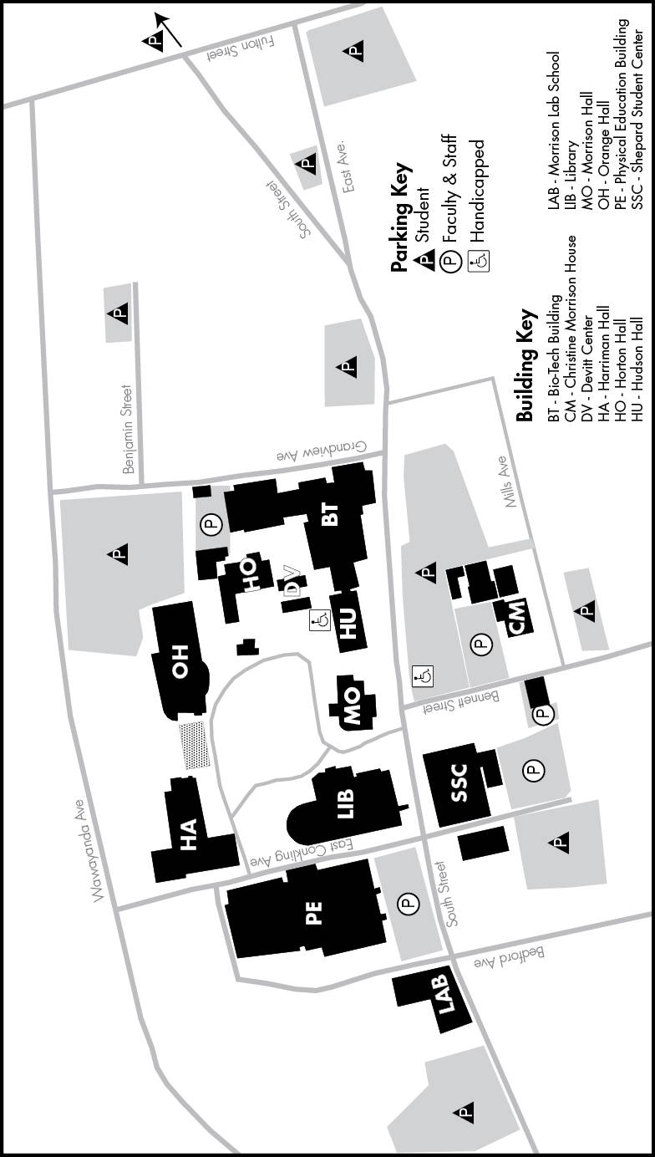

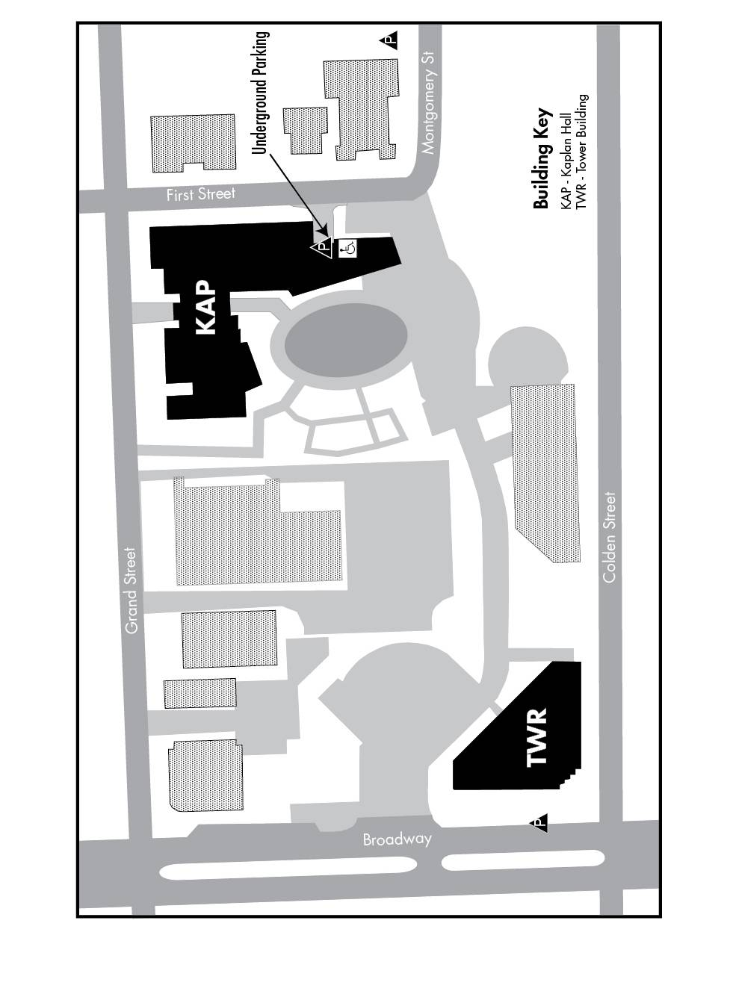
Appendix D: Newburgh Campus Map

